

User Manual
Payroll Module
www.flowhcm.com



Contents
Payroll Setup 5
Pay Schedule 6
Payroll Option 8
Pay slip Items 10
Tax Slabs 12
Salary Setting 13
Overtime 14
Auto Deductions 15
Final Settlement 17
VPS Policy 19
PF Policy 20
Salary Setup 21
Upload Excel 26
Process Payroll 27
Send Pay slip Email 29
Payroll Approvals 30
Pay slip Approvals 31
Advance Salary Request 32
Upload Excel 33
View Report 34
Leave Encashment Request 35
Overtime Request 37
Multiple Overtime Request 39
Upload Excel 40
View Report 41
Allowance Request 42
Upload Excel 43
View Report 44
Tax Adjustment Request 45
Apply for Opening Tax 47
Upload Excel 48
Deduction Request 49
Upload Excel 50
View Report 51
Bonus Request 52
Upload Excel 53
Reimbursement Request 54
Upload Excel 56
Process Salary Distribution 57
Commission Request 58
Loan Request 60
PF Loan 62
Gratuity Loan 63
Upload Excel 64
Loan Adjustment Request 65
PF Loan Adjustment 67
Gratuity Loan Adjustment 68
Profit Fund 69
Upload Excel 70
Fund Management 71
Add Provident Fund 71
Add VPS 72
Pending Entries 73
Upload Excel 74
View Report 75
Salary Change Request 76
Upload Excel 77
Export Allowance Changes Excel 78
PF Withdrawal Request 79
View Report 80
Hold Salary Request 81
View Report 82
Gratuity Withdrawal 83
View Report 84
Payroll Settings 85
Opening PF 86
Upload Excel 86
Employee Recurring Allowances 87
Upload Excel 88
Employee Recurring Deductions 89
Upload Excel 90
Fiscal Year 91
General Loan Type 92
Forex Exchange Rate 95
CPR 96
Tax Adjustment Type 97
Withholding Tax Type 98
Salary Distribution 99
Allowance Rate 100
General Payroll Setting 101

Payroll Setup

- Click on Payroll on the top navigation bar
- Here you can see the Payroll Setup form
- The form consists of multiple forms

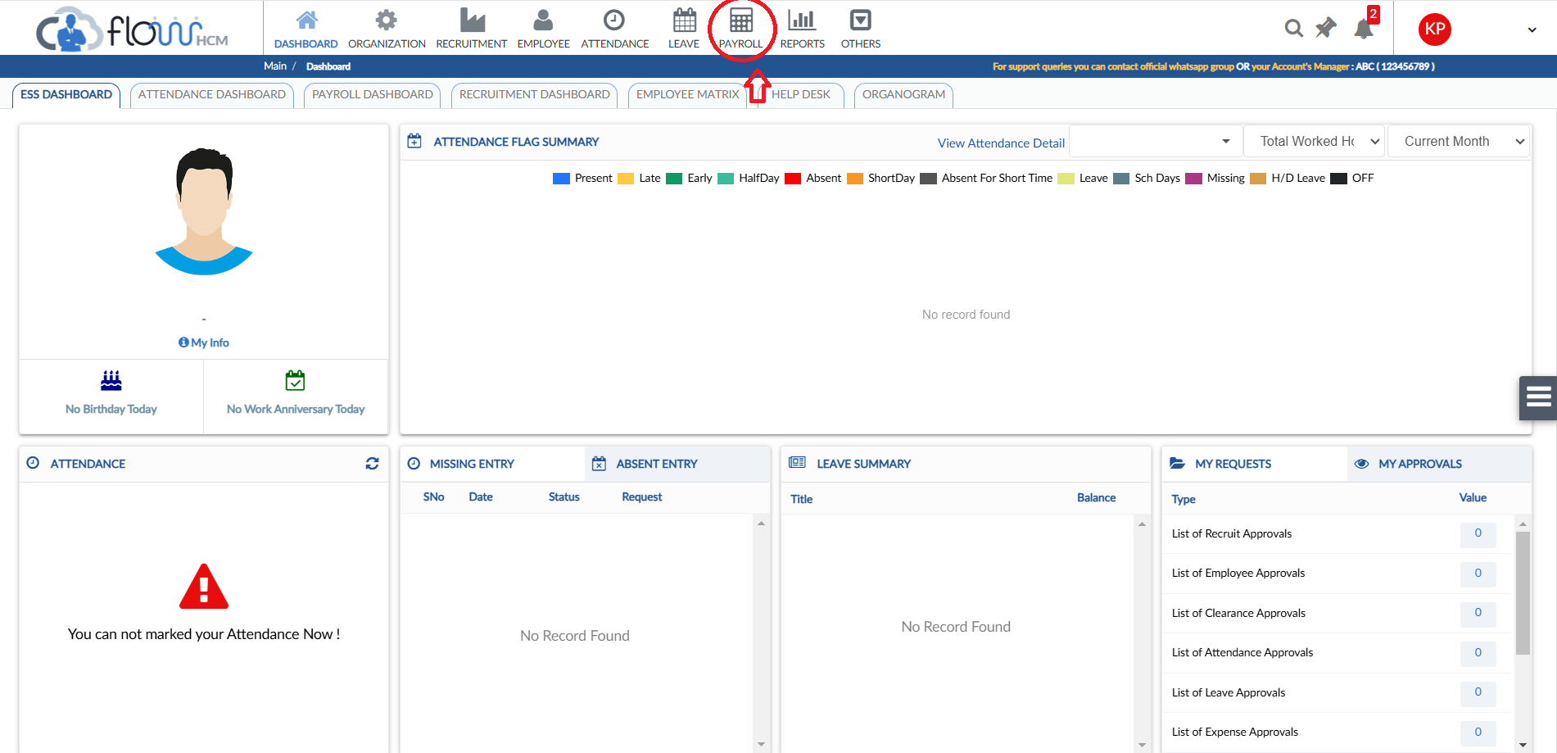
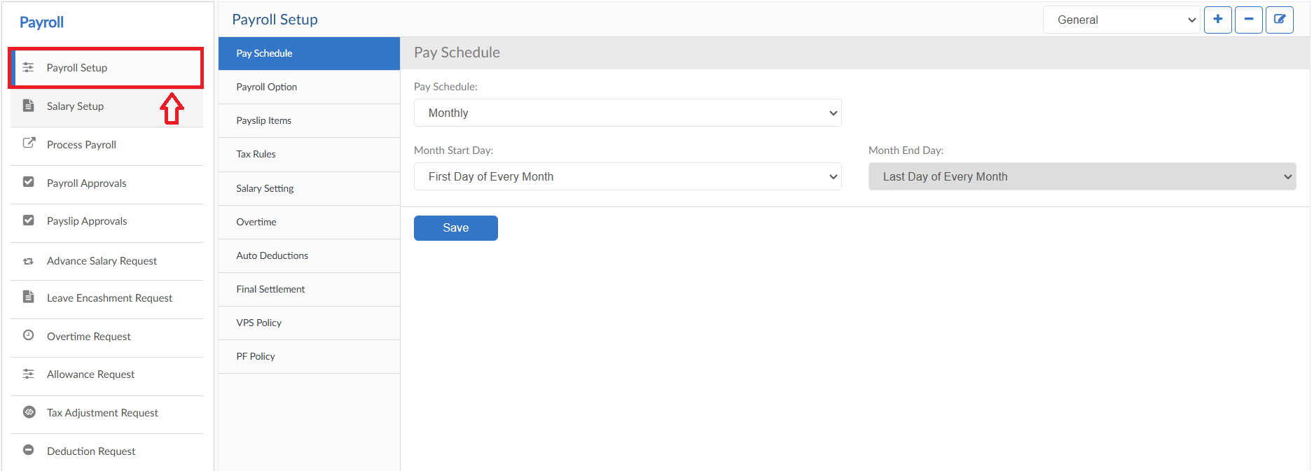

Pay Schedule
- Select the pay criteria for the payroll setup (Monthly/Weekly/Bi-weekly)
- Enter the Start and End date for employee payroll
- To add a new Payroll Setup, click on Plus (+) sign a pop will be visible, enter Setup name and if required to copy from another setup select YES in dropdown then click on save button
- To delete any Payroll Setup, click on Minus (-) sign a confirmation pop up will be visible, enter YES then click on Yes button
- To update any Payroll Setup Title, click on edit button a pop up will be visible, enter the title and then click on UPDATE button
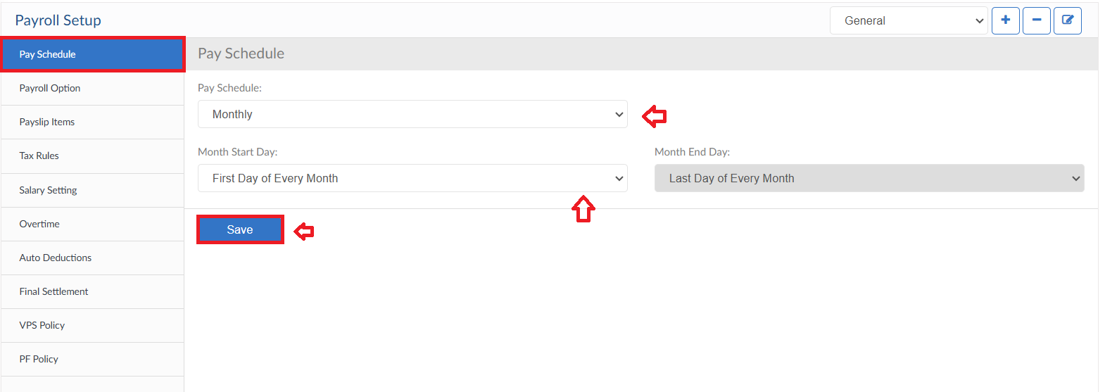
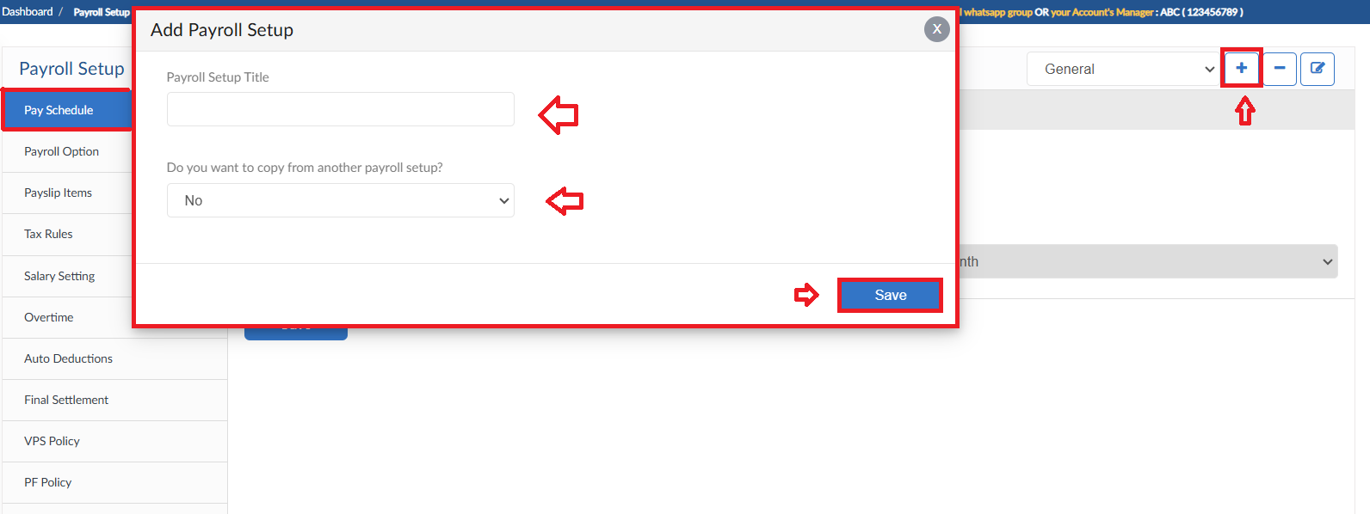
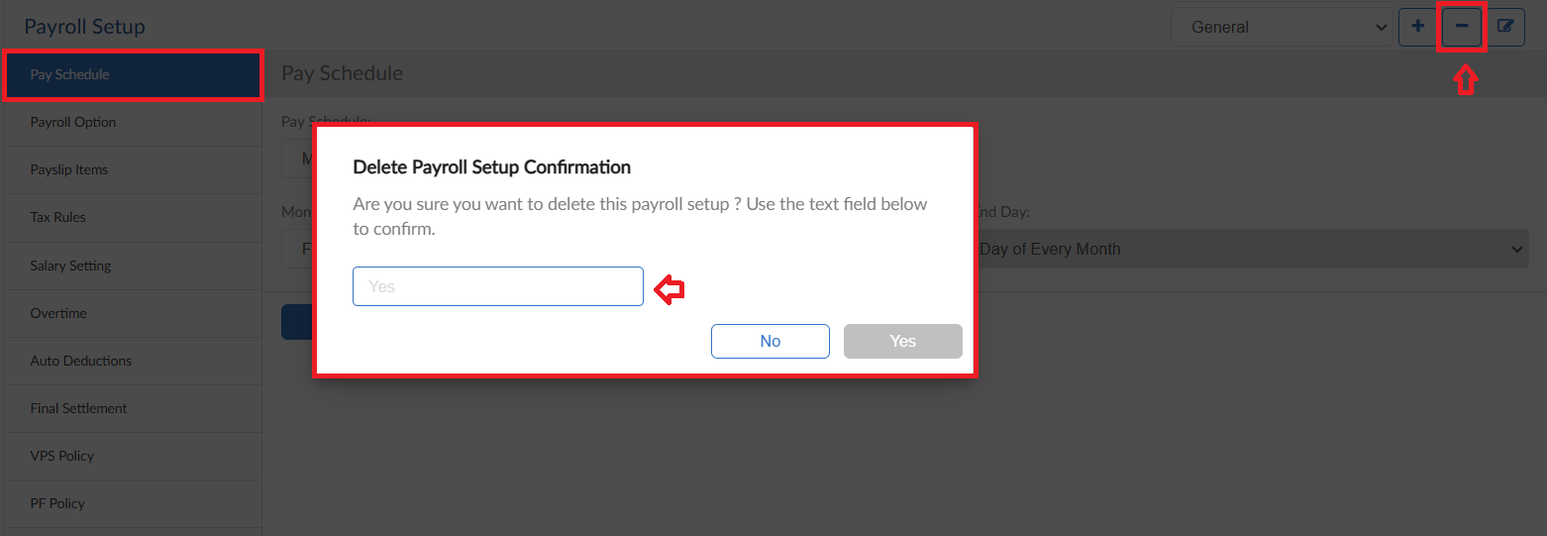
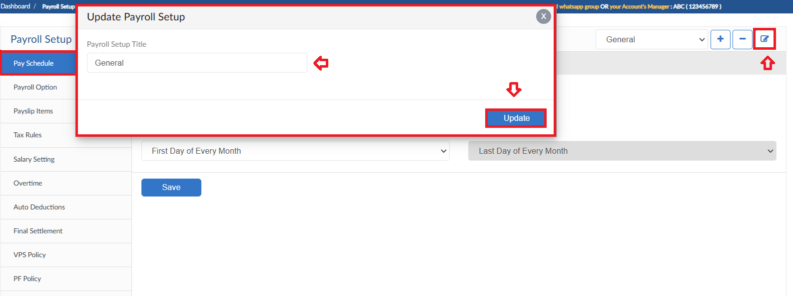

Payroll Option
- Select the functionality of Payroll Options from dropdowns
- Select the calculation methods of salary
- From dropdowns select the currency of Payroll and Remit
- In Pay slip Options header select all the required data to be shown on the Pay slip to the employee
- Payroll Summary Options allows user to add Signatures with Designations up to 5 Levels on Payroll Summary Report
- After all the settings click on save button
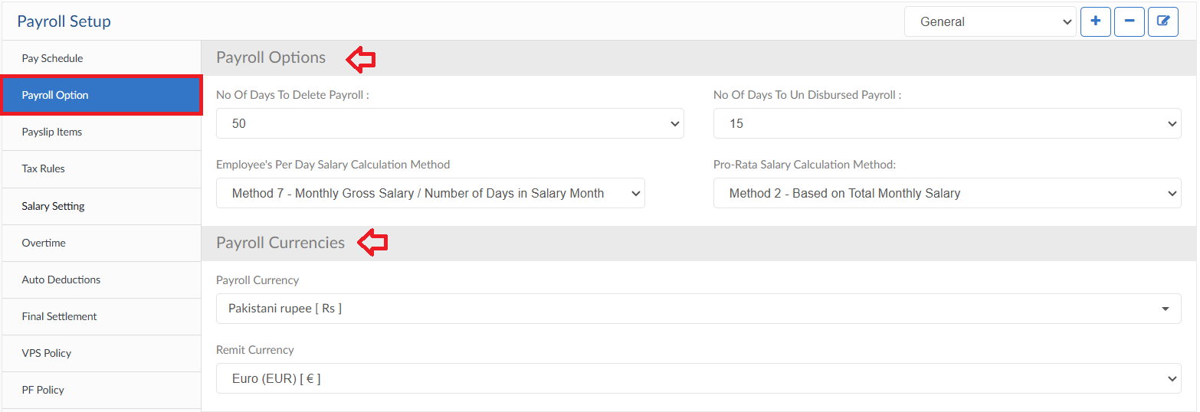
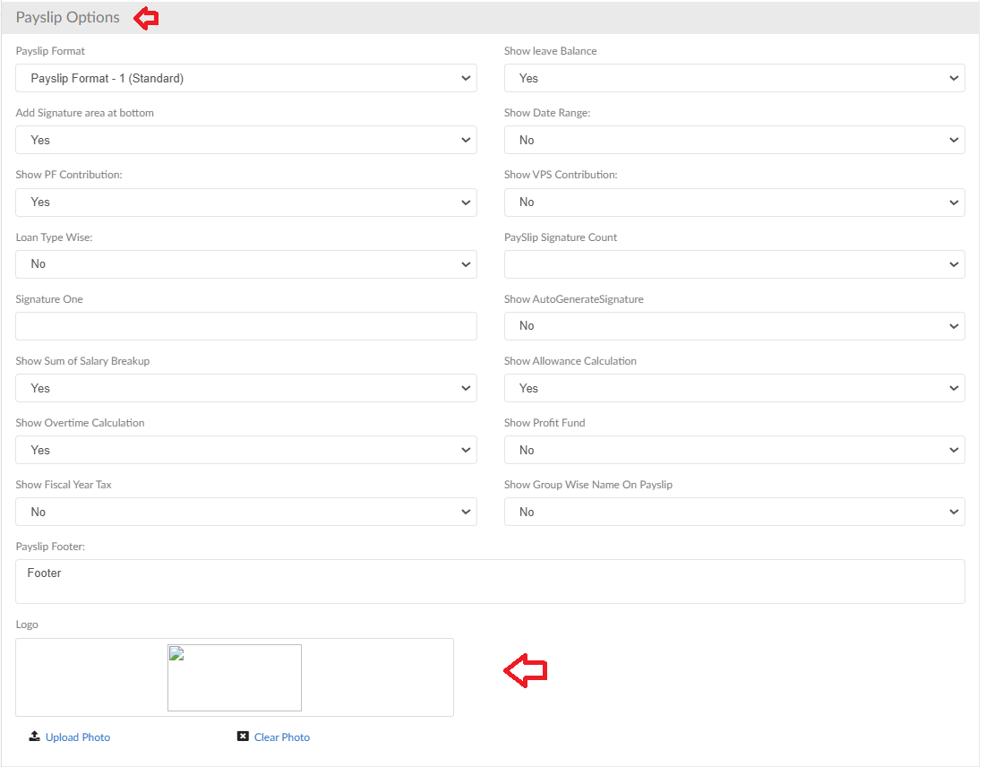
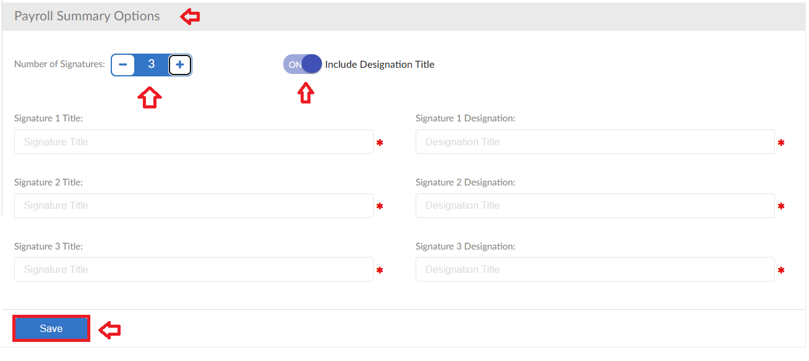

Pay slip Items
- In this form the Salary breakup of the employees in this Payroll Setup is defined
- Select the Basic salary type from dropdown and enter the percentage
- Further the remaining the salary is entered in Allowances
- For deductions select from dropdown then select deduction type and enter amount/percentage of that deduction
- In case of EOBI in deduction an additional option is available, click on the Plus (+) sign a pop up will be visible select the criteria and click on save button
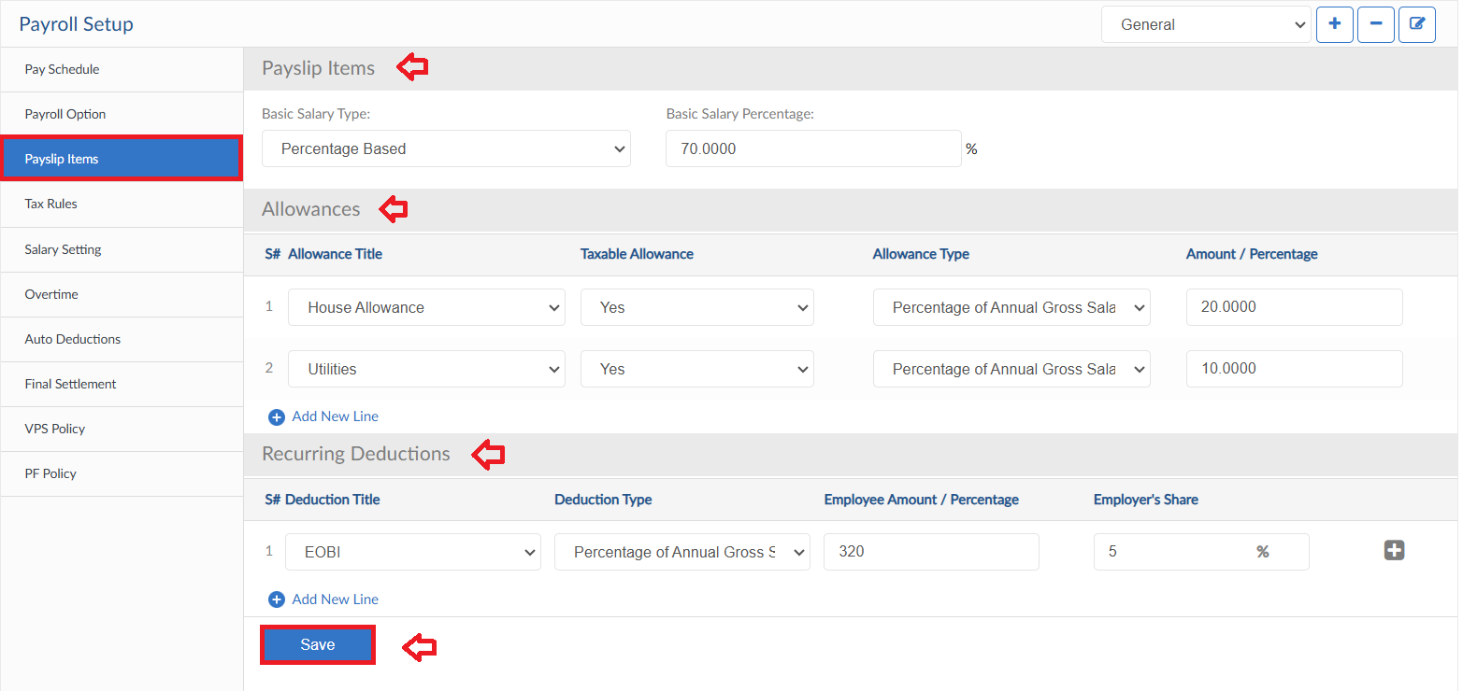
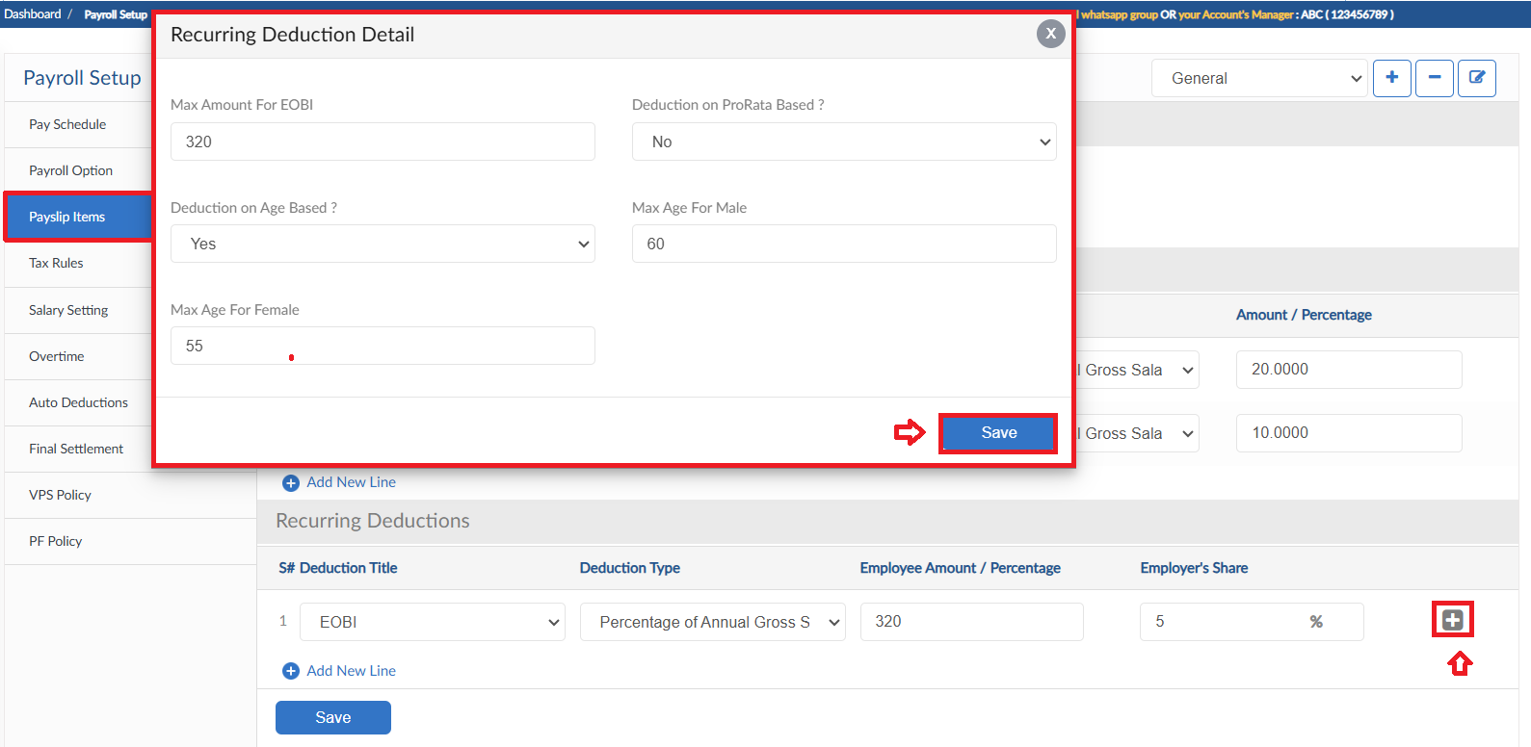

Tax Slabs
- Click on Update Tax Slabs button
- System will show the current Tax Slabs maintained by the Government of Pakistan
- Then click on save button, the tax deduction will be processed accordingly
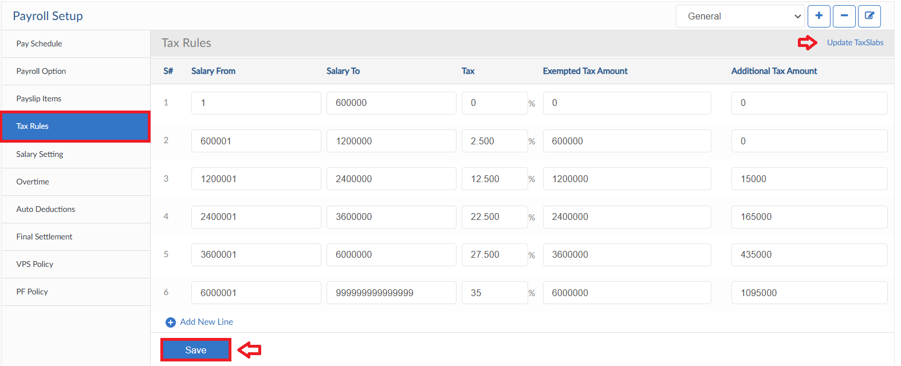

Salary Setting
- This form consists of settings for Advance Salary and Salary Chane request
- Select the criteria from dropdowns
- Then click on save button
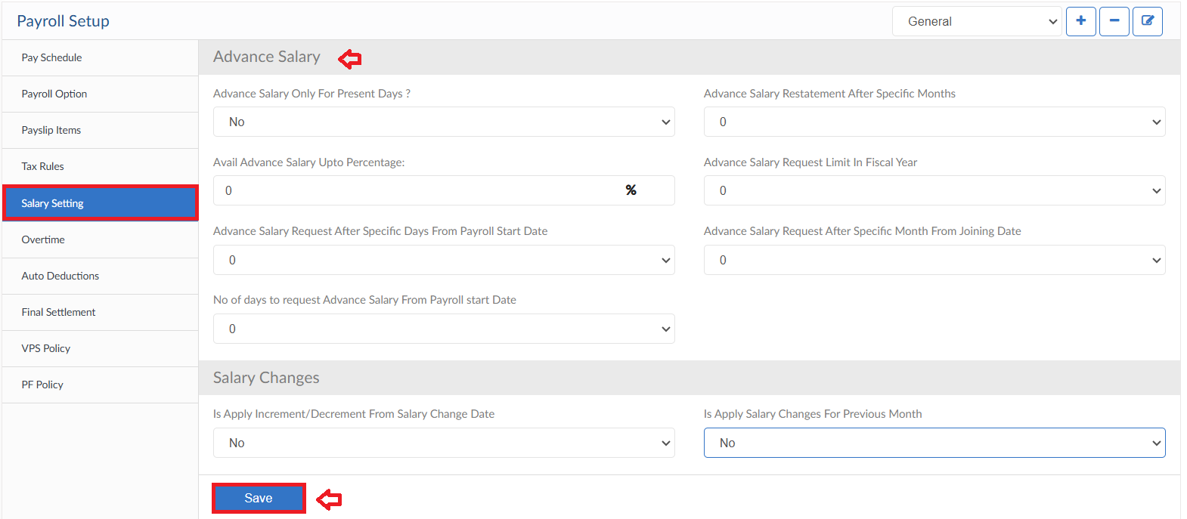

Overtime
- Overtime form allows you select the criteria of overtime calculation and settings of hours
- Criteria can be different for Working and non-working day, Holiday etc.
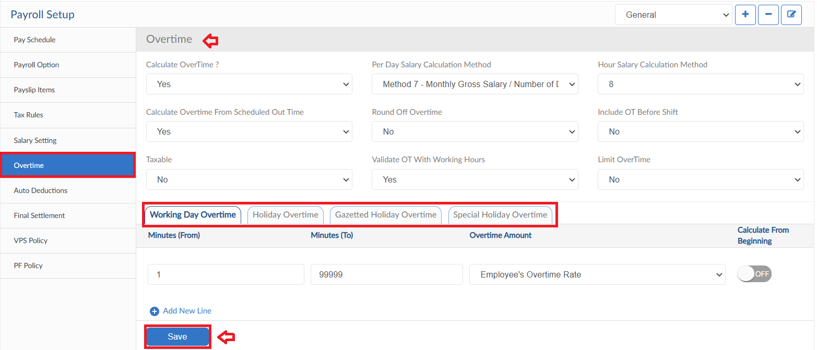

Auto Deductions
- In this form the settings for Auto deductions according to the rules set are applied
- Select the attendance flags, enter the count and exemption with the frequency for deductions. Define the deduction amount
- Furthermore, additional settings are available for each attendance flag rule
- Same as auto deduction rules for attendance flags system has provision for Absence, Shor Time, Pre-Joining and Post-Leaving deductions
- Click save button to update the rules definitions
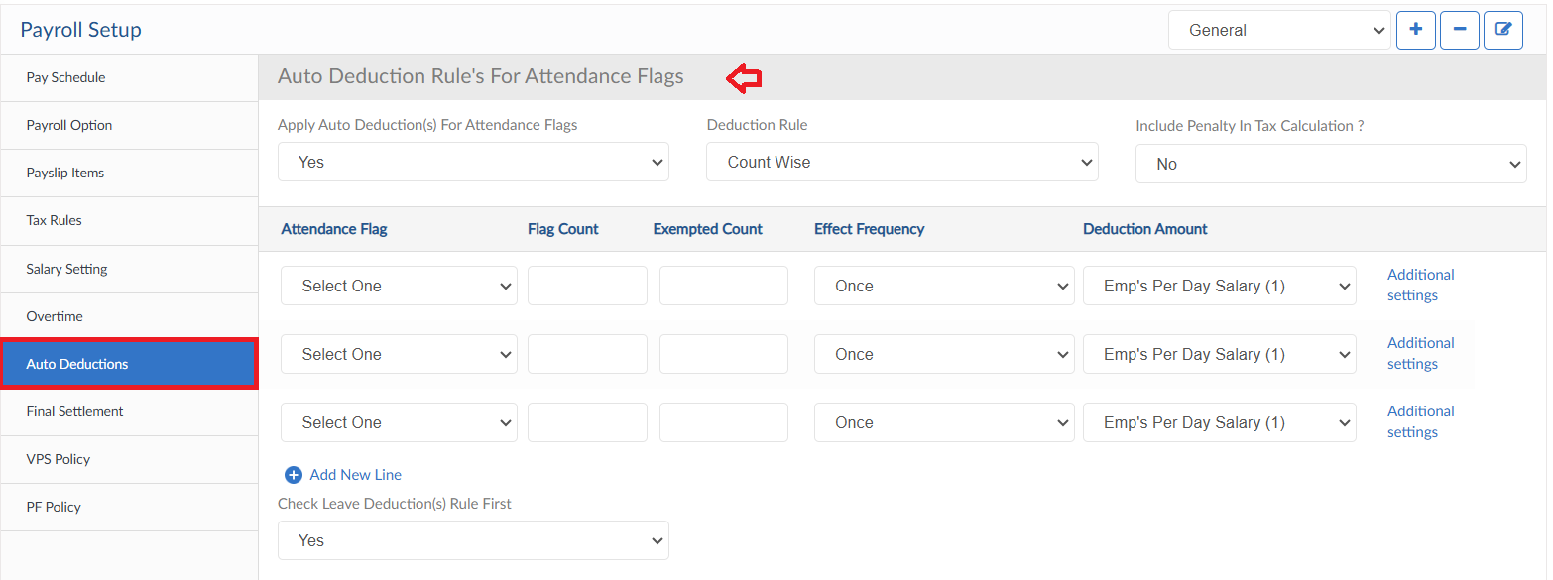
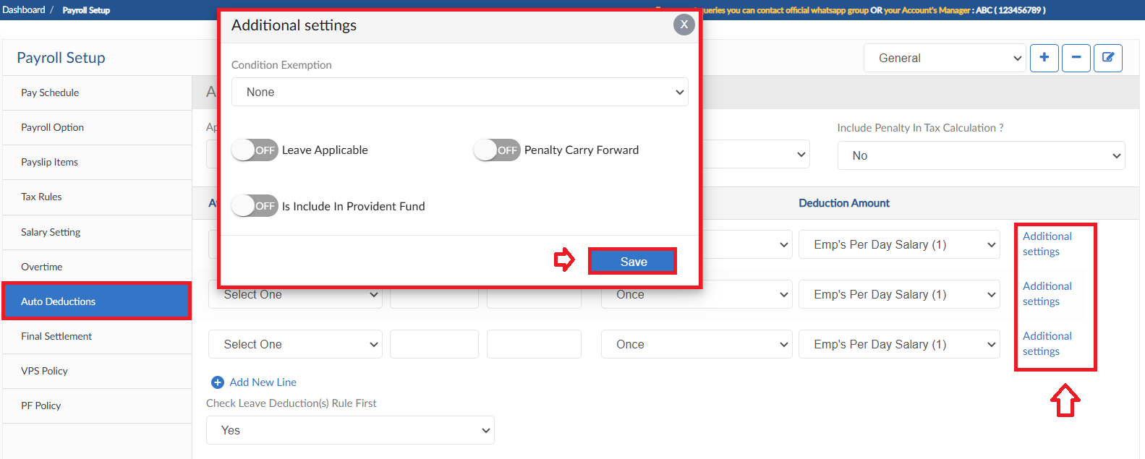
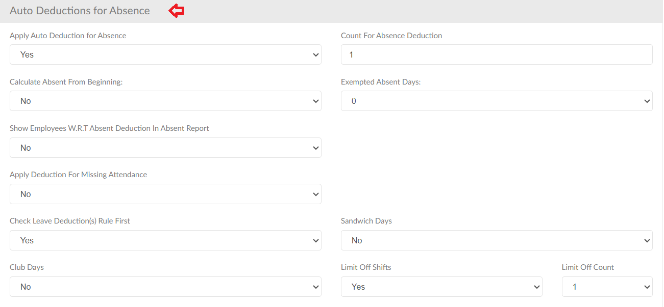
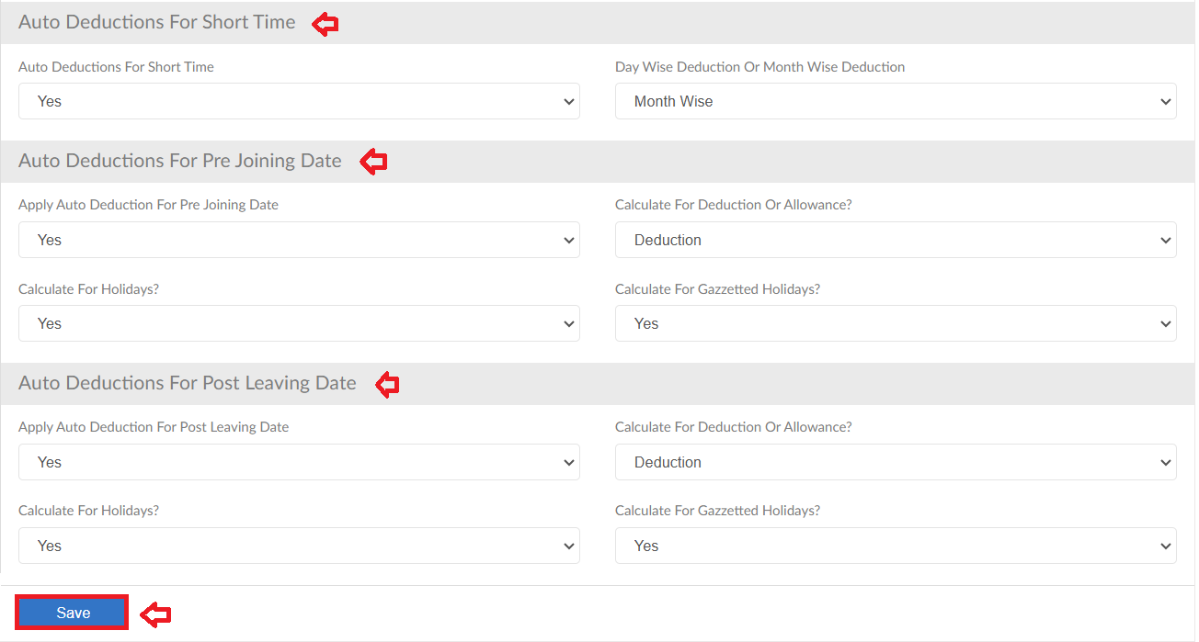

Final Settlement
- Final Settlement form consists the settings for End of Service procedures
- First tab selects the criteria for FnF
- Next is gratuity, define the gratuity criteria if applied in organization
- Gratuity Loan is also available in the system, user can define the percentage for loan if allowed
- Report Setting is for the summary report of Final Settlement that consists all the details for the employee
- FnF options allows user to add Signatures with Designations up to 5 Levels on Final Settlement Report
- After all the settings click on save button
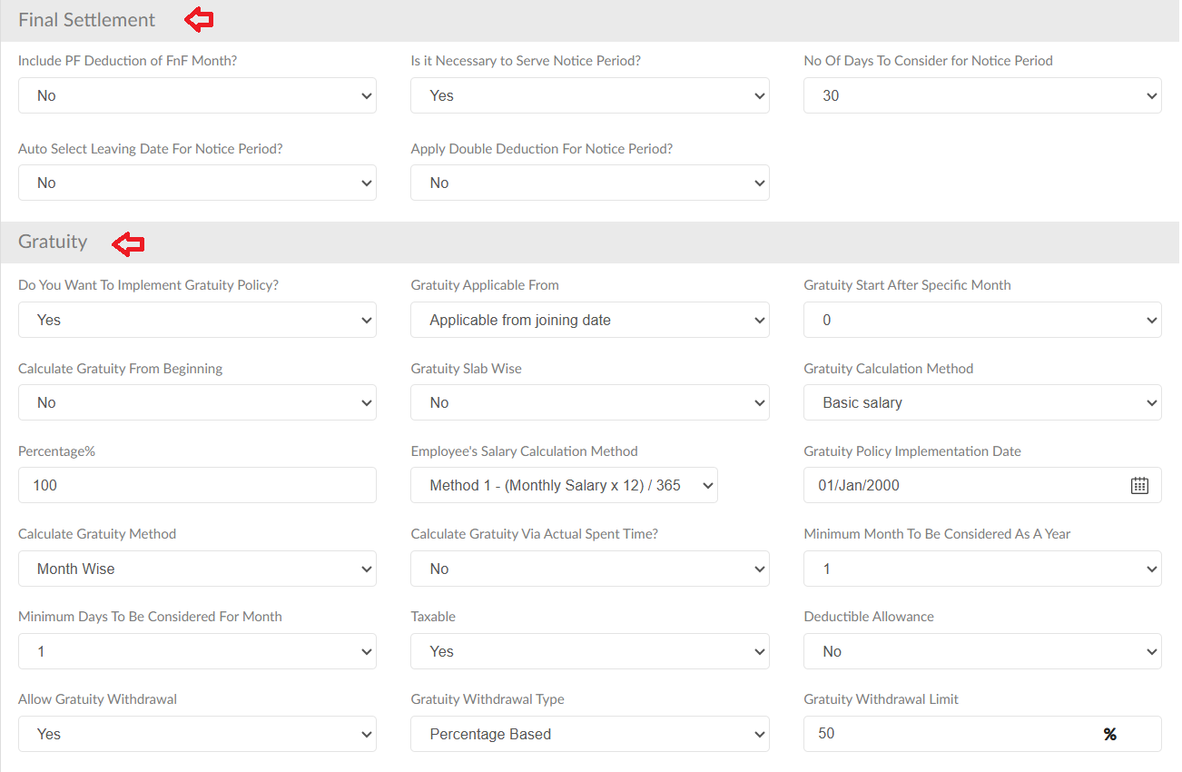
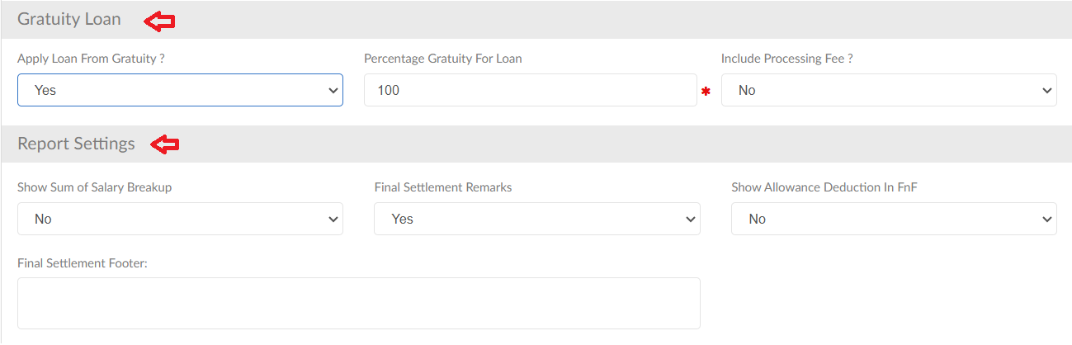

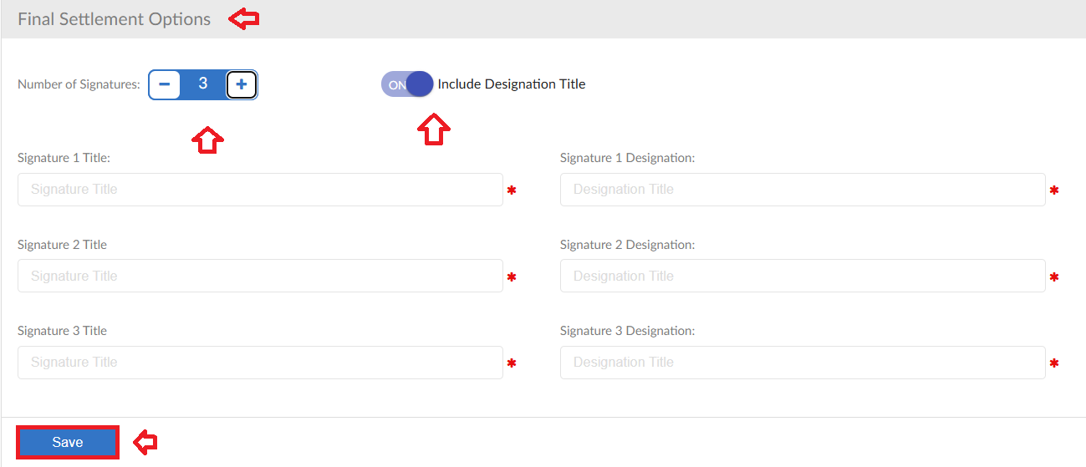

VPS Policy
- Any organization with VPS policy, can implement through system
- Select the criteria of policy then click on save button
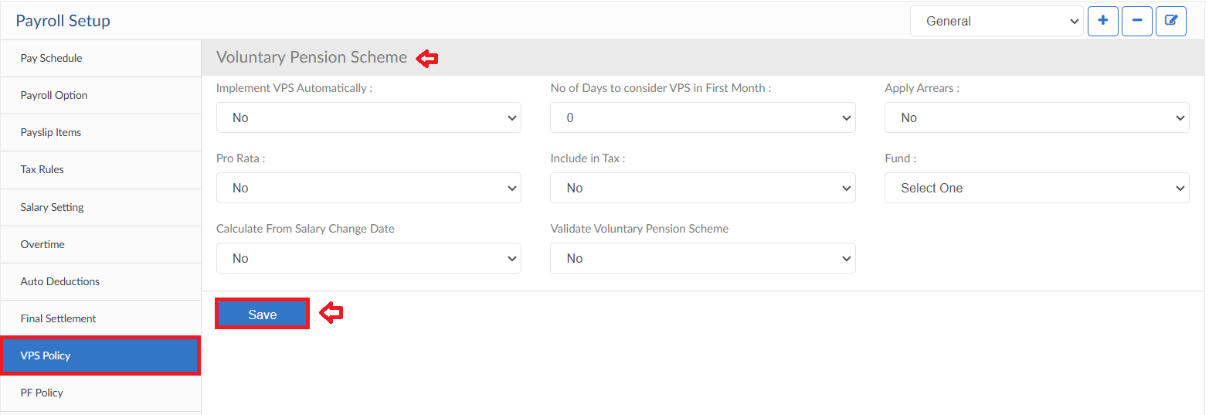

PF Policy
- Any organization with Provident Fund policy, can implement through system
- Select the criteria of policy and all the validation
- PF loan is also part of system, select the criteria of loan
- PF withdrawal policy can also be applied
- PF withdrawal options allows user to add Signatures with Designations up to 5 Levels on PF withdrawal Request Report
- After all the settings click on save button
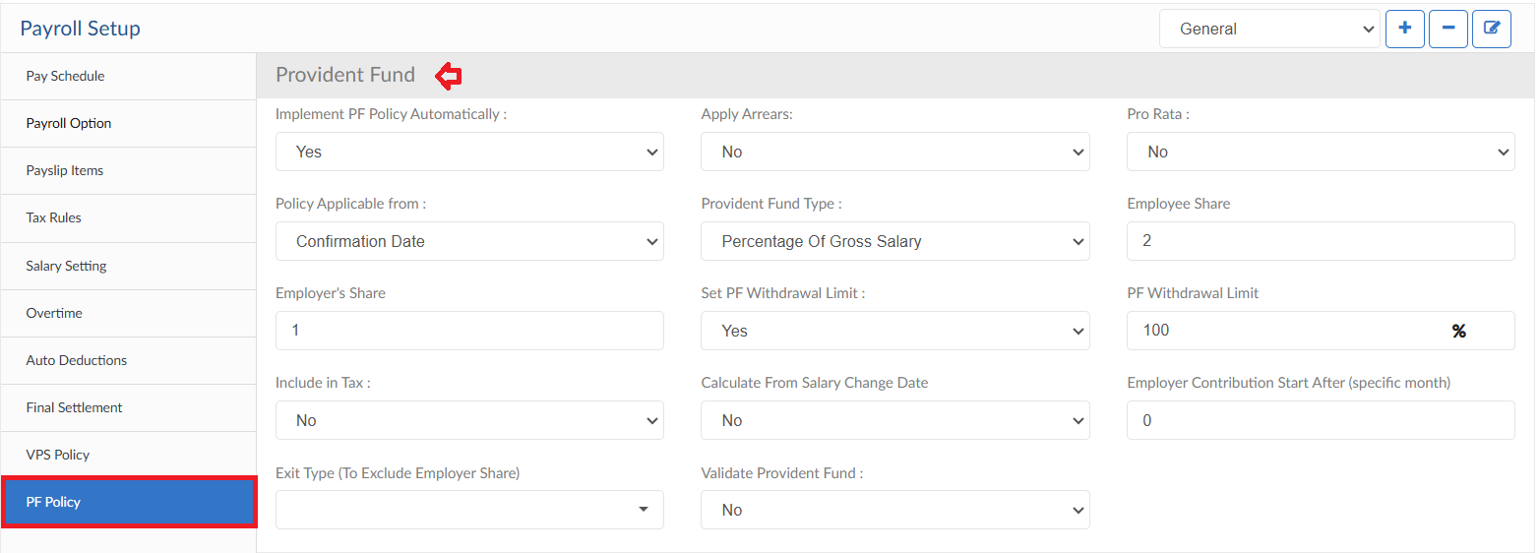
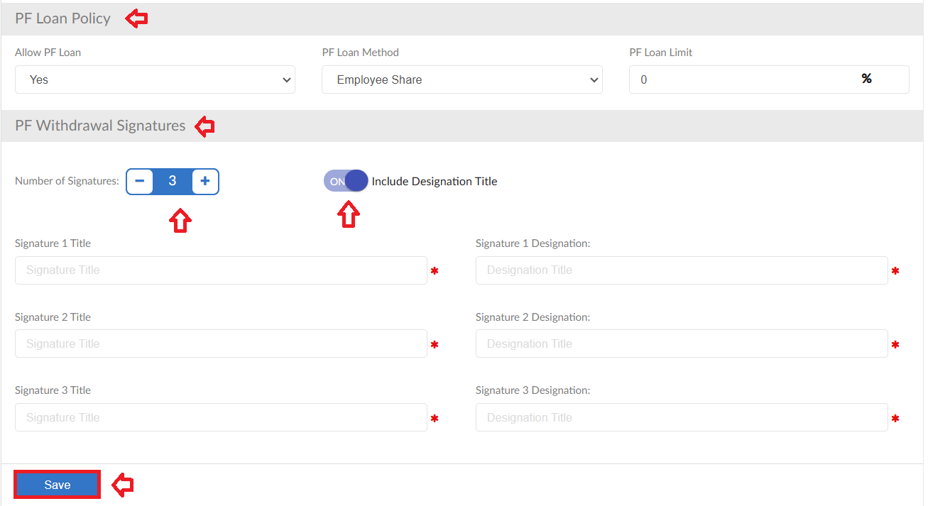

Salary Setup

- To add salary details of an Employee, select the employee from dropdown in the Salary Setup form
- Next, map the employee with a payroll setup then define the salary type from dropdown. System will automatically show the currency
- There are multiple toggle buttons to enter details, to define overtime and short time rates of an employee enable the toggle buttons and enter the required information
- Same process for payment details of an employee
- Enter the monthly salary of the employee, system will automatically distribute the amount according to the salary breakup defined in Payroll Setup
- Furthermore, if any recurring Allowances or Deductions need to be entered, enable the toggle button and enter the required data for calculations
- System will show the Estimated Monthly Salary of the employee
- After all settings click on save button
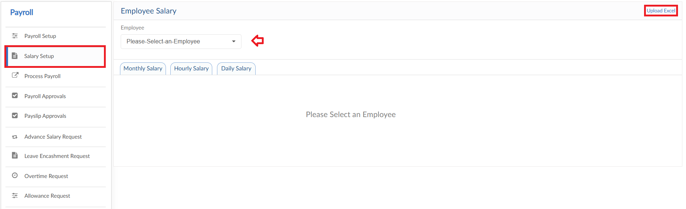
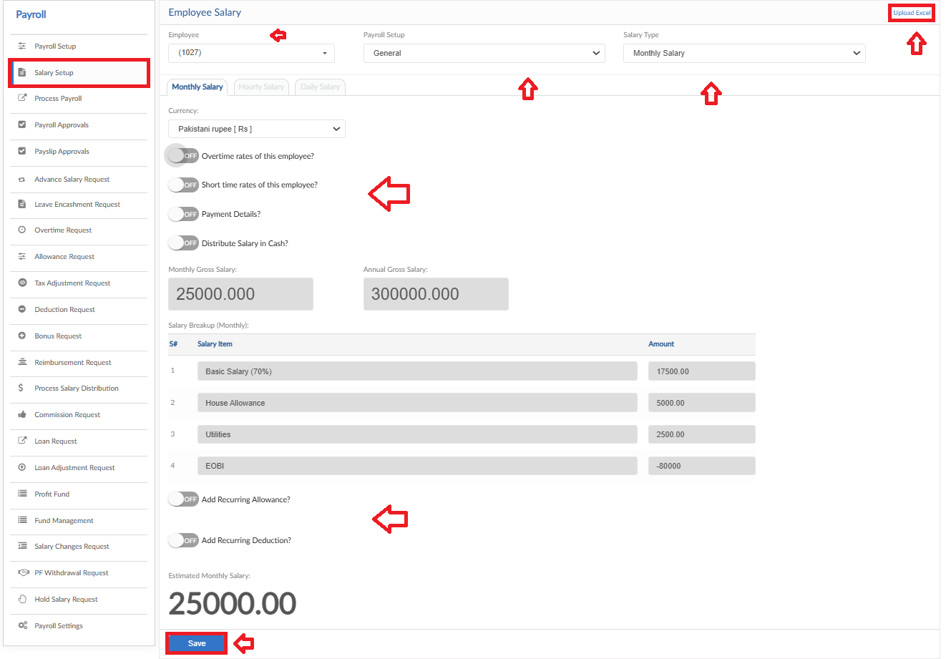
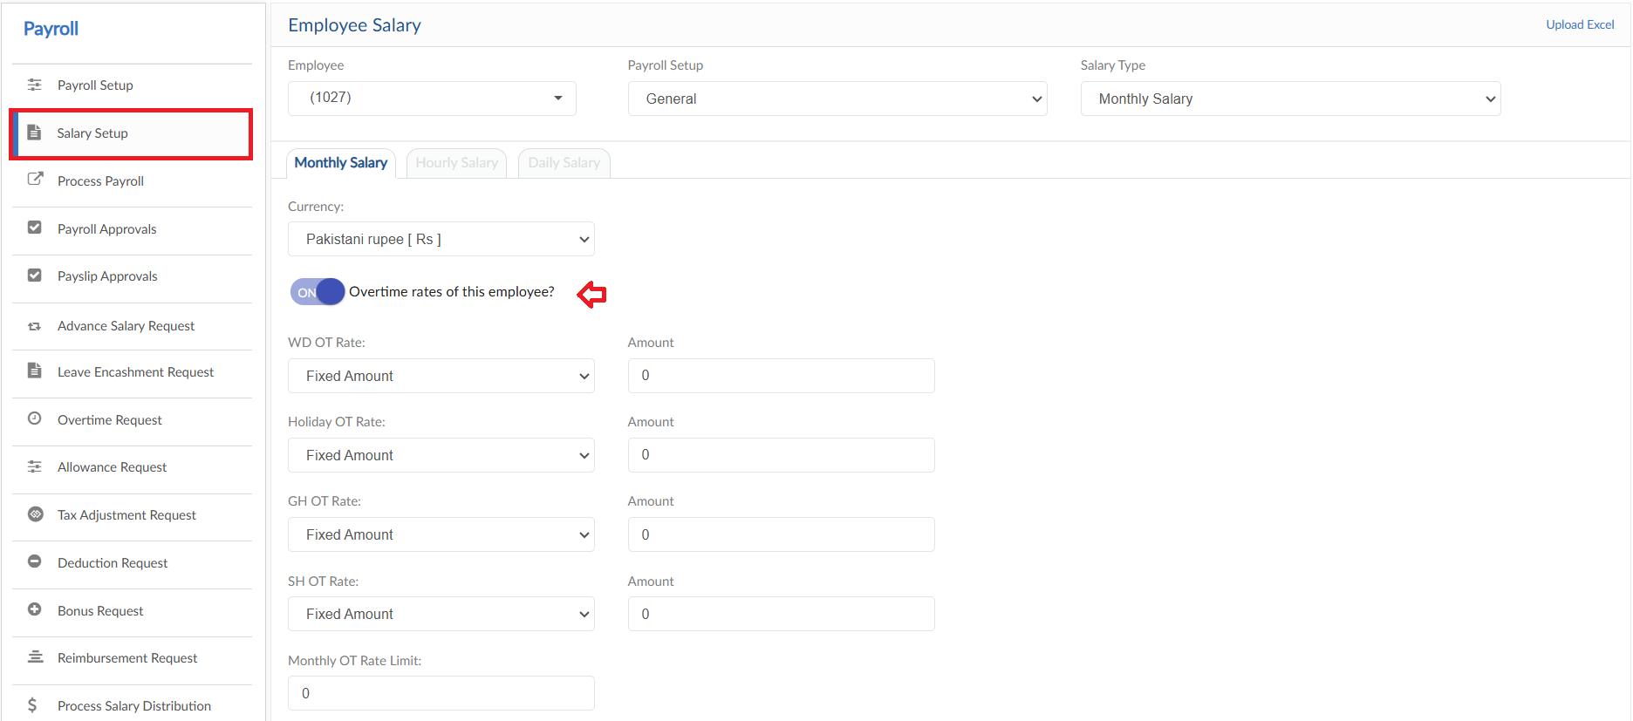
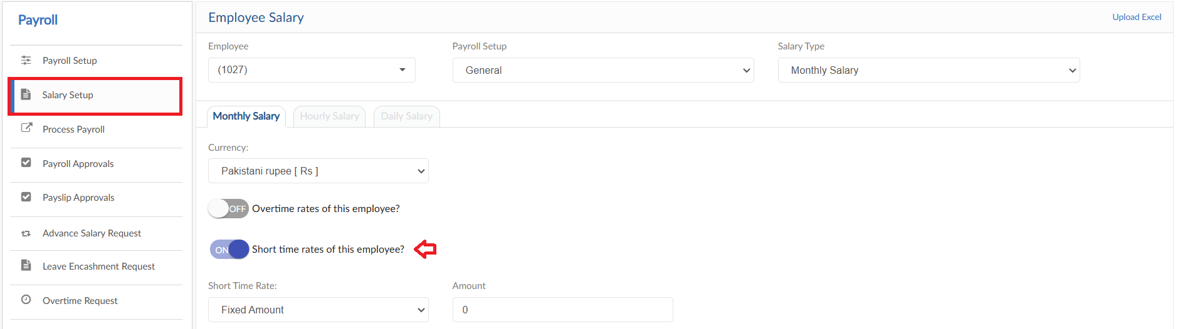
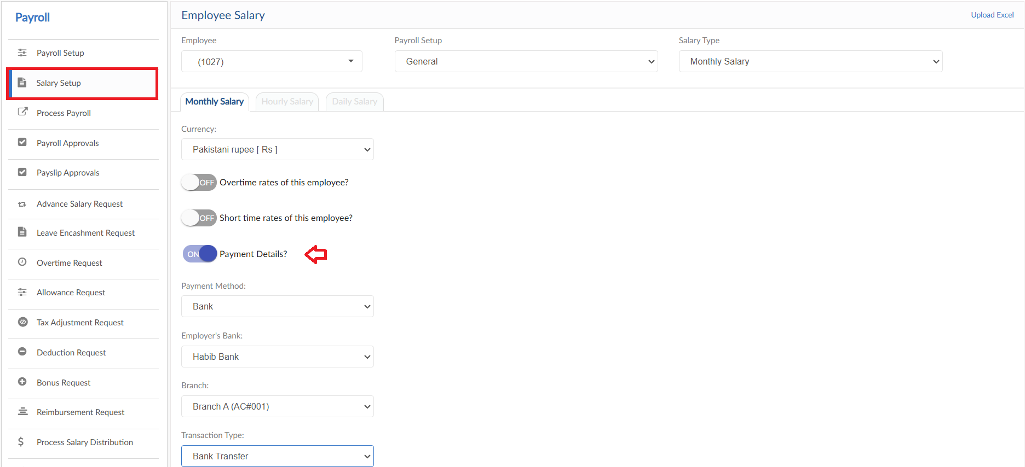
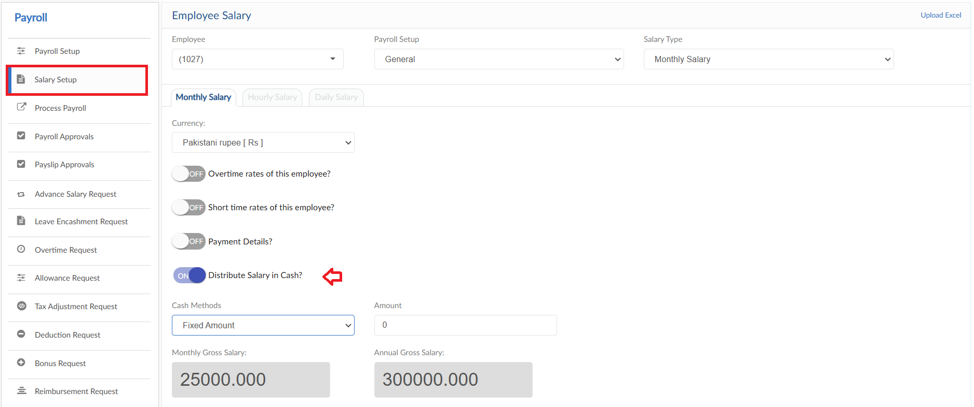
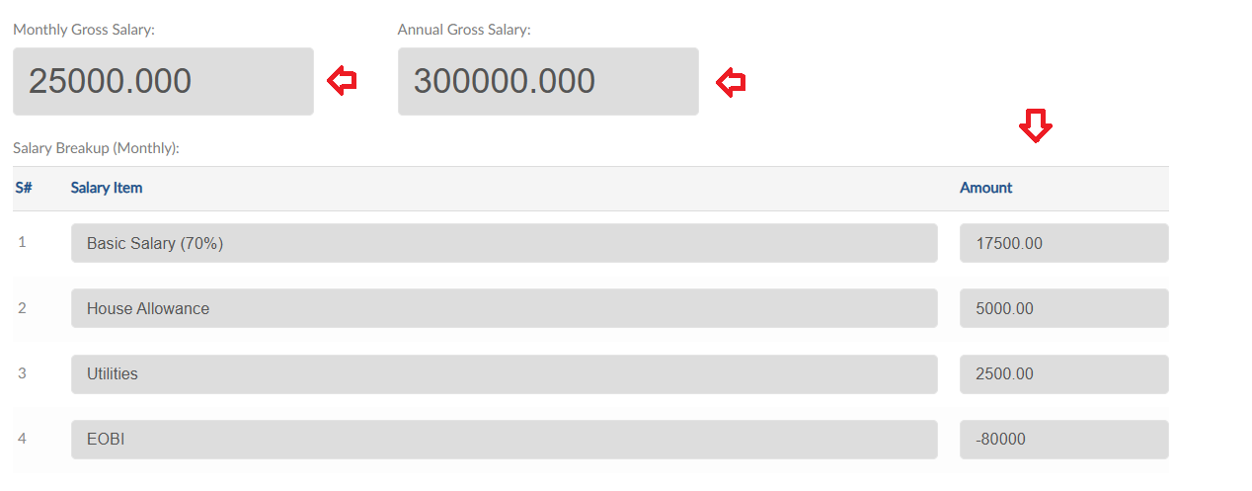
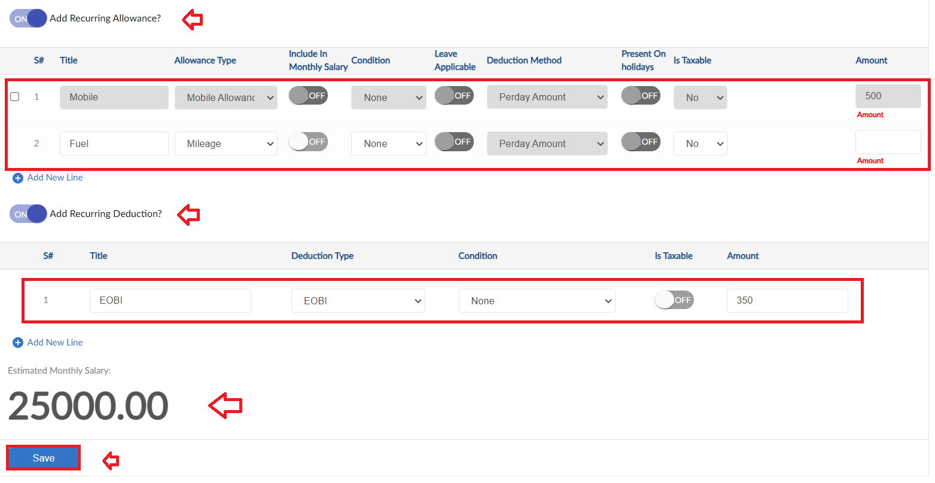

Upload Excel
- If required, upload all employee salary in one go user can use upload excel
- Click on Upload Excel button, pop up will be visible
- Then click on Download Sample Template and enter required data
- Click on choose file and then click on Save button to upload all employee salary
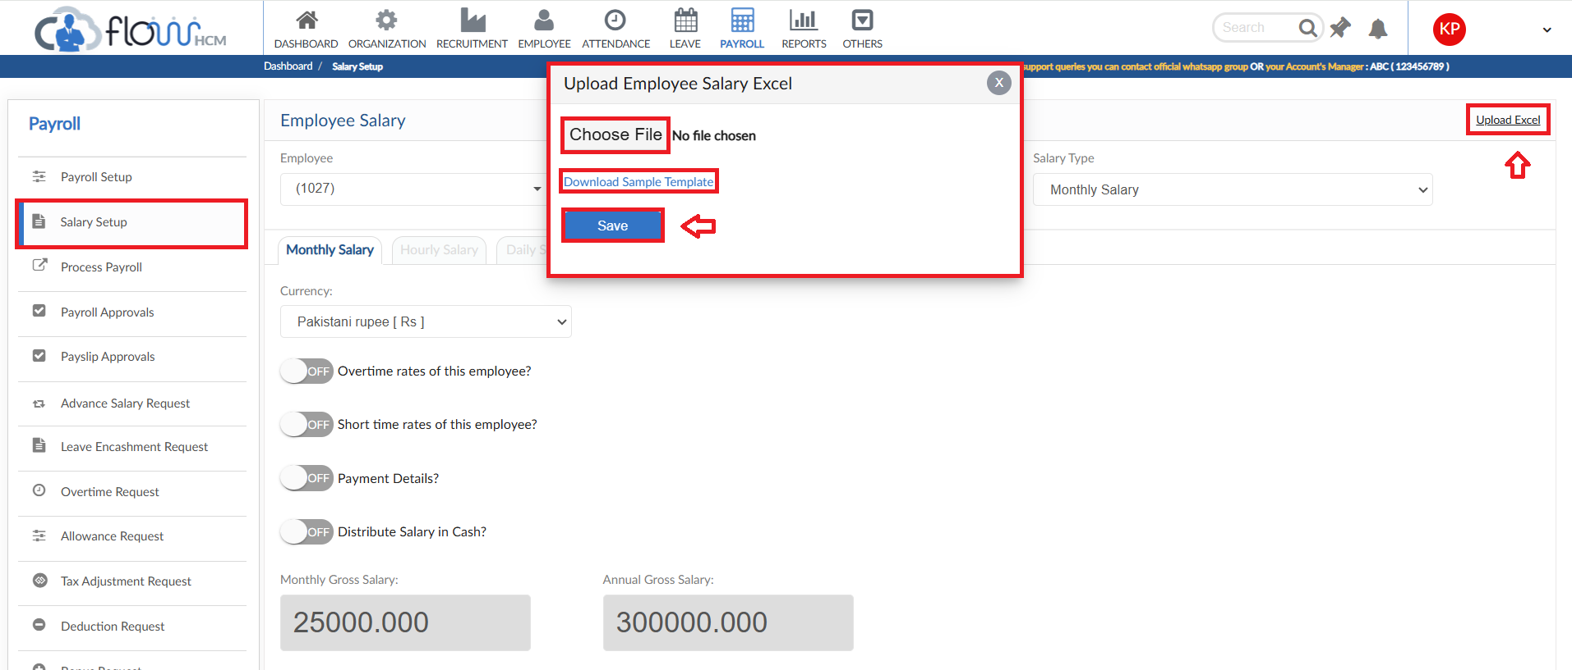

Process Payroll

- To calculate the income of employees, click on Run Payroll button in the Process Payroll form
- Select the filter criteria for employees, enable the required toggle buttons then click on Preview button
- System will list down the employees according to the filter selection along with their payroll information
- List allows provision to download all pay slips in PDF and Excel report
- Click on Save button if don’t want to disburse salaries else click on Save and Disburse button
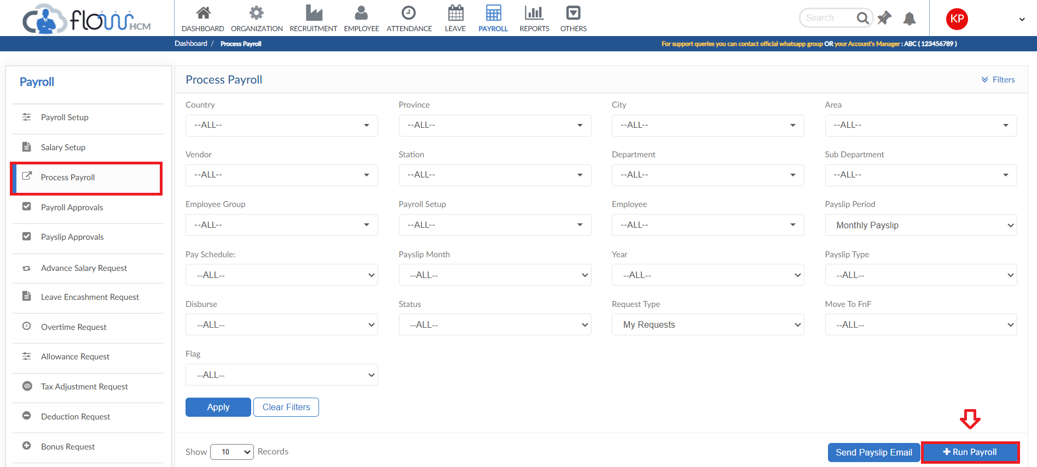
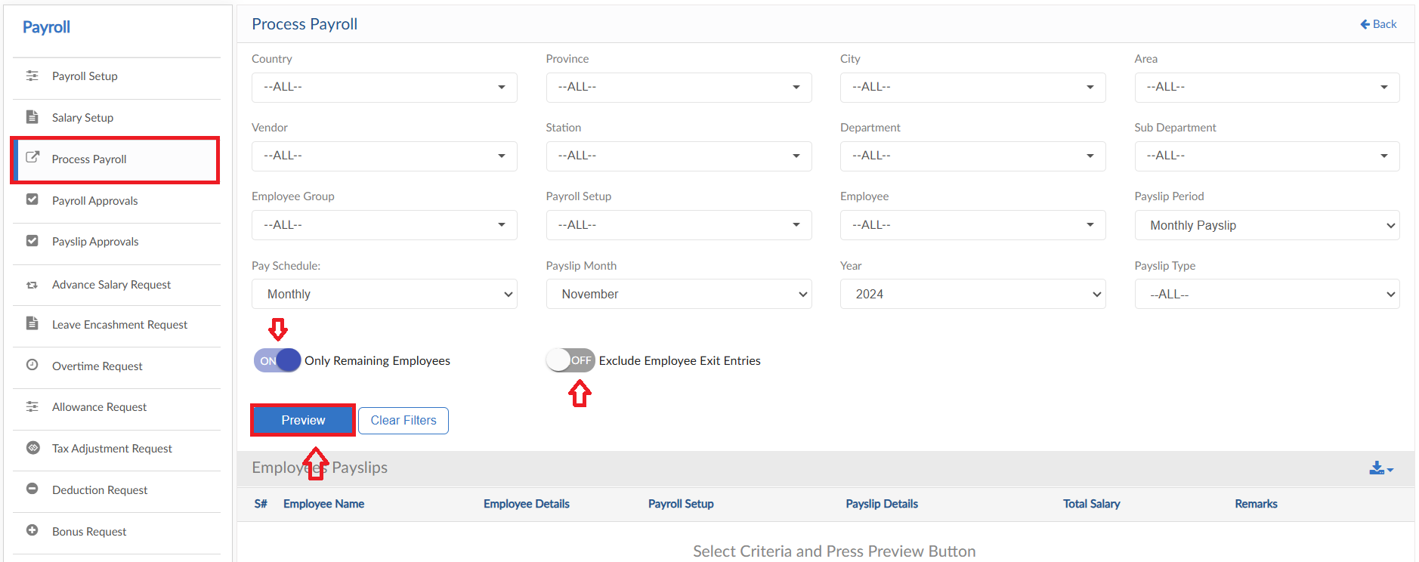
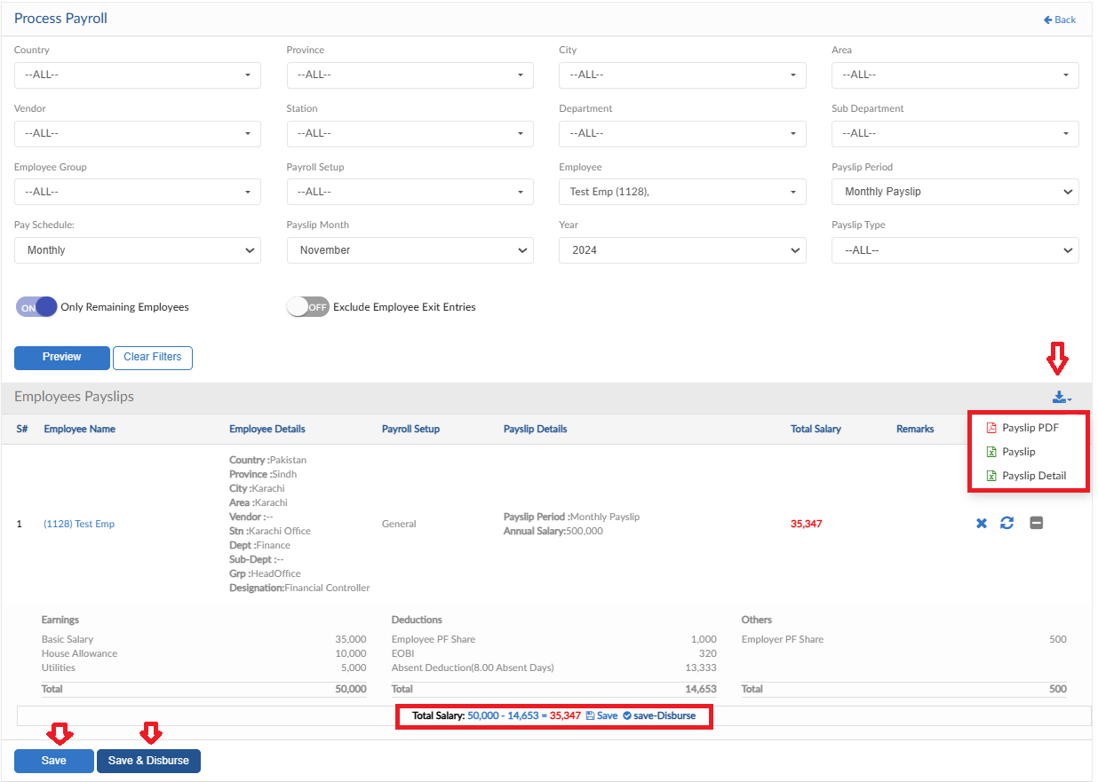

Send Pay slip Email
- To send the pay slips of employees all in one go lick on Send Pay slip Email button
- Pop up will be shown on screen, select the filter criteria and then click on Send button
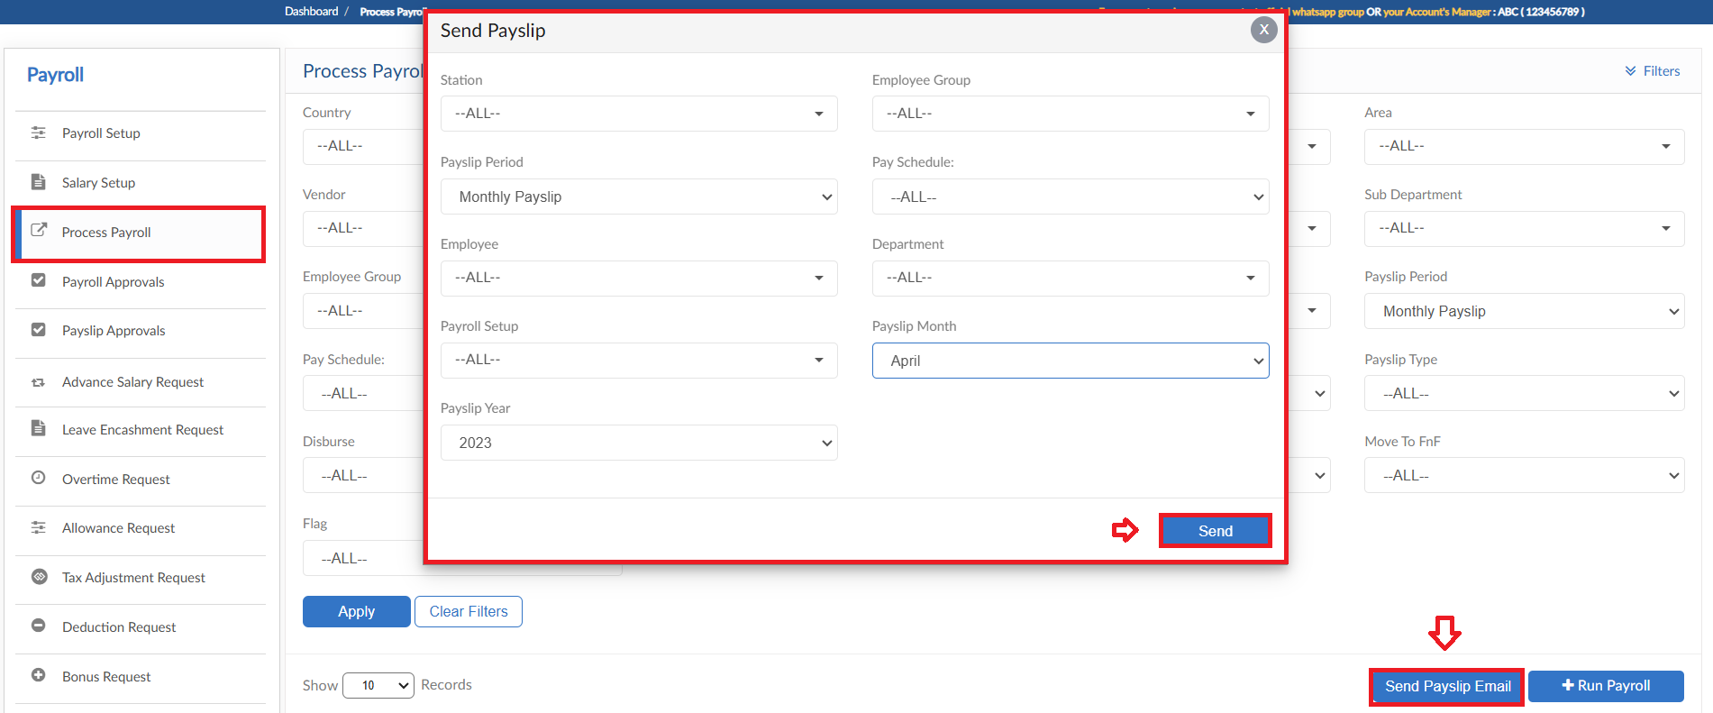

Payroll Approvals

- All the requests of Payroll Module will fall in Payroll Approval form
- User can select criteria for specific requests and click Apply button
- System will fill the grid with required data
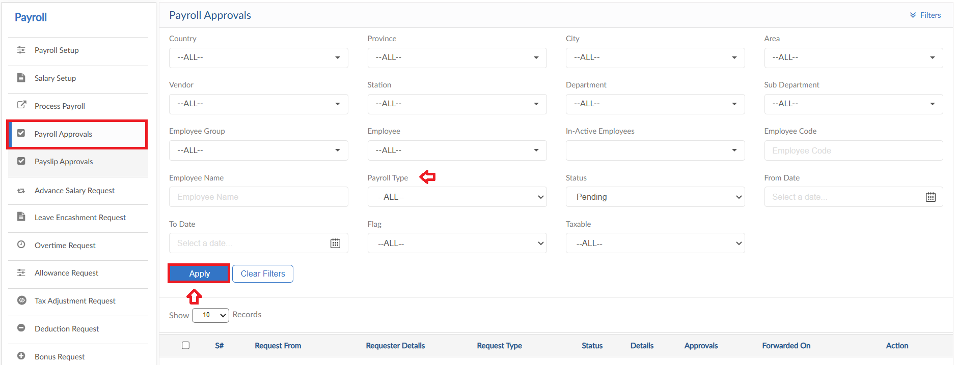

Pay slip Approvals

- All the requests related to pay slip items will fall in Pay slip Approval form
- User can select criteria for specific requests and click Apply button
- System will fill the grid with required data
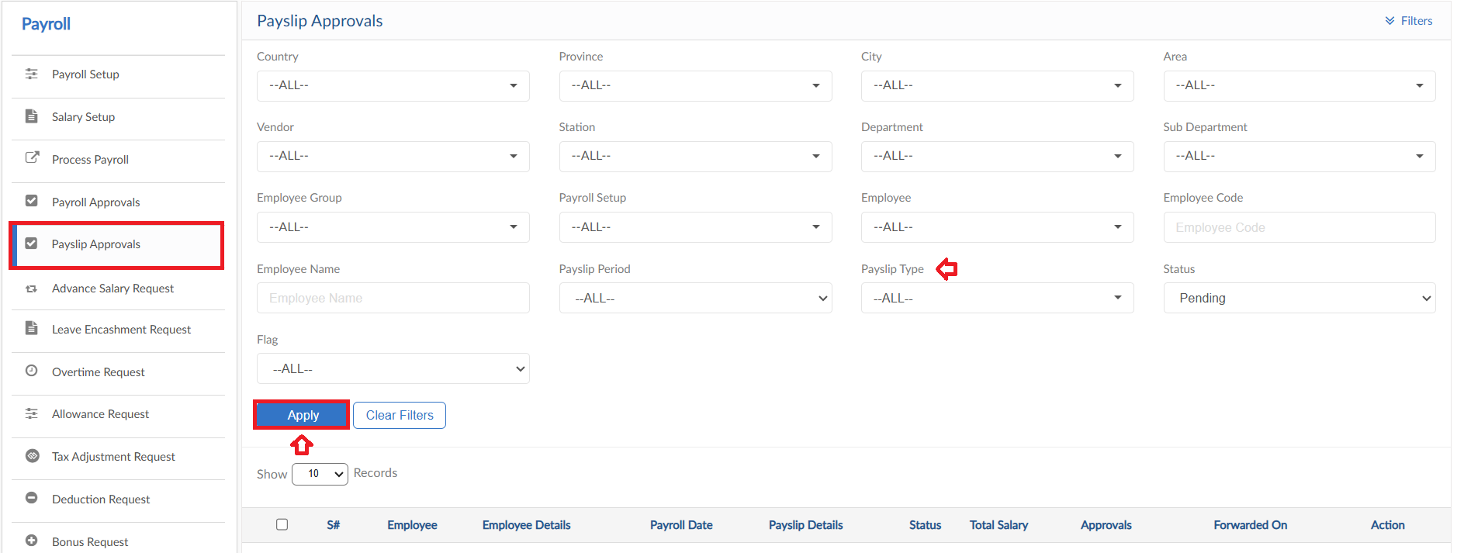

Advance Salary Request

- To add an Advance Salary Request, click on Apply for Advance salary button
- Select an employee and enter tile for request
- System will automatically show history of Advance Salary requests of the selected employee
- Select a date and enter amount of advance salary required
- Enter a reason
- Then click on submit to raise a requisition
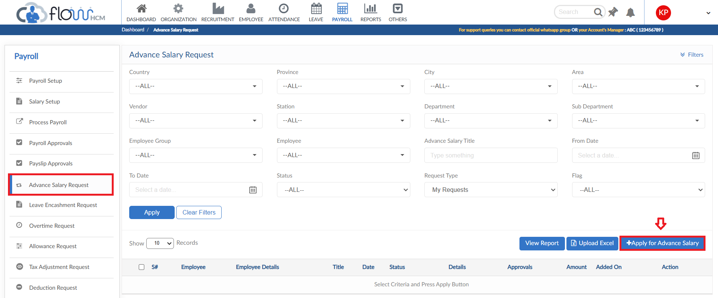
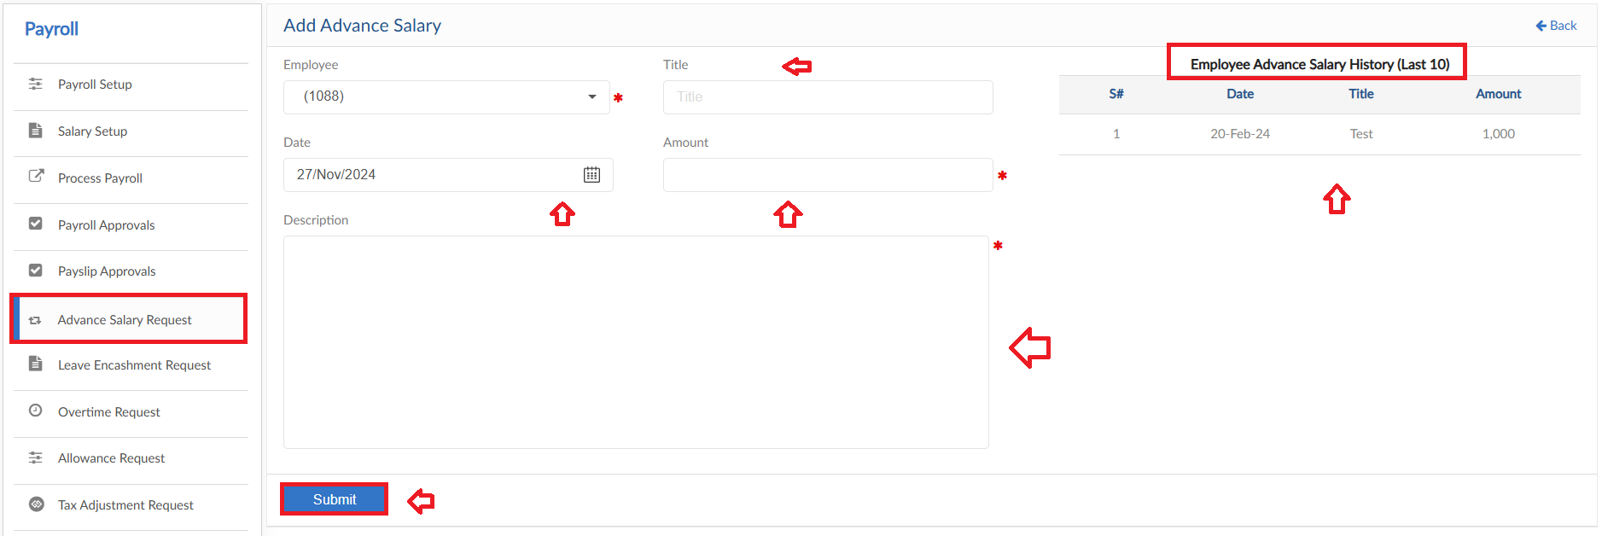

Upload Excel
- If required, upload all Advance Salary entries in one go user can use upload excel
- Click on Upload Excel button, pop up will be visible
- Then click on Download Sample Template and enter required data
- Click on choose file and then click on Save button to upload all Advance Salary entries
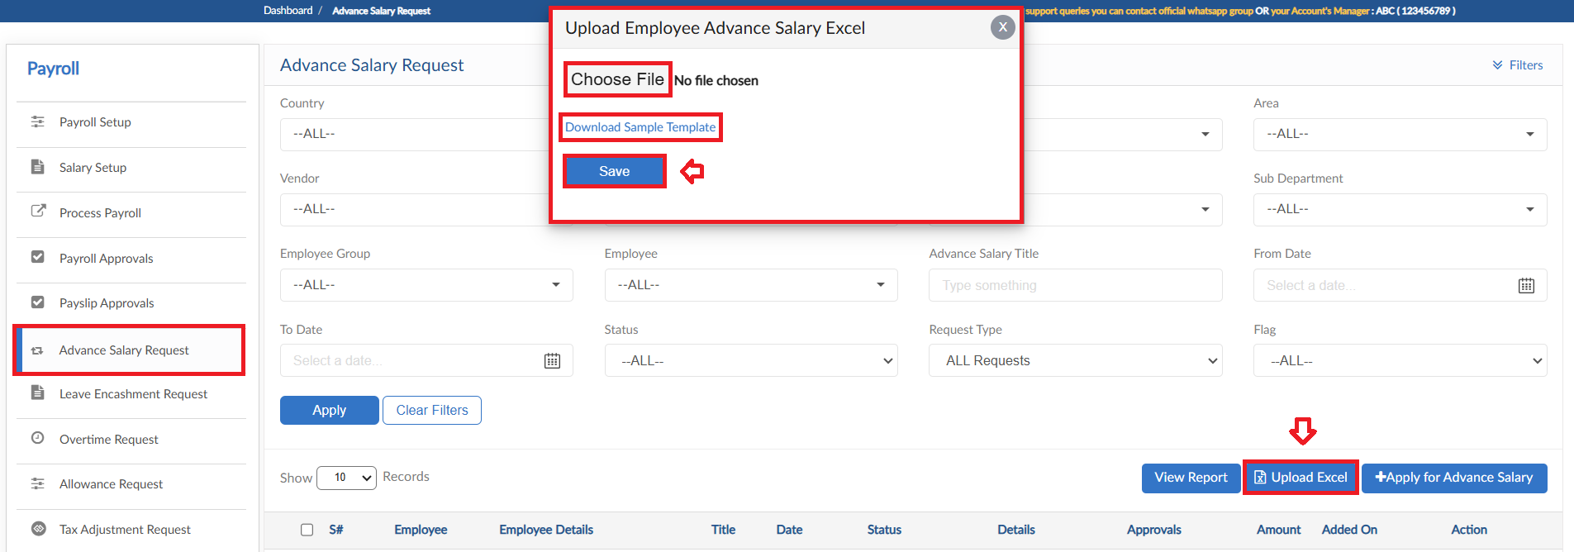

View Report
- To view the data of grid in Advance Salary Request form click on view report
- Advance Salary Report will pop up on screen
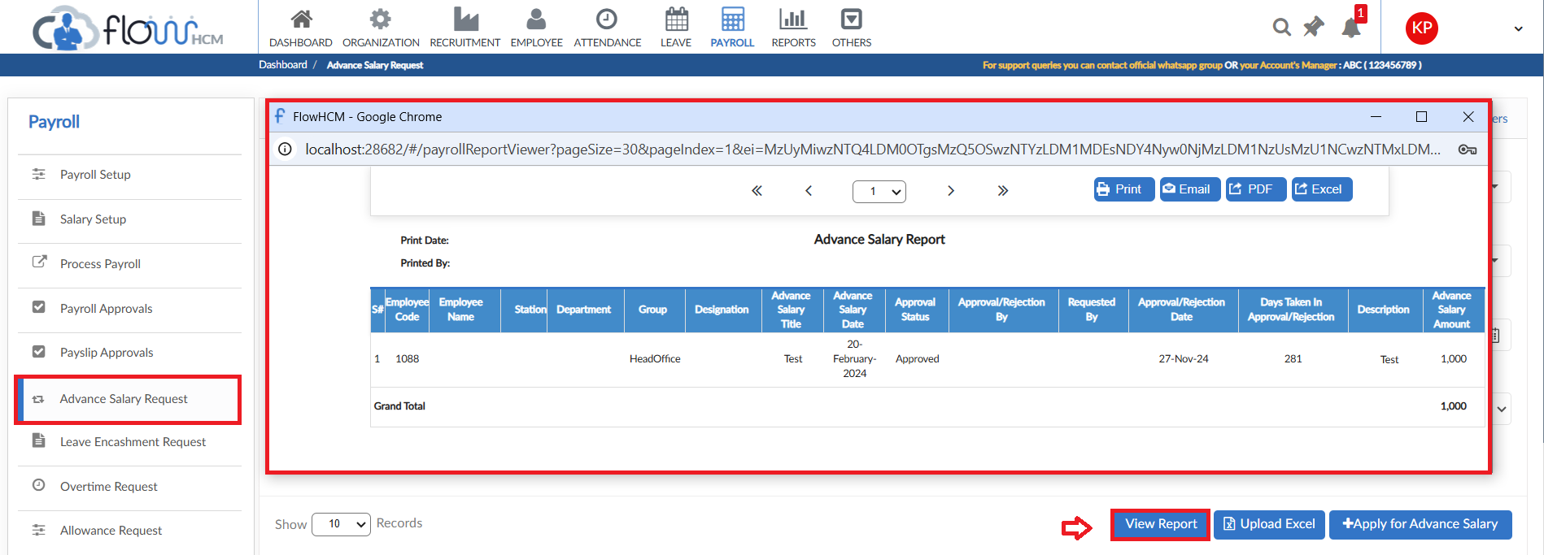

Leave Encashment Request

- To add a Leave Encashment Request, click on Create Encashment button in Leave Encashment Request form
- Select the filter criteria for employees and their leaves
- Then click on Preview button, system will list down all the data of employees Leave encashment
- Manual intervention is allowed in leave to increase/decrease the count of leaves against all leave types
- Then click on submit to raise a requisition
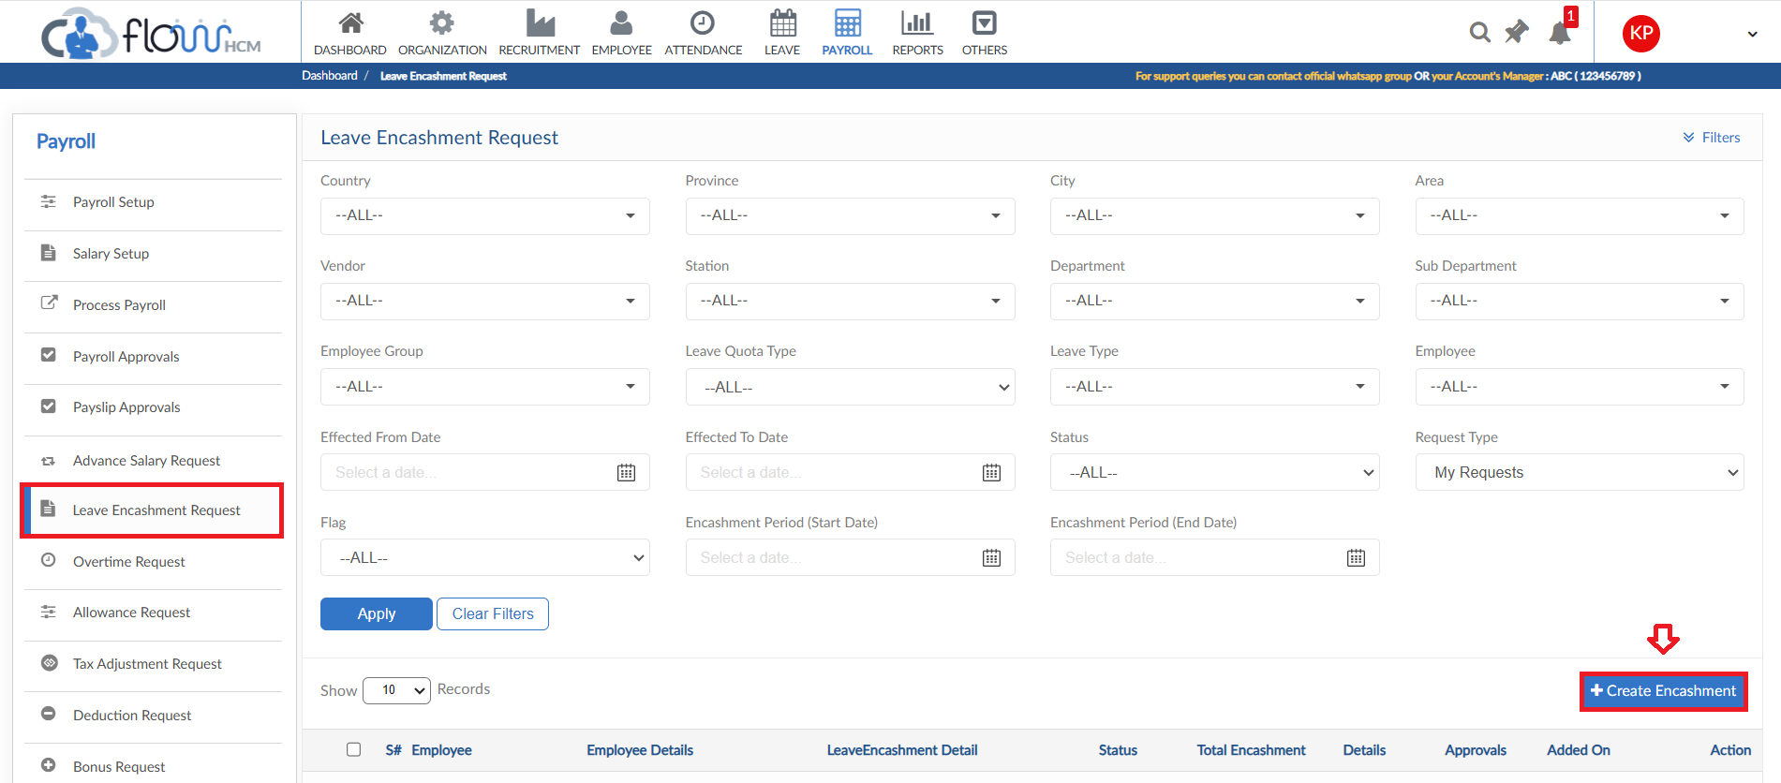
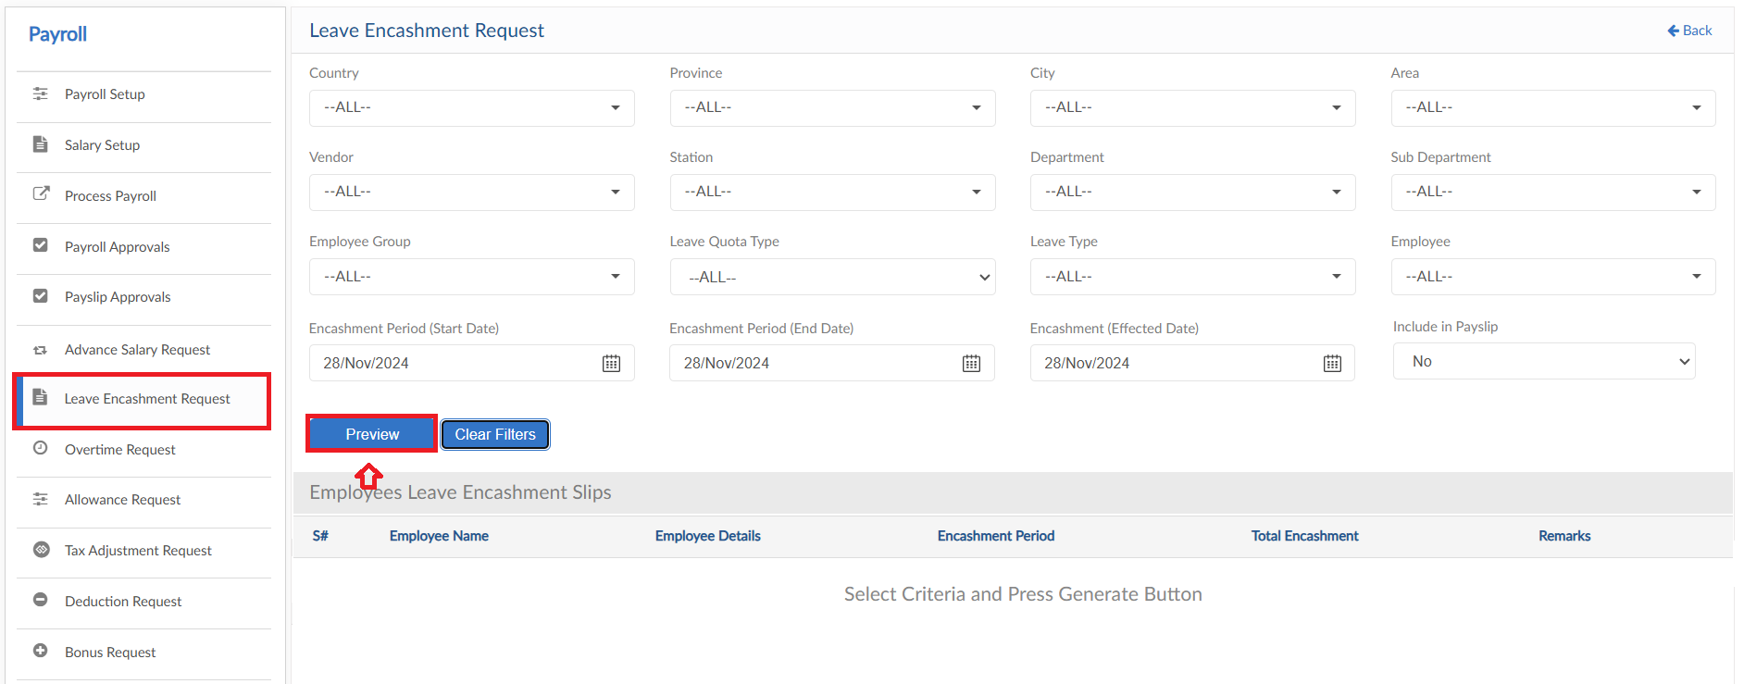
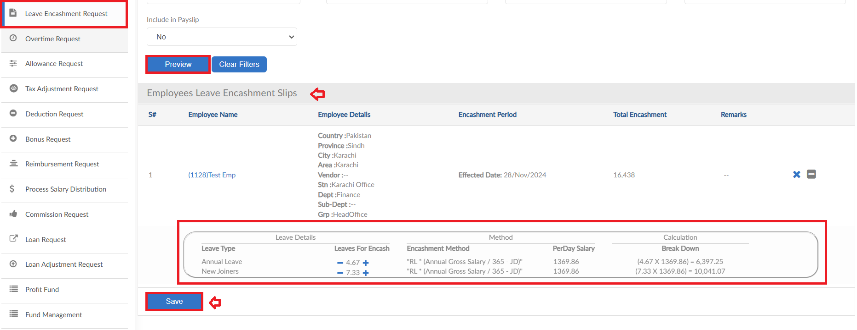

Overtime Request
The form consists of multiple buttons/features

- To add an Overtime Request, click on Apply for overtime in Overtime Request form
- Select an employee and enter Title
- Select date that will enable the desired overtime type field to enter hours
- Enter a reason for Overtime Request
- Then click on submit to raise a requisition
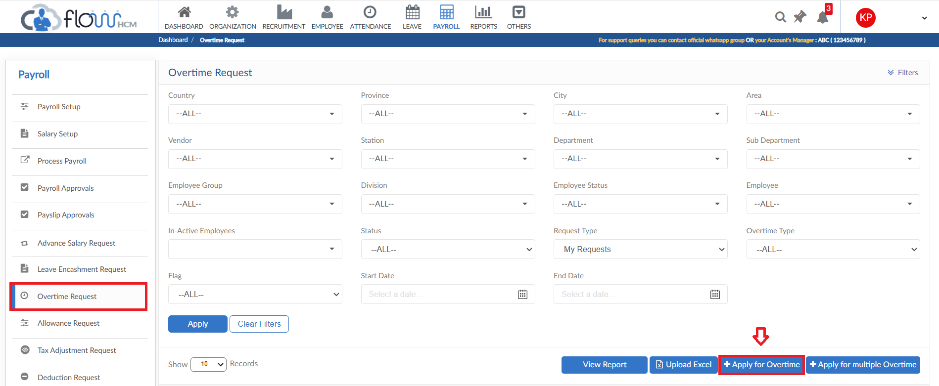
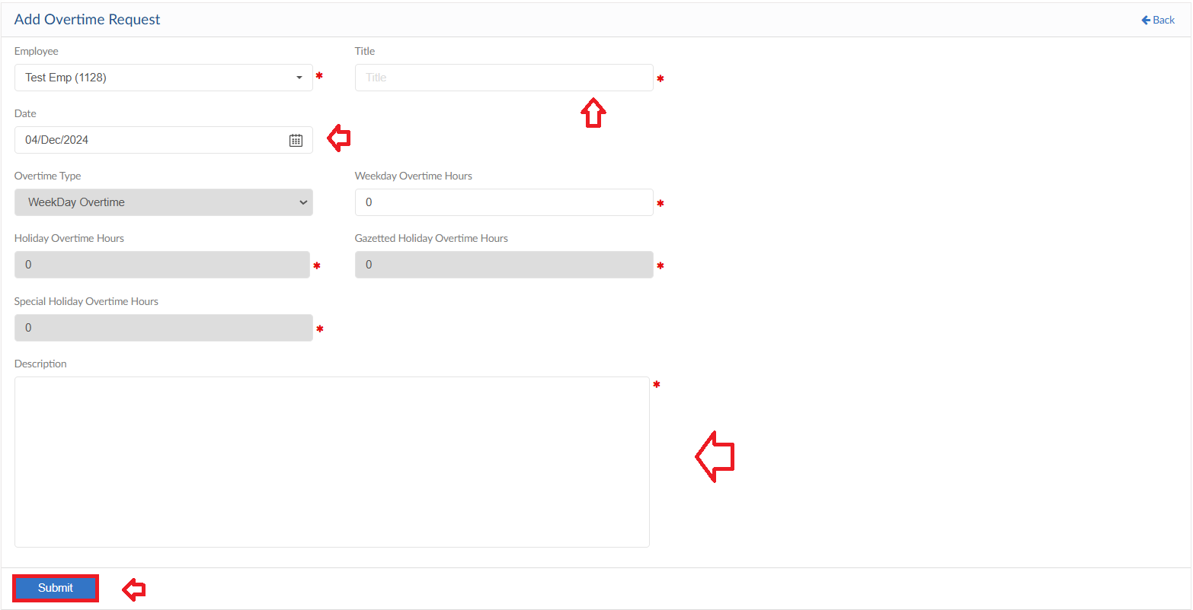

Multiple Overtime Request
- To add Multiple Overtime Requests, click on Apply for multiple overtime in Overtime Request form
- Select the filter criteria and then click on apply button
- System will list down the data according to the criteria selected
- Edit the hours if required else system will show the hours according to the policy
- Select a reason for every Request and enter Remarks
- Then click on submit to raise a requisition
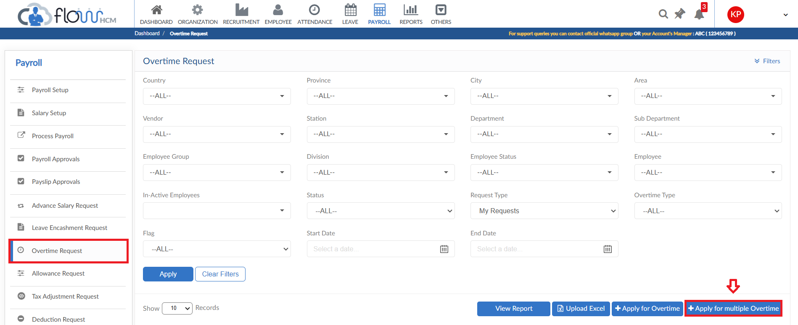
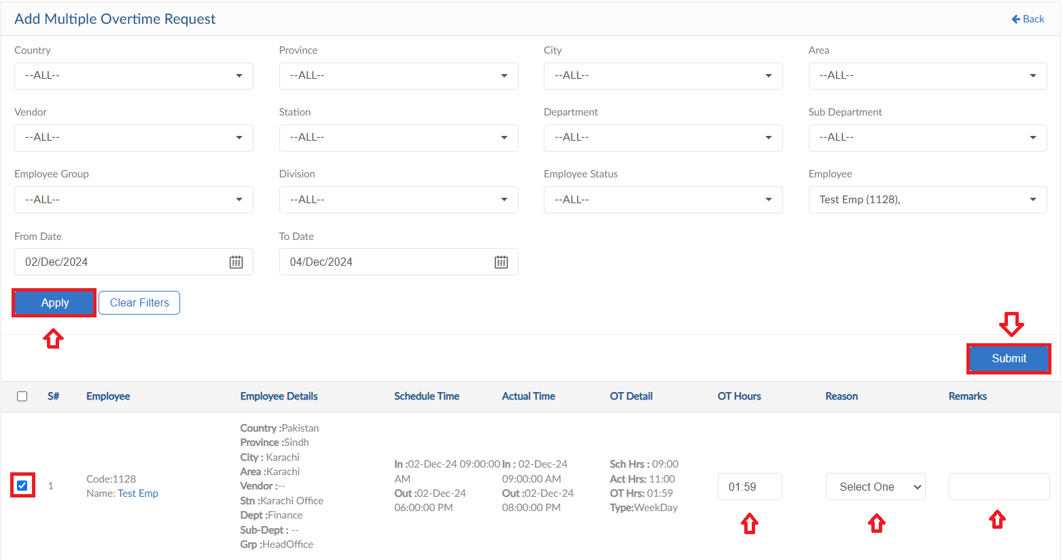

Upload Excel
- If required, upload all overtime entries in one go user can use upload excel
- Click on Upload Excel button, pop up will be visible
- Then click on Download Sample Template and enter required data
- Click on choose file and then click on Save button to upload all Overtime entries
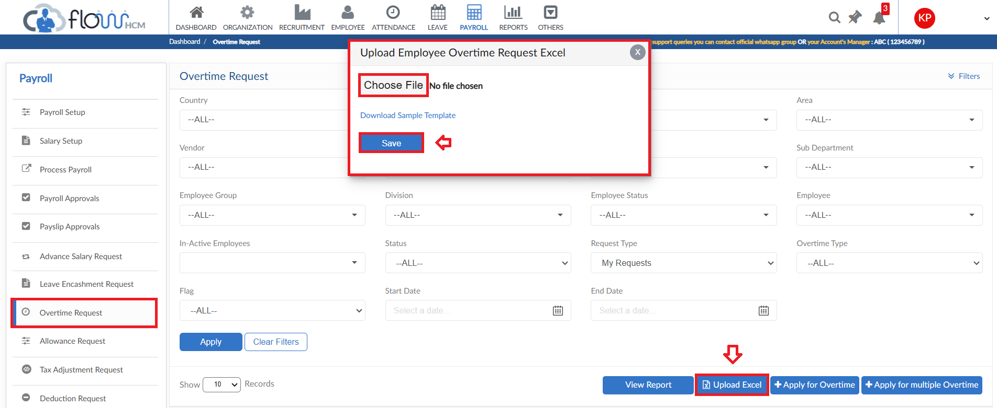

View Report
- To view the data of grid in Overtime Request form click on view report
- Overtime Request Report will pop up on screen
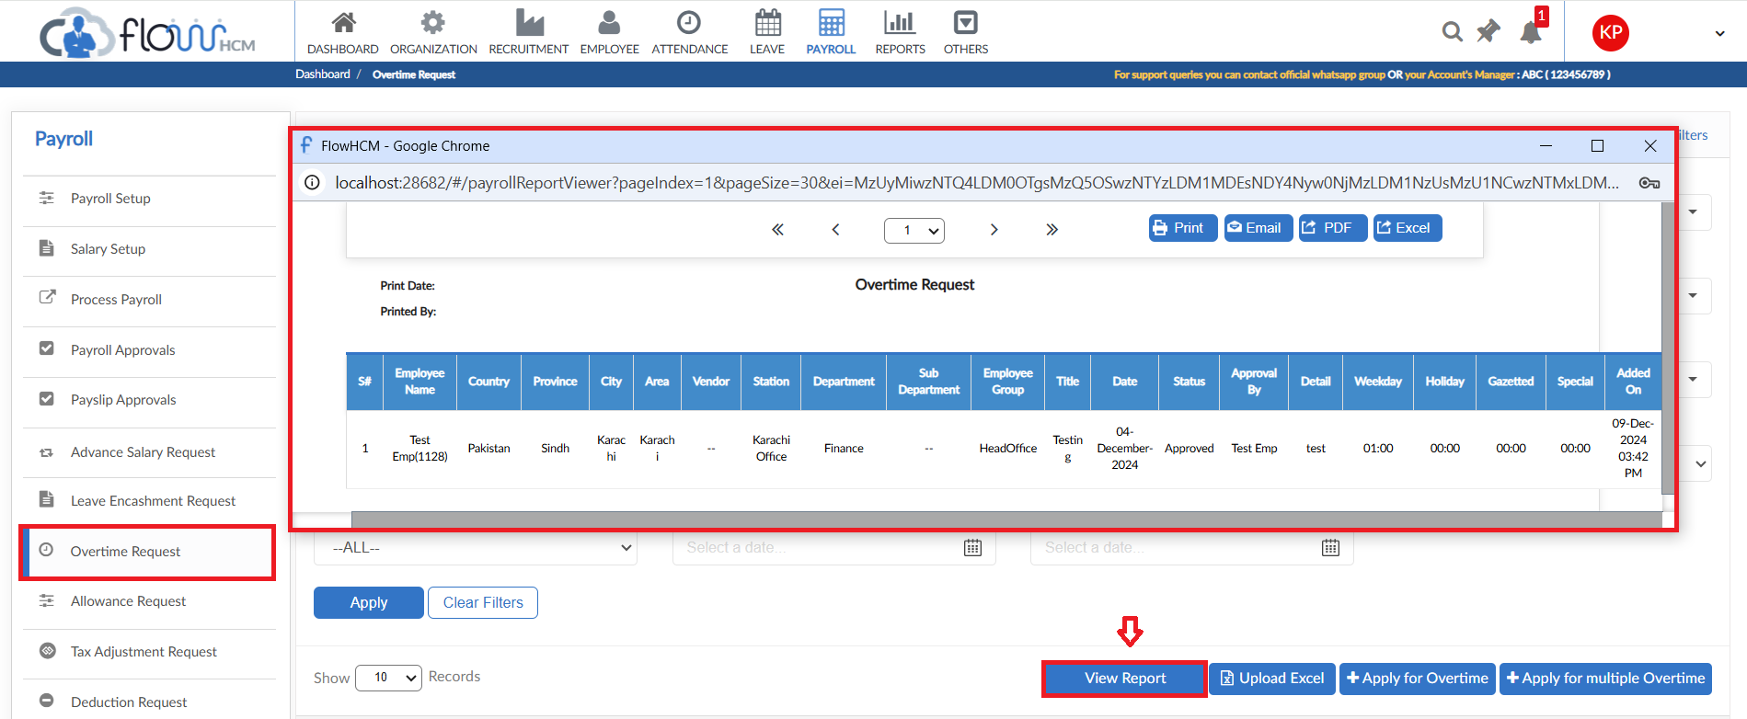

Allowance Request

- To add Allowance Request, click on Apply for Allowance in Allowance Request form
- Select the employee from dropdown and enter Title of request
- Select allowance type and enter the required amount
- Select date and define whether the allowance will be taxable or not
- If yes then select the Tax Adjustment method
- Enter a reason for request
- Then click on submit to raise a requisition
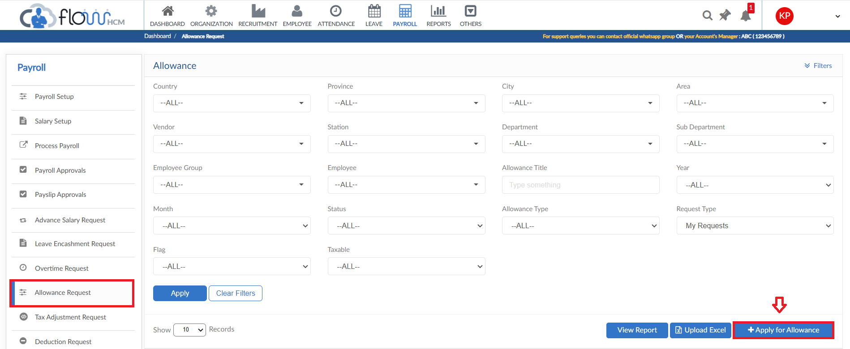
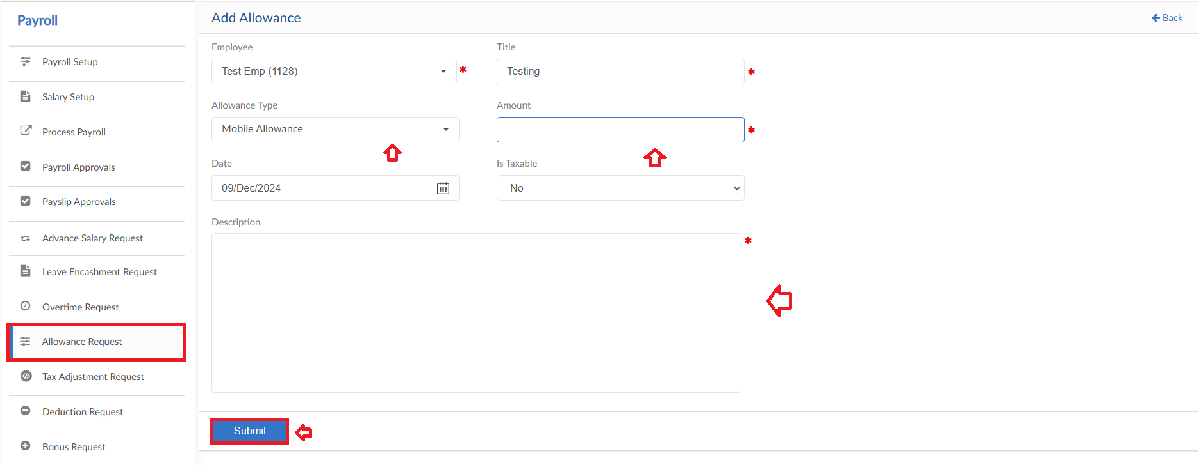

Upload Excel
- If required, upload all allowances in one go user can use upload excel
- Click on Upload Excel button, pop up will be visible
- Then click on Download Sample Template and enter required data
- Click on choose file and then click on Save button to upload all allowances
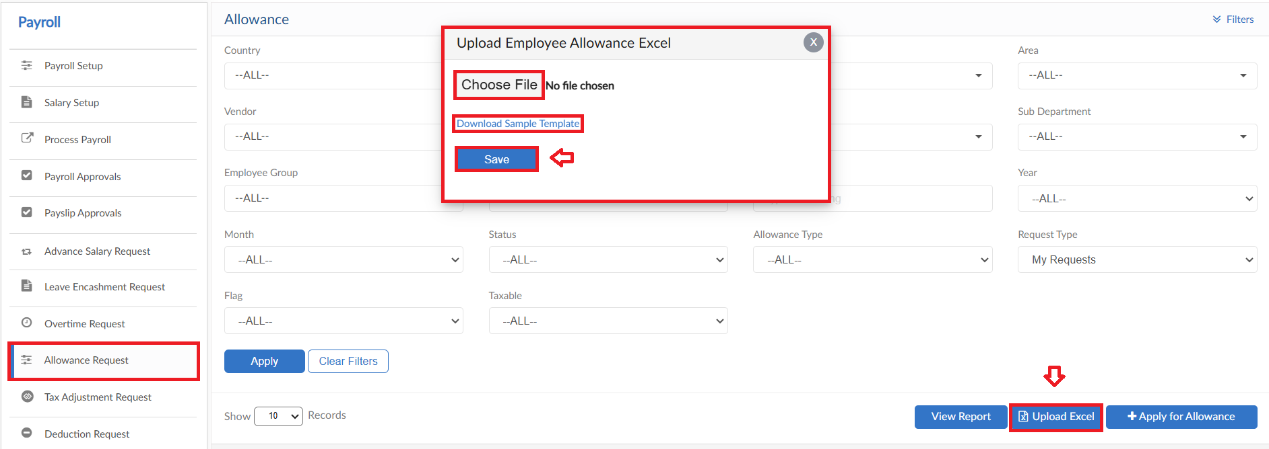

View Report
- To view the data of grid in Allowance Request form click on view report
- Allowance Request Report will pop up on screen
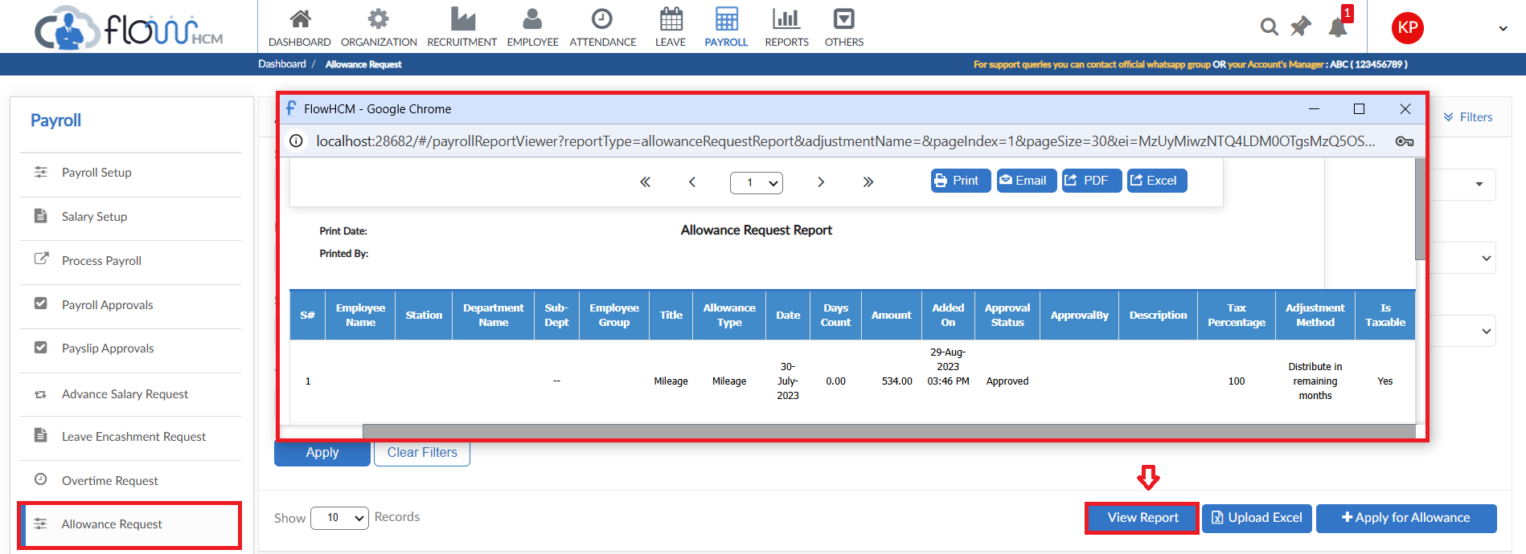

Tax Adjustment Request
The form consists of multiple buttons/features

- To add Tax Adjustment Request, click on Apply for Tax Adjustment in Tax Adjustment Request form
- Select the employee and Category from dropdowns
- For details enter date, select Type and then enter Amount
- Attachment functionality is available as well
- If required user can add multiple lines for different details
- Enter a reason for request
- Then click on submit to raise a requisition
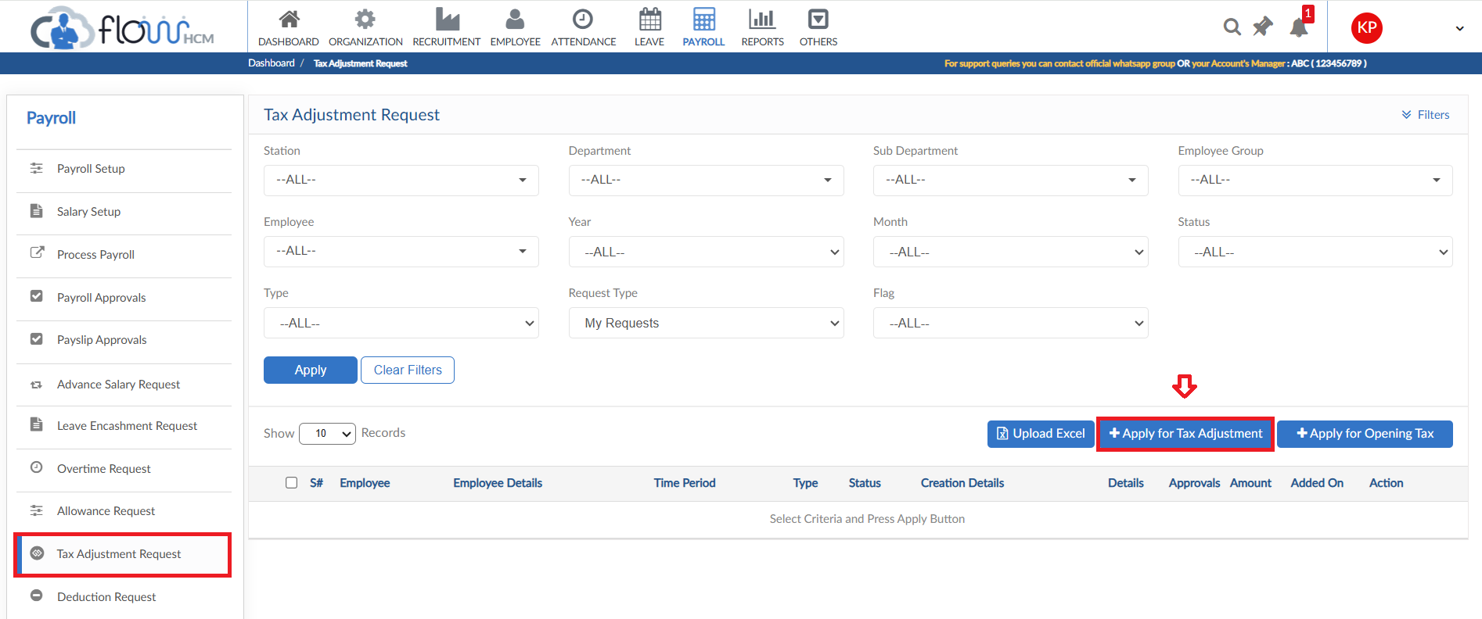
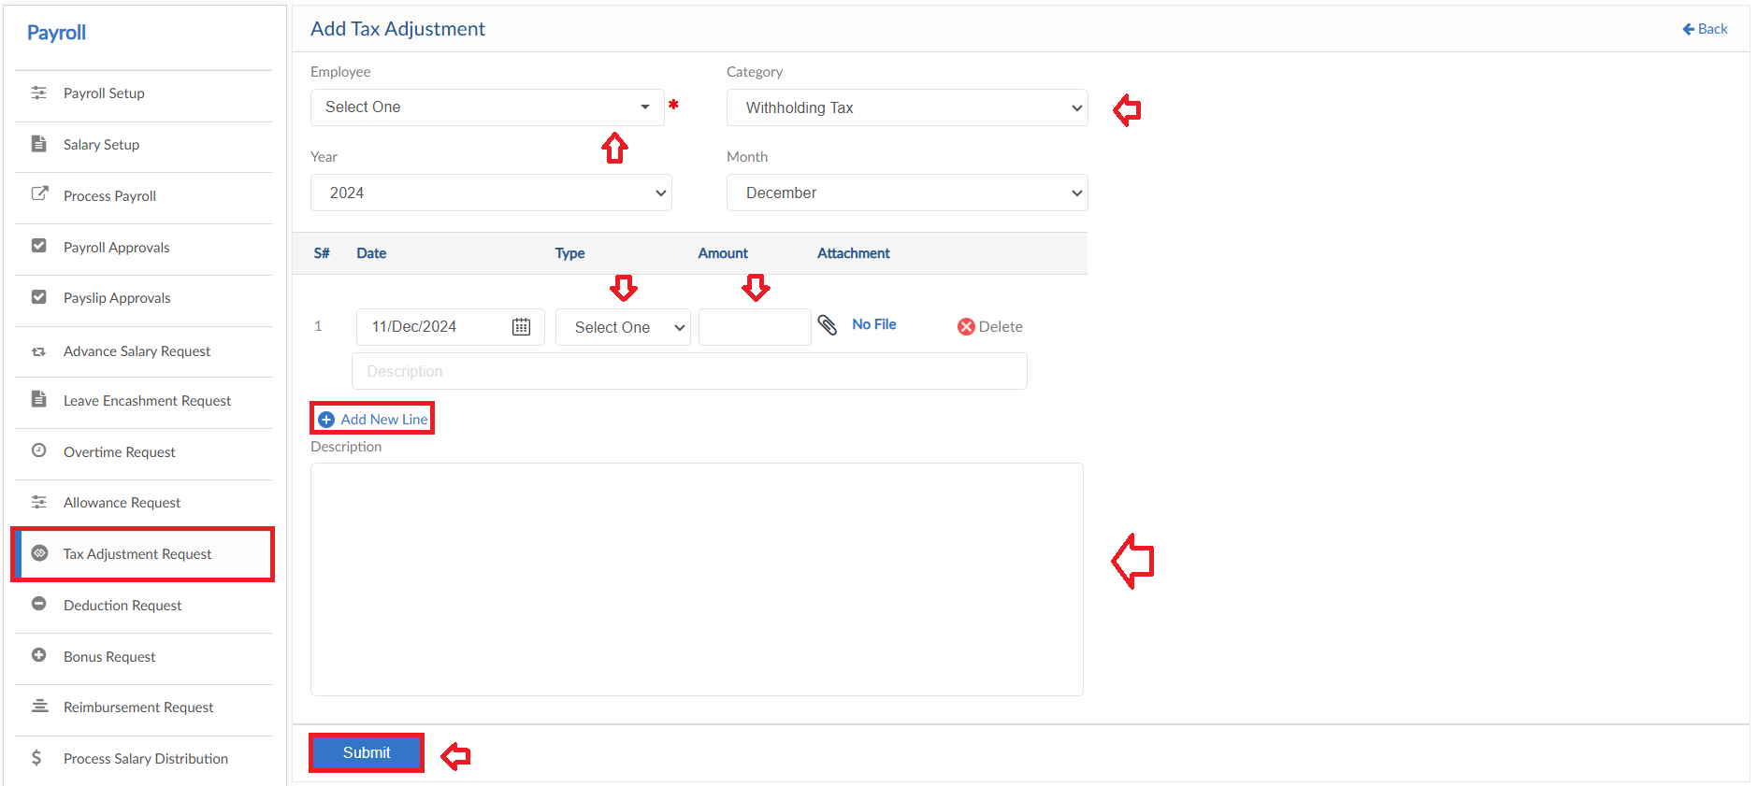

Apply for Opening Tax
- To add Opening Tax Request, click on Apply for Opening Tax in Tax Adjustment Request form
- Select the employee from dropdown
- Enter Year and Month from dropdowns
- Enter the required Amount
- Enter a reason for request
- Then click on submit to raise a requisition
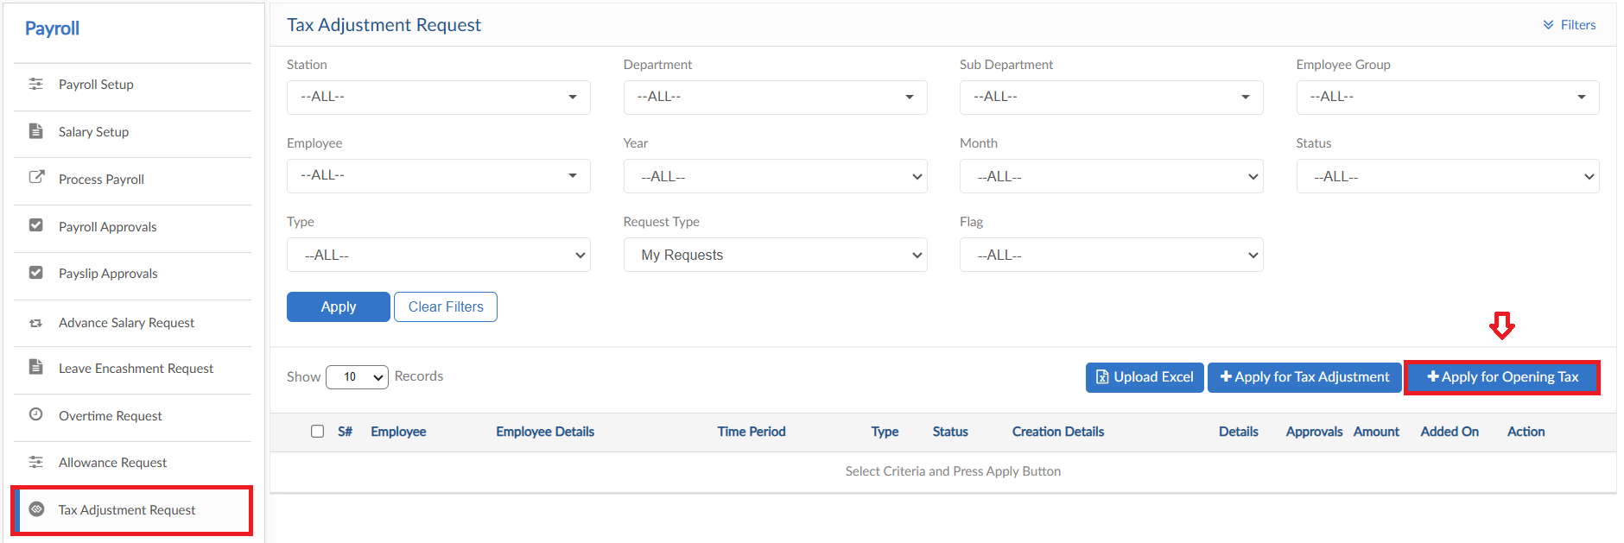
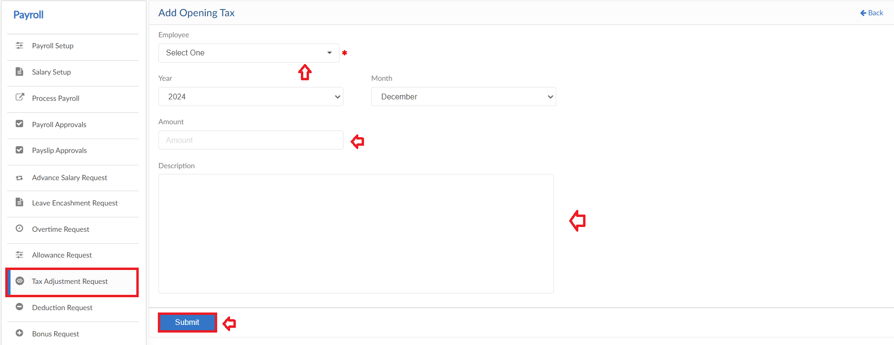

Upload Excel
- If required, upload all Tax Adjustments in one go user can use upload excel
- Click on Upload Excel button, pop up will be visible then select type
- Click on Download Sample Template and enter required data
- Click on choose file and then click on Save button to upload all Tax Adjustments
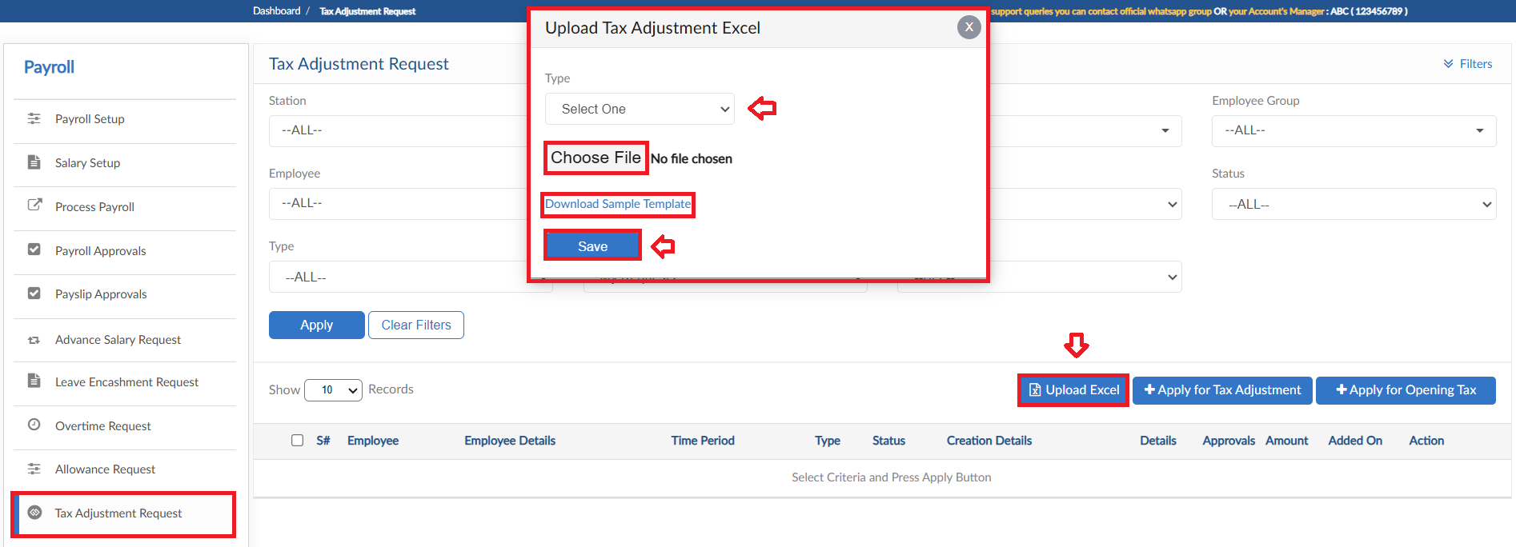

Deduction Request

- To add Deduction Request, click on Apply for Deduction in Deduction Request form
- Select the employee from dropdown and enter Title of request
- Select deduction type and enter the required amount
- Select date and define whether the deduction will be taxable or not
- If yes then enter the tax percentage
- If required attachment feature is available
- Enter a reason for request
- Then click on submit to raise a requisition
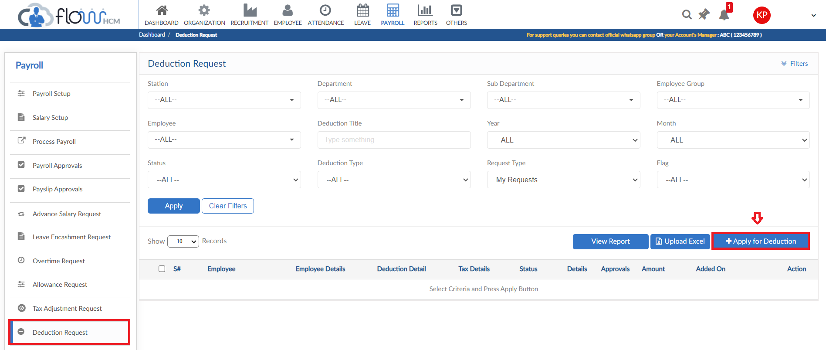
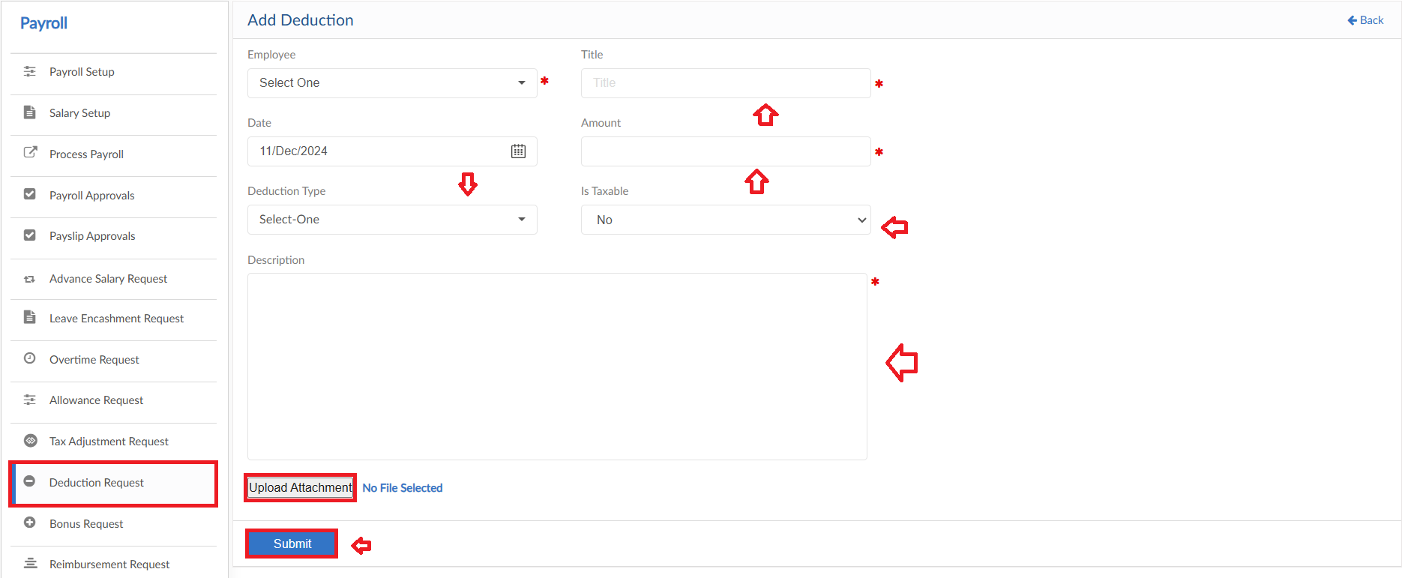

Upload Excel
- If required, upload all Deductions in one go user can use upload excel
- Click on Upload Excel button, pop up will be visible
- Click on Download Sample Template and enter required data
- Click on choose file and then click on Save button to upload all Deductions
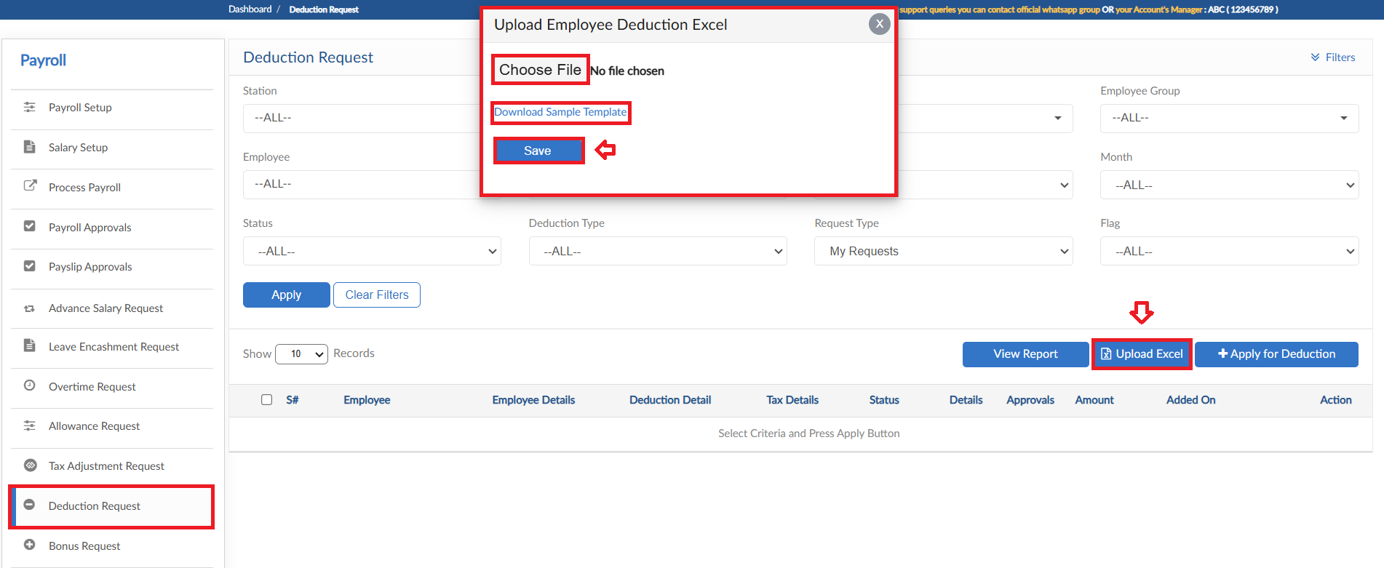

View Report
- To view the data of grid in Deduction Request form click on view report
- Deduction Request Report will pop up on screen
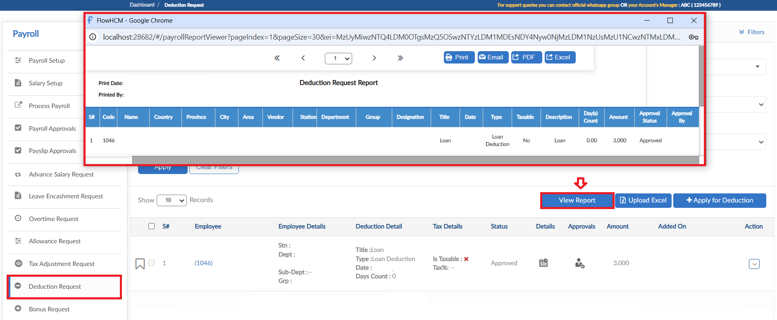

Bonus Request

- To add Bonus Request, click on Apply for Bonus in Bonus Request form
- Select the employee from dropdown and enter Title of request
- Select bonus type and enter the required amount
- Select date and define whether the deduction will be taxable or not
- If yes then select the tax adjustment method
- Enter a reason for request
- Then click on submit to raise a requisition
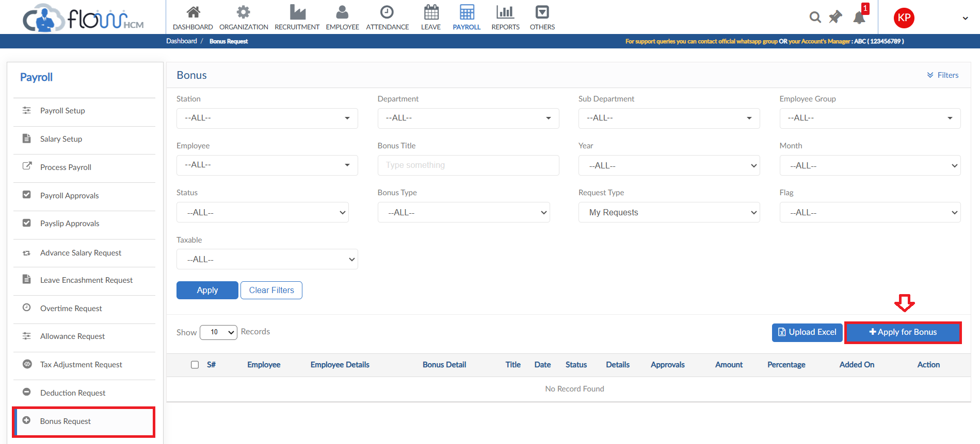
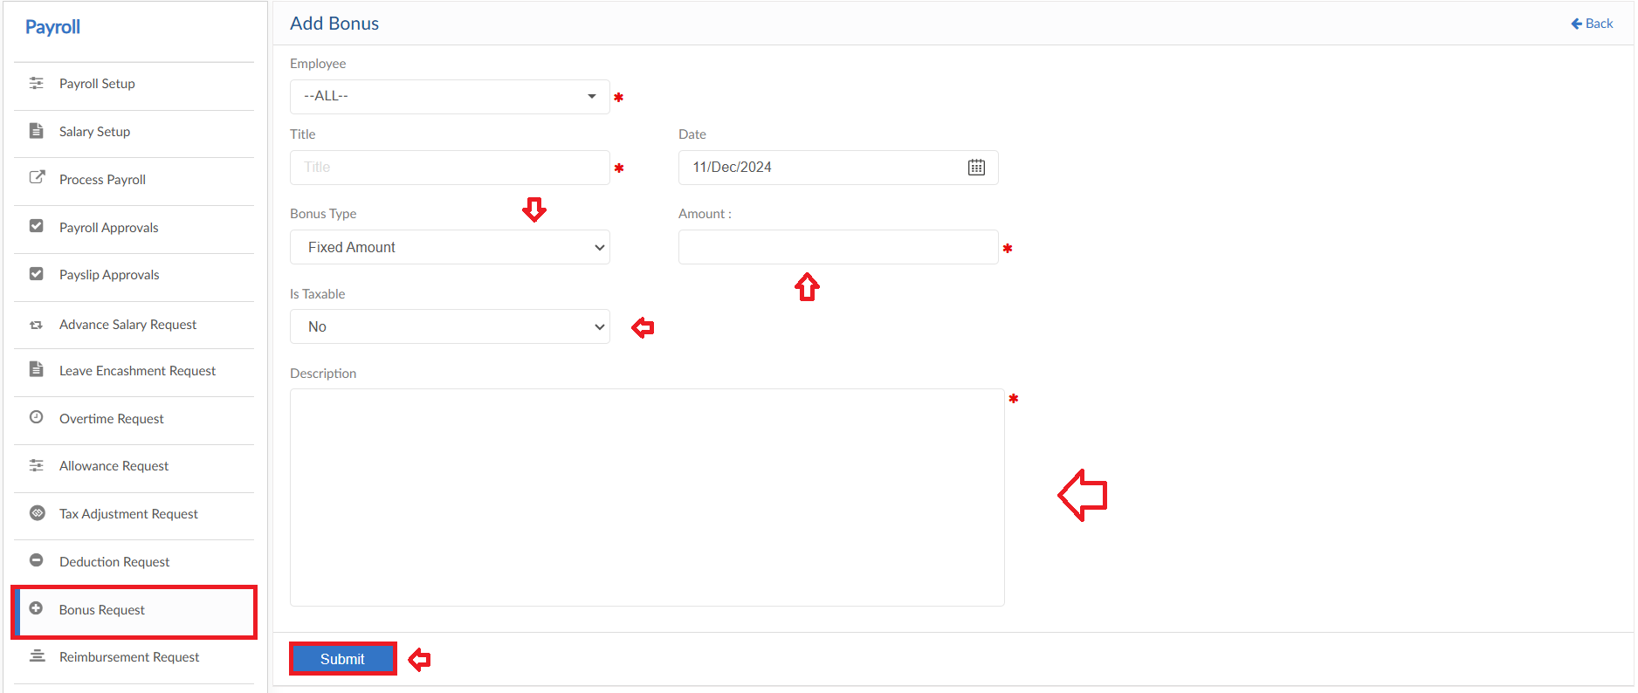

Upload Excel
- If required, upload all bonus amount in one go user can use upload excel
- Click on Upload Excel button, pop up will be visible
- Click on Download Sample Template and enter required data
- Click on choose file and then click on Save button to upload all bonus amount
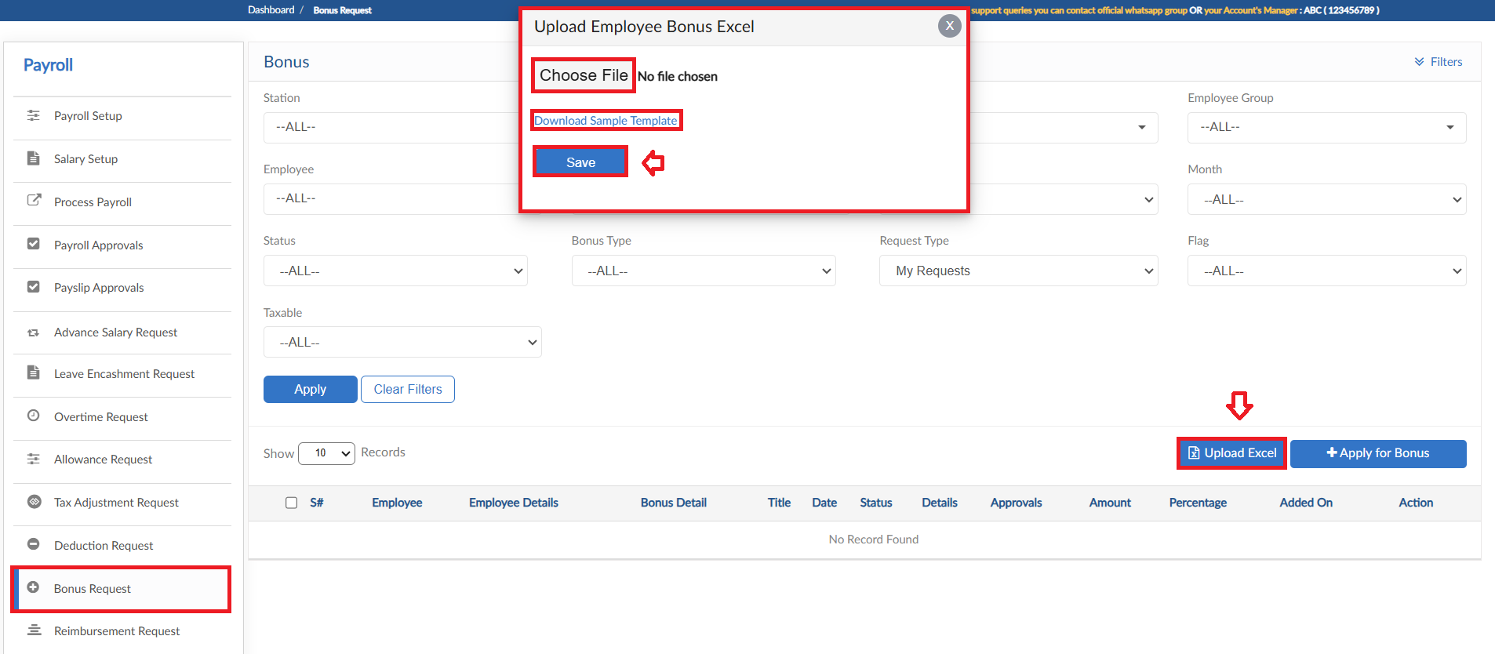

Reimbursement Request

- To add Reimbursement Request, click on Apply for Reimbursement in Reimbursement Request form
- Select the either to include in pay slip or not
- For details enter Date, select Category
- If required enter the Item number and Receipt number and then enter Amount
- User can add multiple lines for different details
- Enter a reason for request
- Then click on submit to raise a requisition
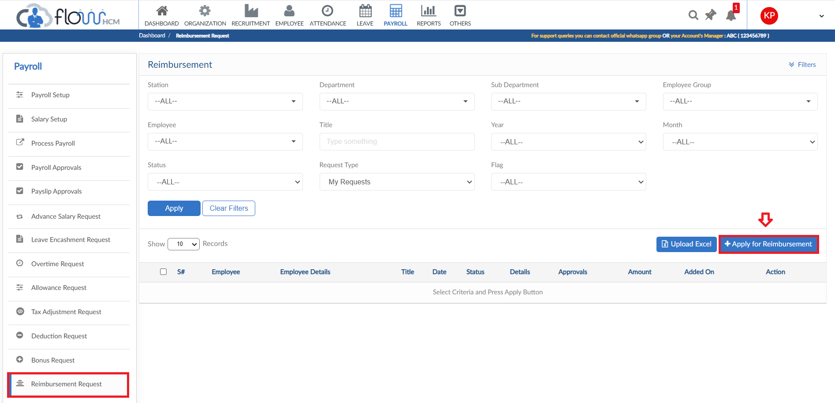
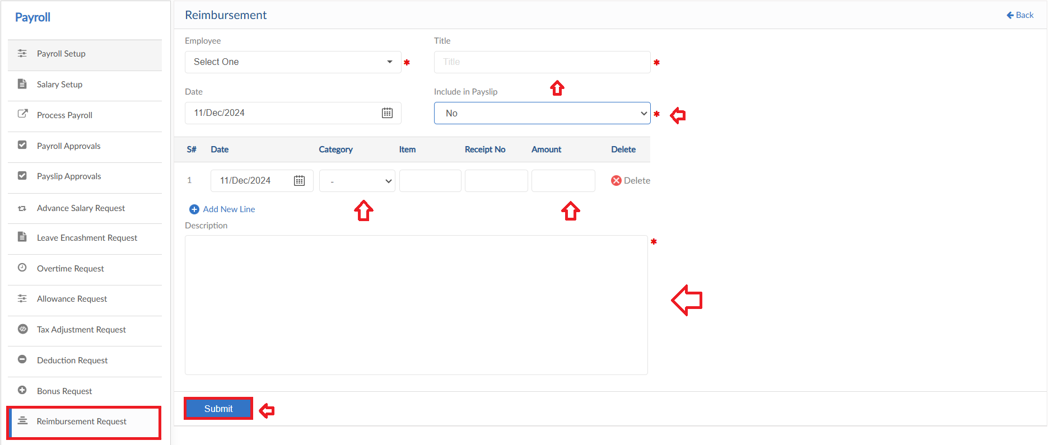

Upload Excel
- If required, upload all reimbursement requests in one go user can use upload excel
- Click on Upload Excel button, pop up will be visible
- Click on Download Sample Template and enter required data
- Click on choose file and then click on Save button to upload all reimbursement requests
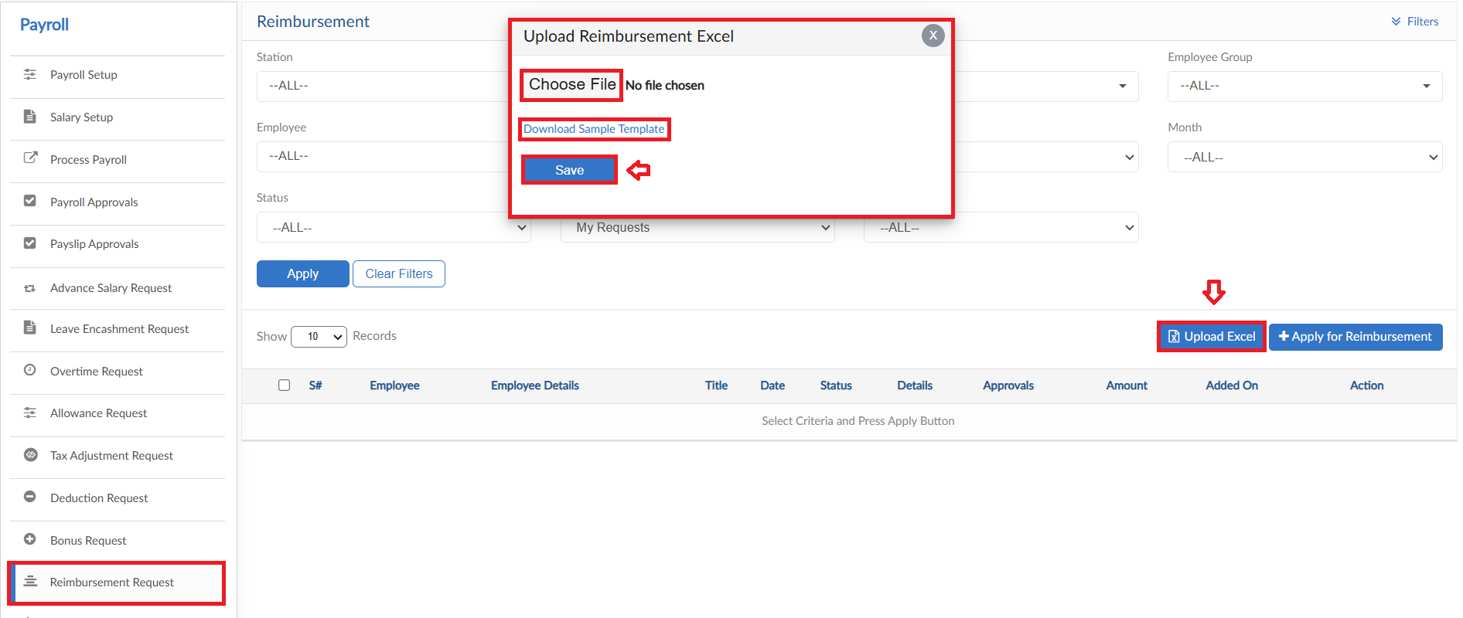

Process Salary Distribution

- To process Salary Distribution, click on Process Salary Distribution
- Select the filter criteria and then click on Preview button
- System will list down the employees and their details
- Then save button to Process Salary Distribution
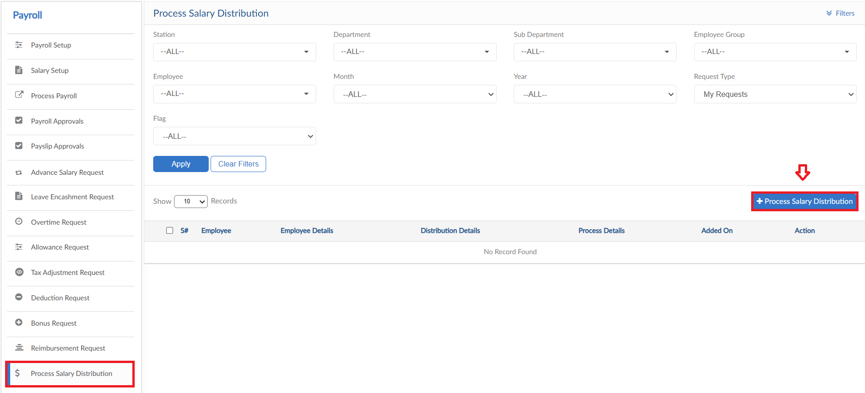
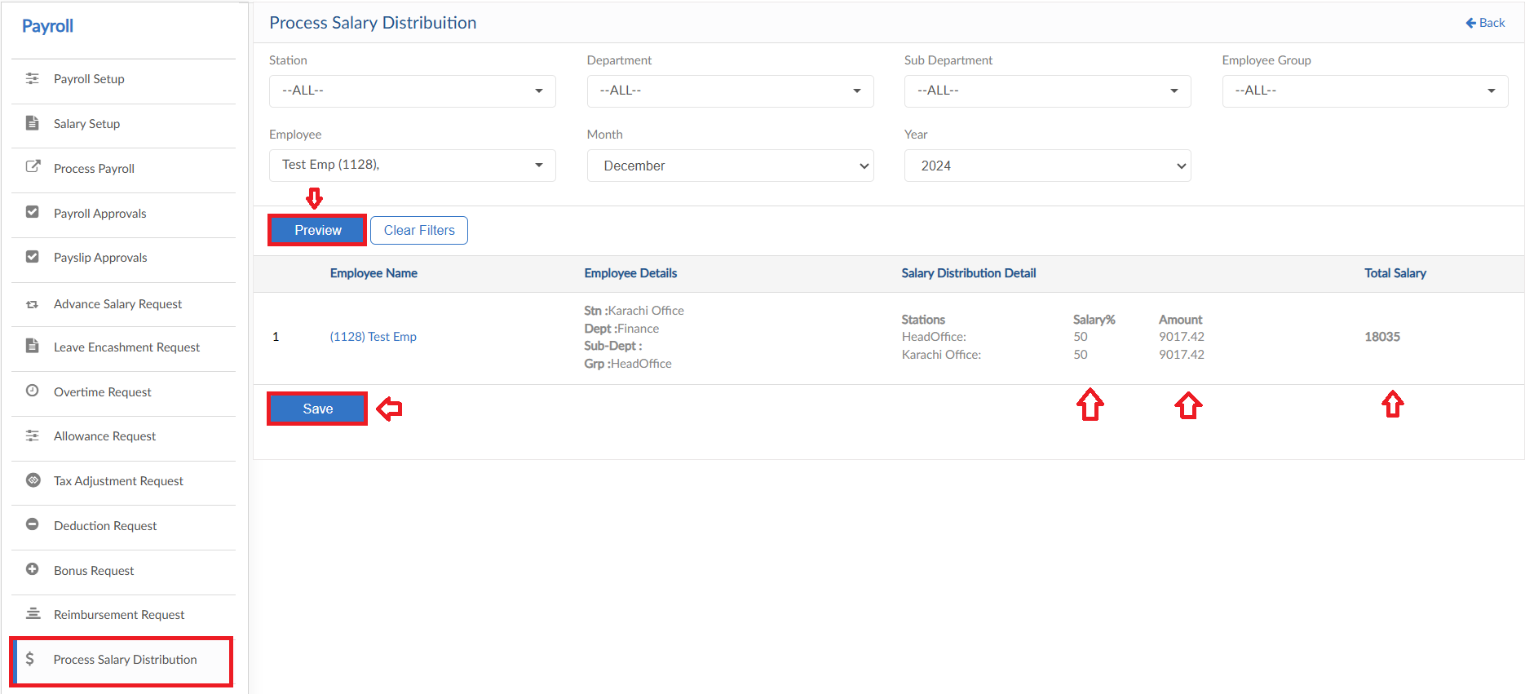

Commission Request

- To add Commission Request, click on Apply for Commission in Commission Request form
- Select the employee from dropdown and enter Title of request
- Select date and enter the required amount
- Enter a reason for request
- Then click on submit to raise a requisition
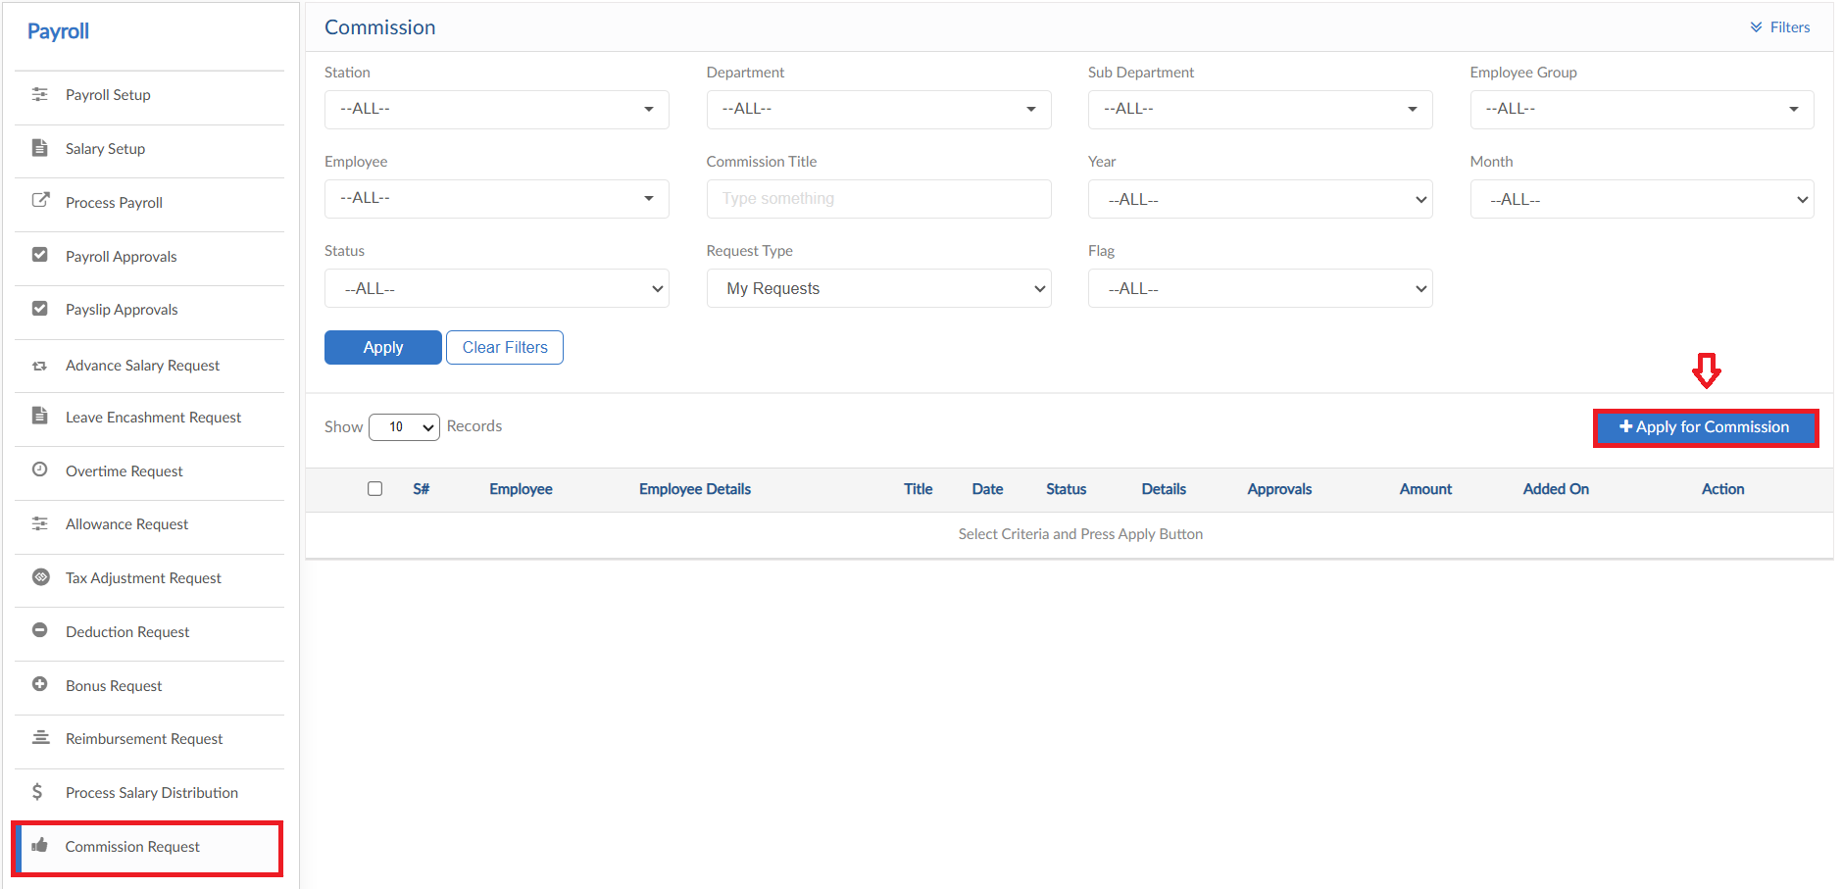
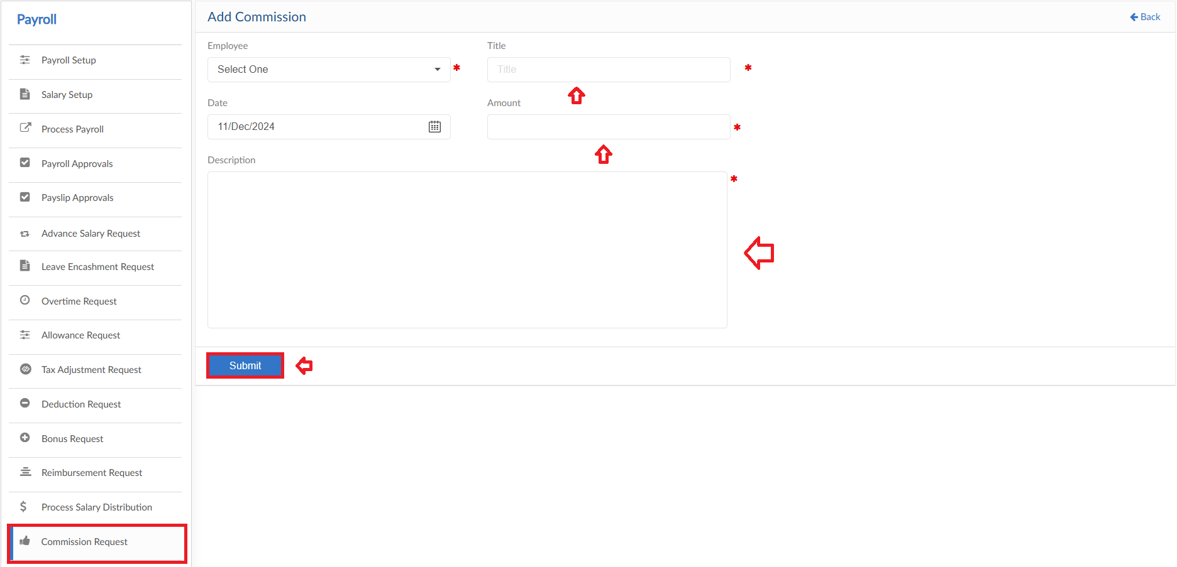

Loan Request
The form consists of multiple buttons/features

- To add General Loan Request, click on Apply for Loan (General) in Loan Request form
- Select the employee and Loan Type from dropdowns
- System will show the Loan History of selected employee
- Enter Date and Title for request
- Next, enter the Loan and Monthly Repayment amount
- Select the repayment start date
- Enter a reason for request
- Then click on submit to raise a requisition
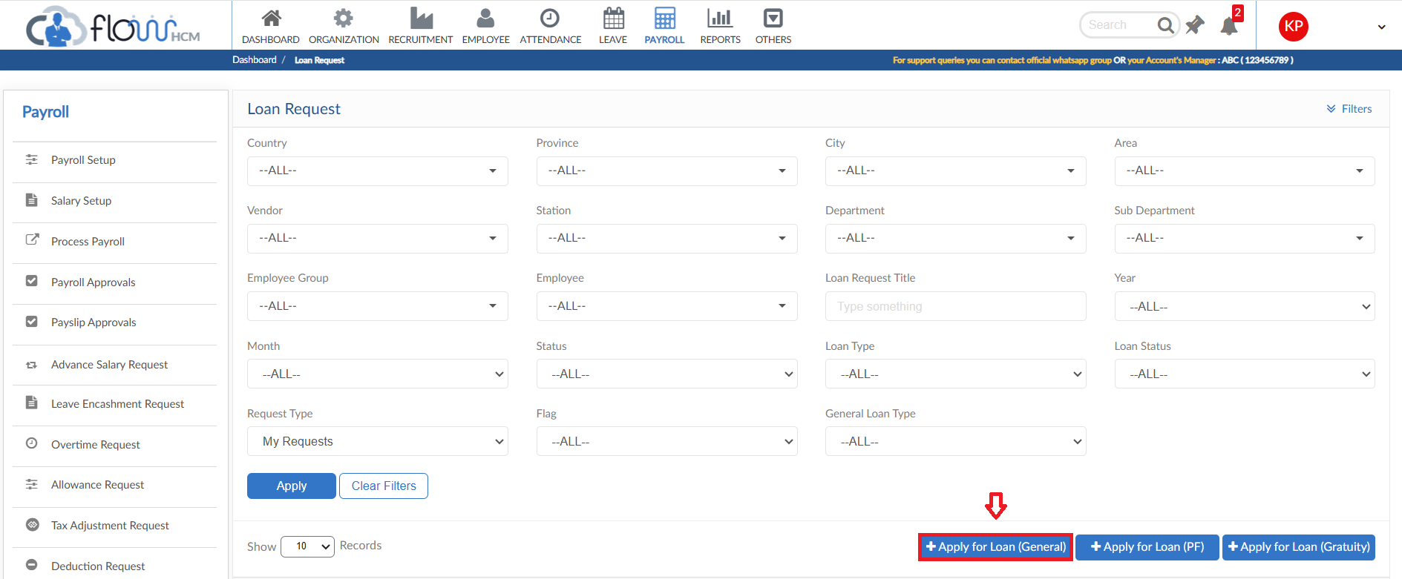
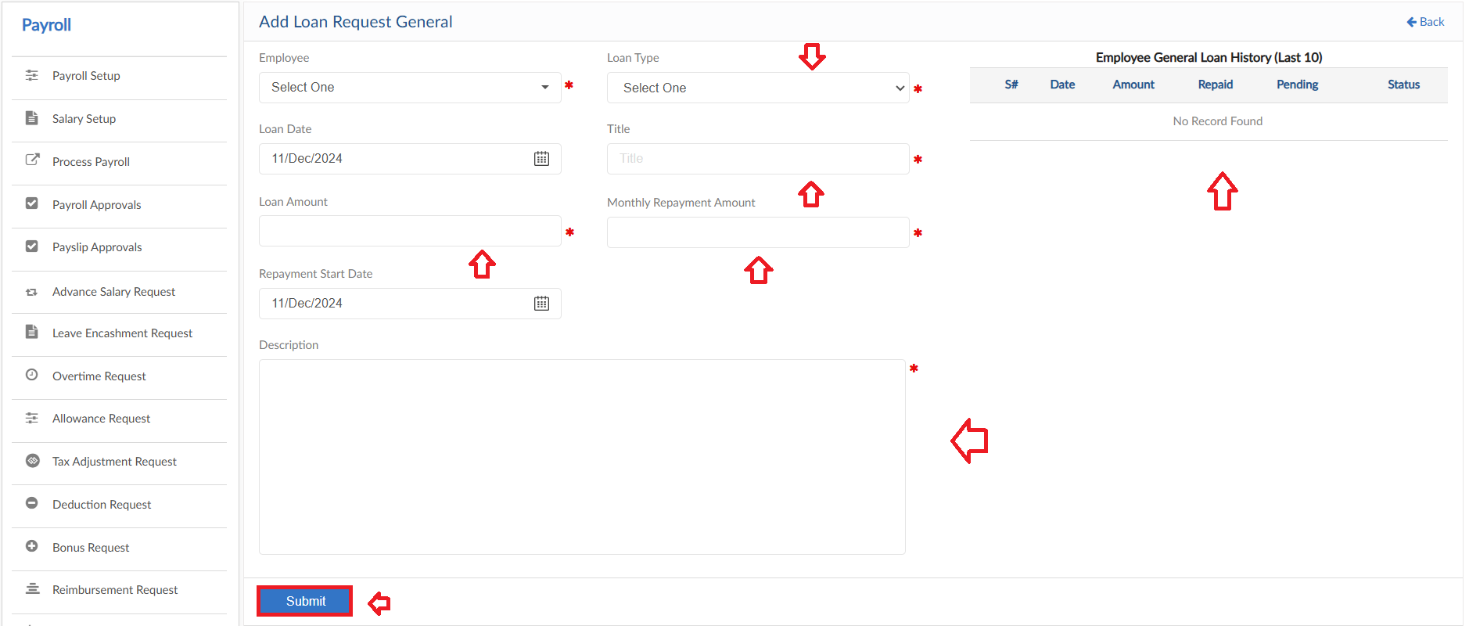

PF Loan
- To add PF Loan Request, click on Apply for Loan (PF) in Loan Request form
- Select the employee from dropdown and select loan date
- System will show the Loan History of selected employee
- Enter Title for request, system will show the PF balance amount
- Next, enter the Loan and Monthly Repayment amount
- Select the repayment start date
- Enter a reason for request
- Then click on submit to raise a requisition
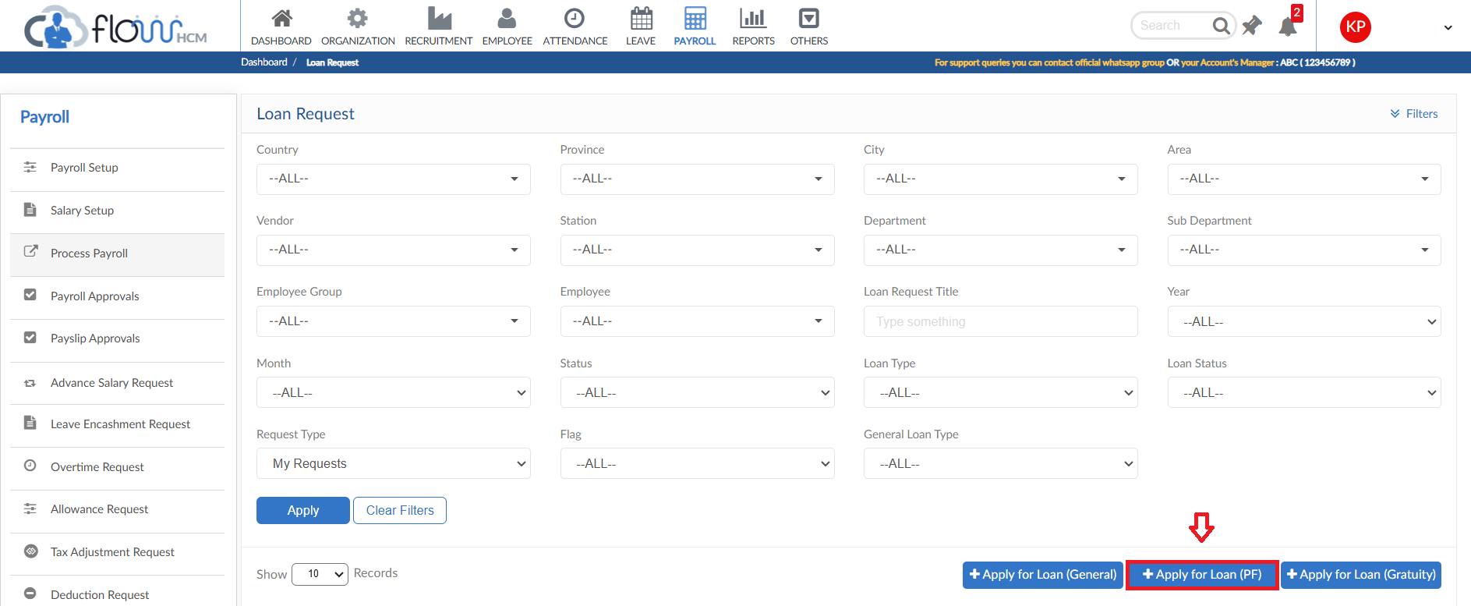
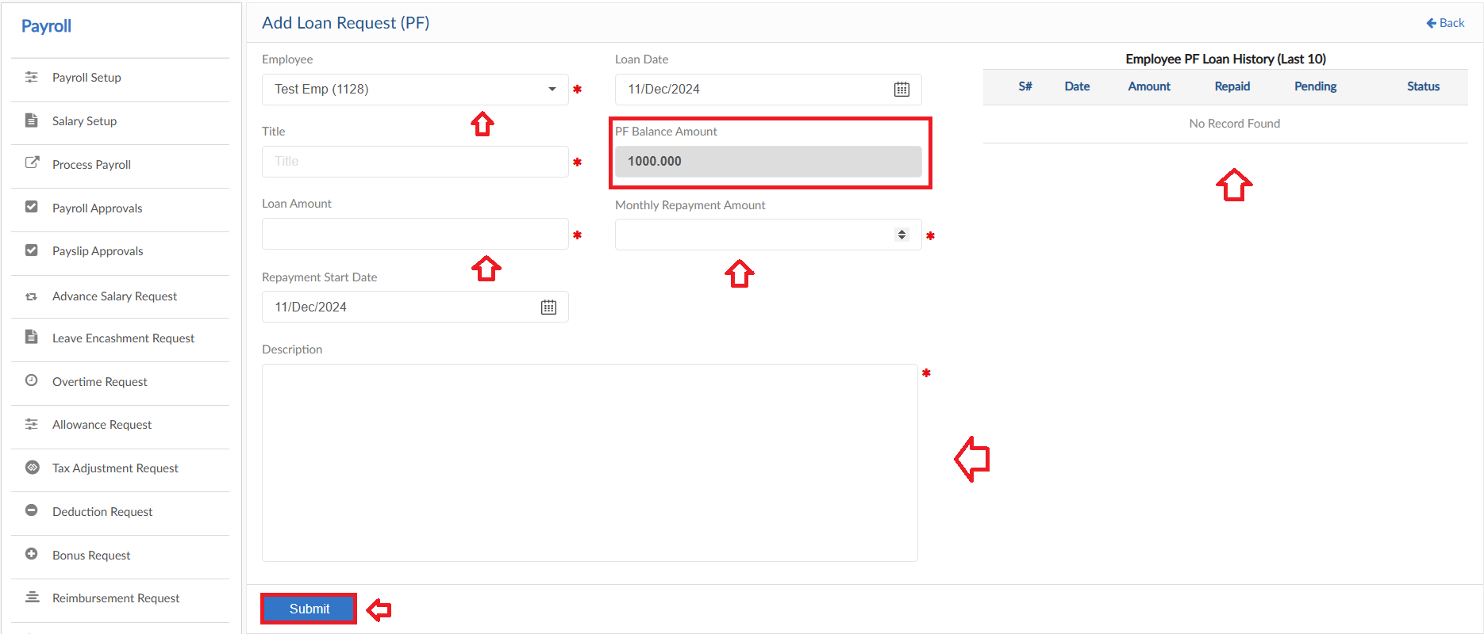

Gratuity Loan
- To add Gratuity Loan Request, click on Apply for Loan (Gratuity) in Loan Request form
- Select the employee from dropdown and select loan date
- System will show the Loan History of selected employee
- Enter Title for request, system will show the Gratuity balance amount
- Next, enter the Loan and Monthly Repayment amount
- Select the repayment start date
- Enter a reason for request
- Then click on submit to raise a requisition
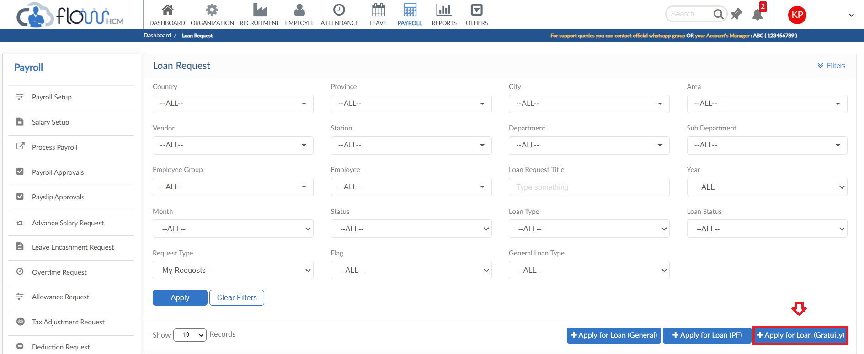
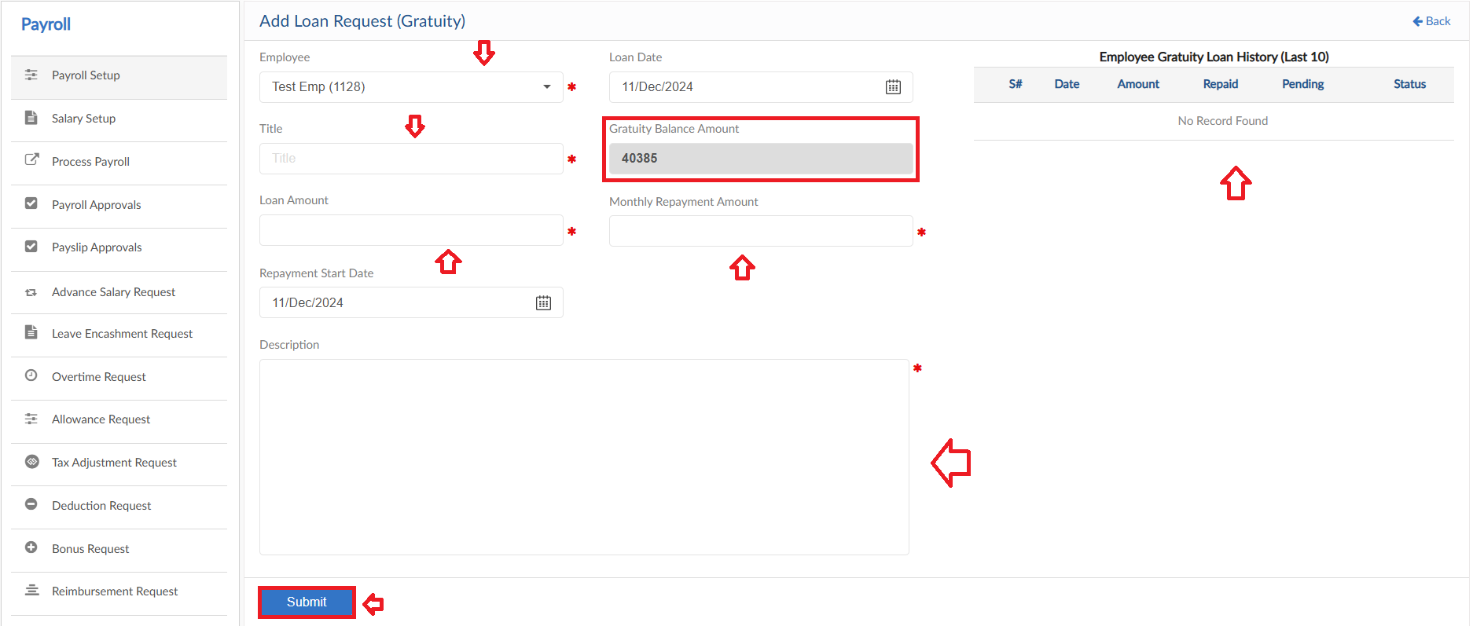

Upload Excel
- If required, upload all Loan requests in one go user can use upload excel
- Click on Upload Excel button, pop up will be visible
- Click on Download Sample Template and enter required data
- Click on choose file and then click on Save button to upload all Loan requests

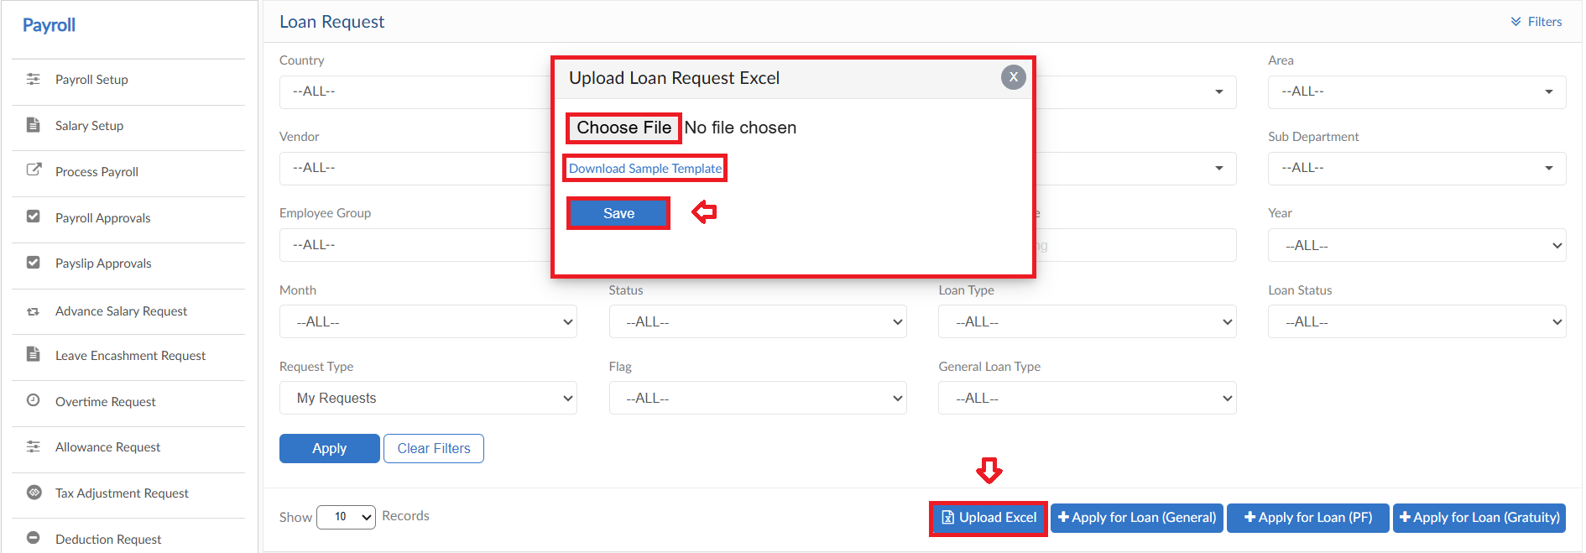

Loan Adjustment Request
The form consists of multiple buttons/features

- To add General Loan Adjustment Request, click on Apply for Adjustment (General) in Loan Adjustment Request form
- Select the employee and Loan Type from dropdown
- Enter Title for request and select Loan Adjustment type
- Select the Operation of Adjustment and date
- System will show the amount on the basis of Adjustment type then enter the amount
- Enter a reason for request
- Then click on submit to raise a requisition
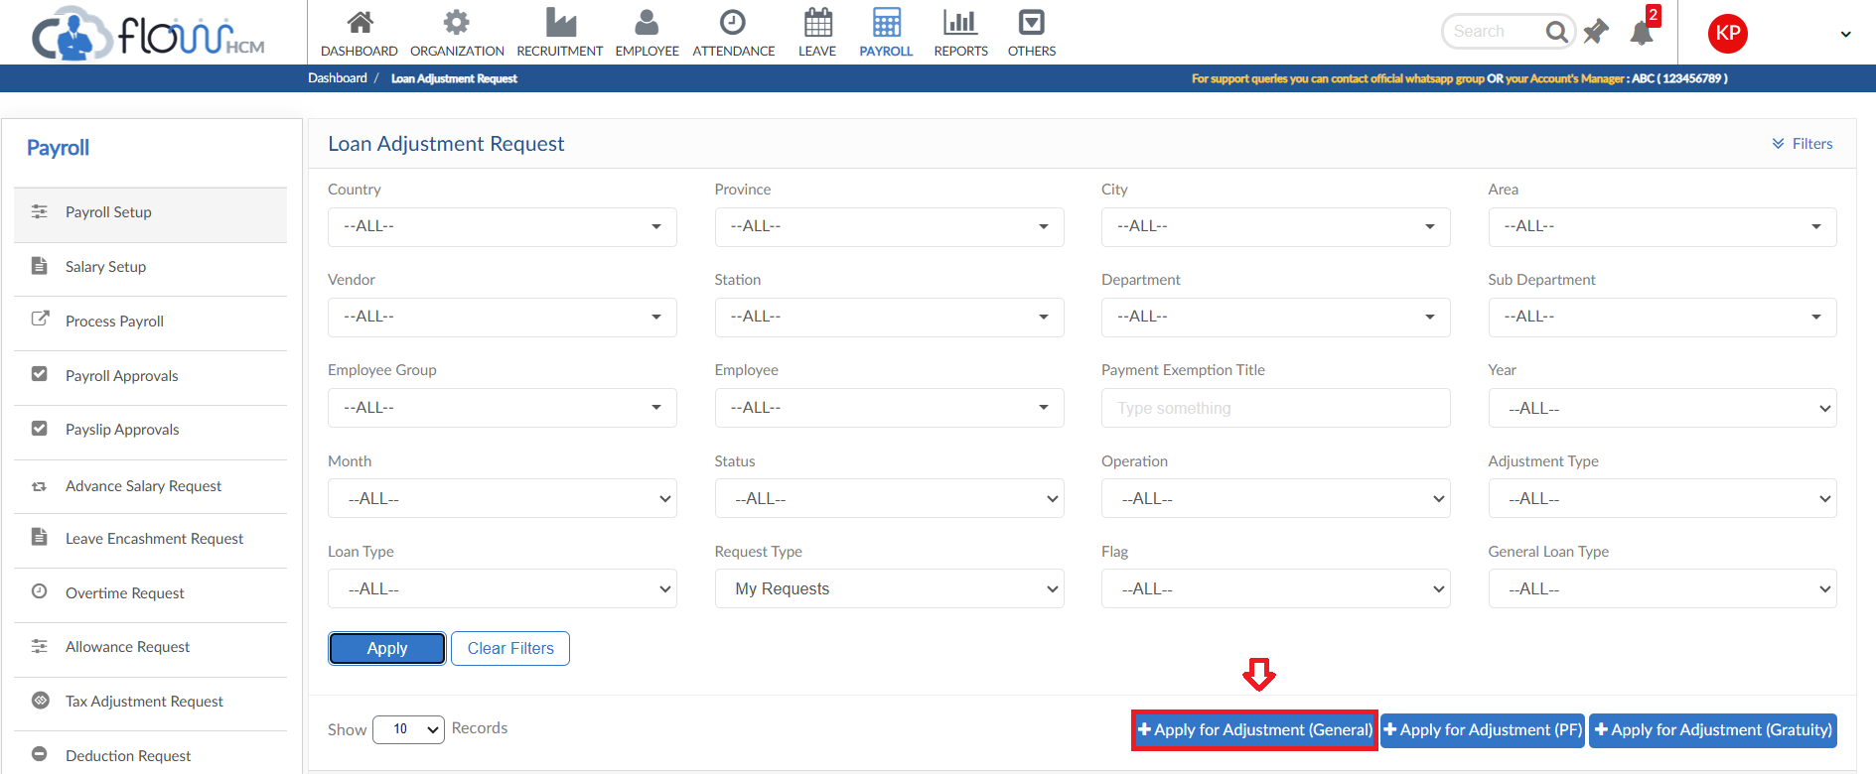
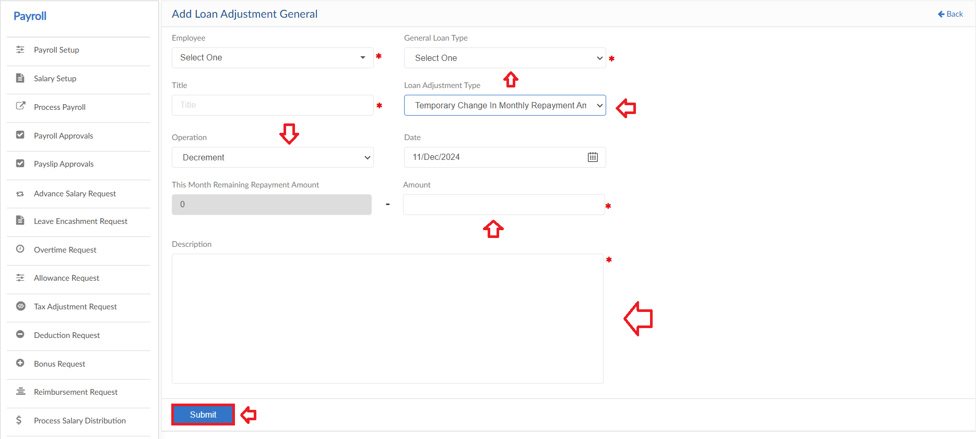

PF Loan Adjustment
- To add PF Loan Adjustment Request, click on Apply for Adjustment (PF) in Loan Adjustment Request form
- Select the employee from dropdown
- Enter Title for request and select Loan Adjustment type
- Select the Operation of Adjustment and date
- System will show the amount on the basis of Adjustment type then enter the amount
- Enter a reason for request
- Then click on submit to raise a requisition
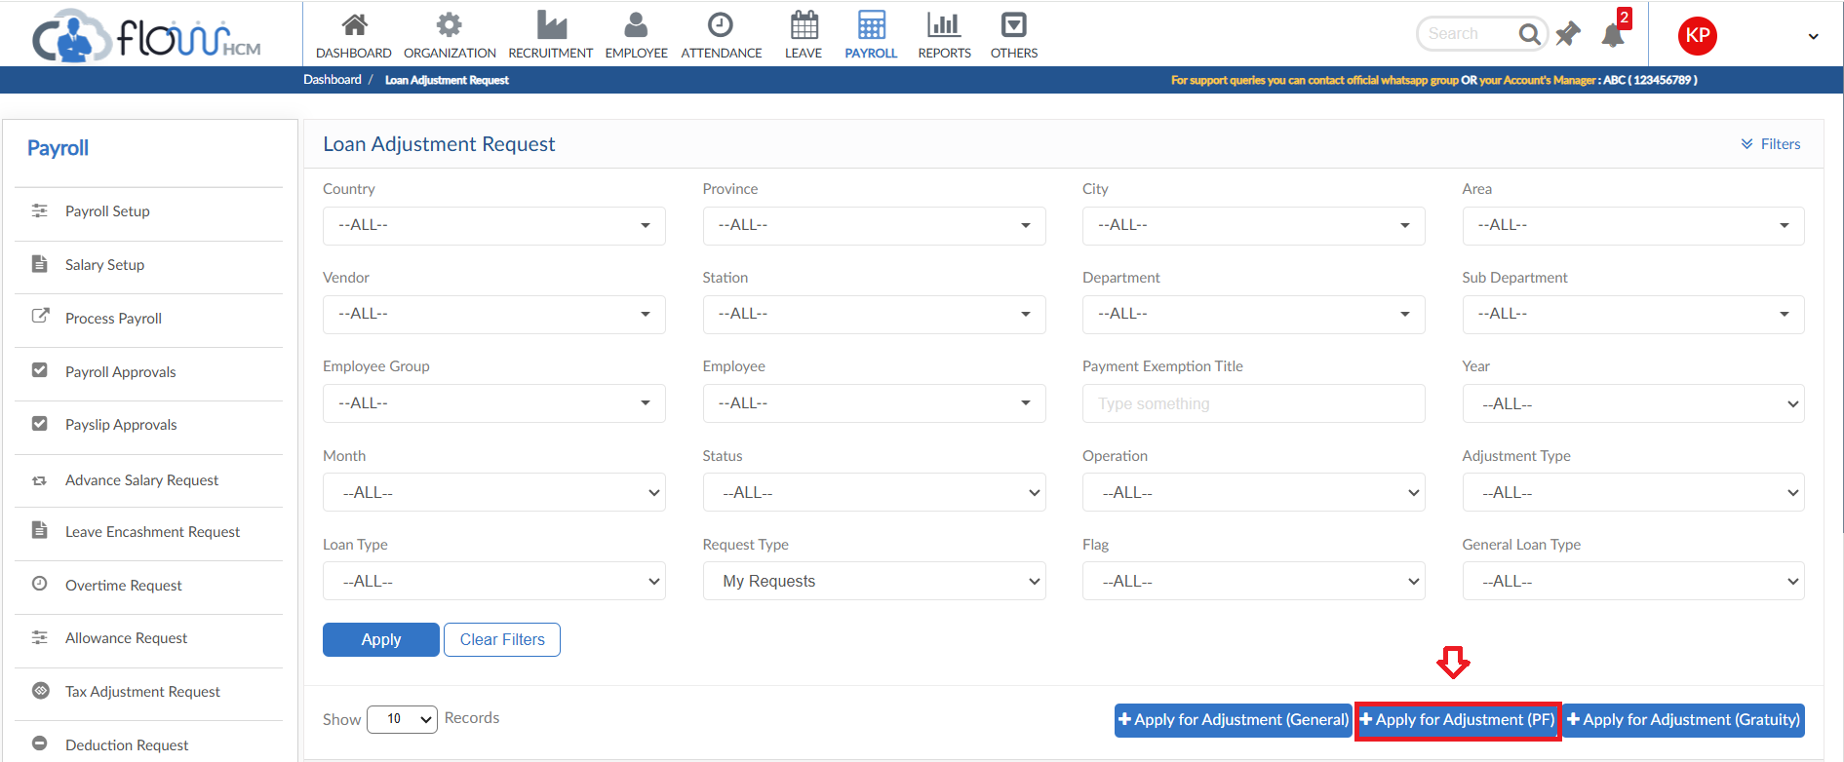
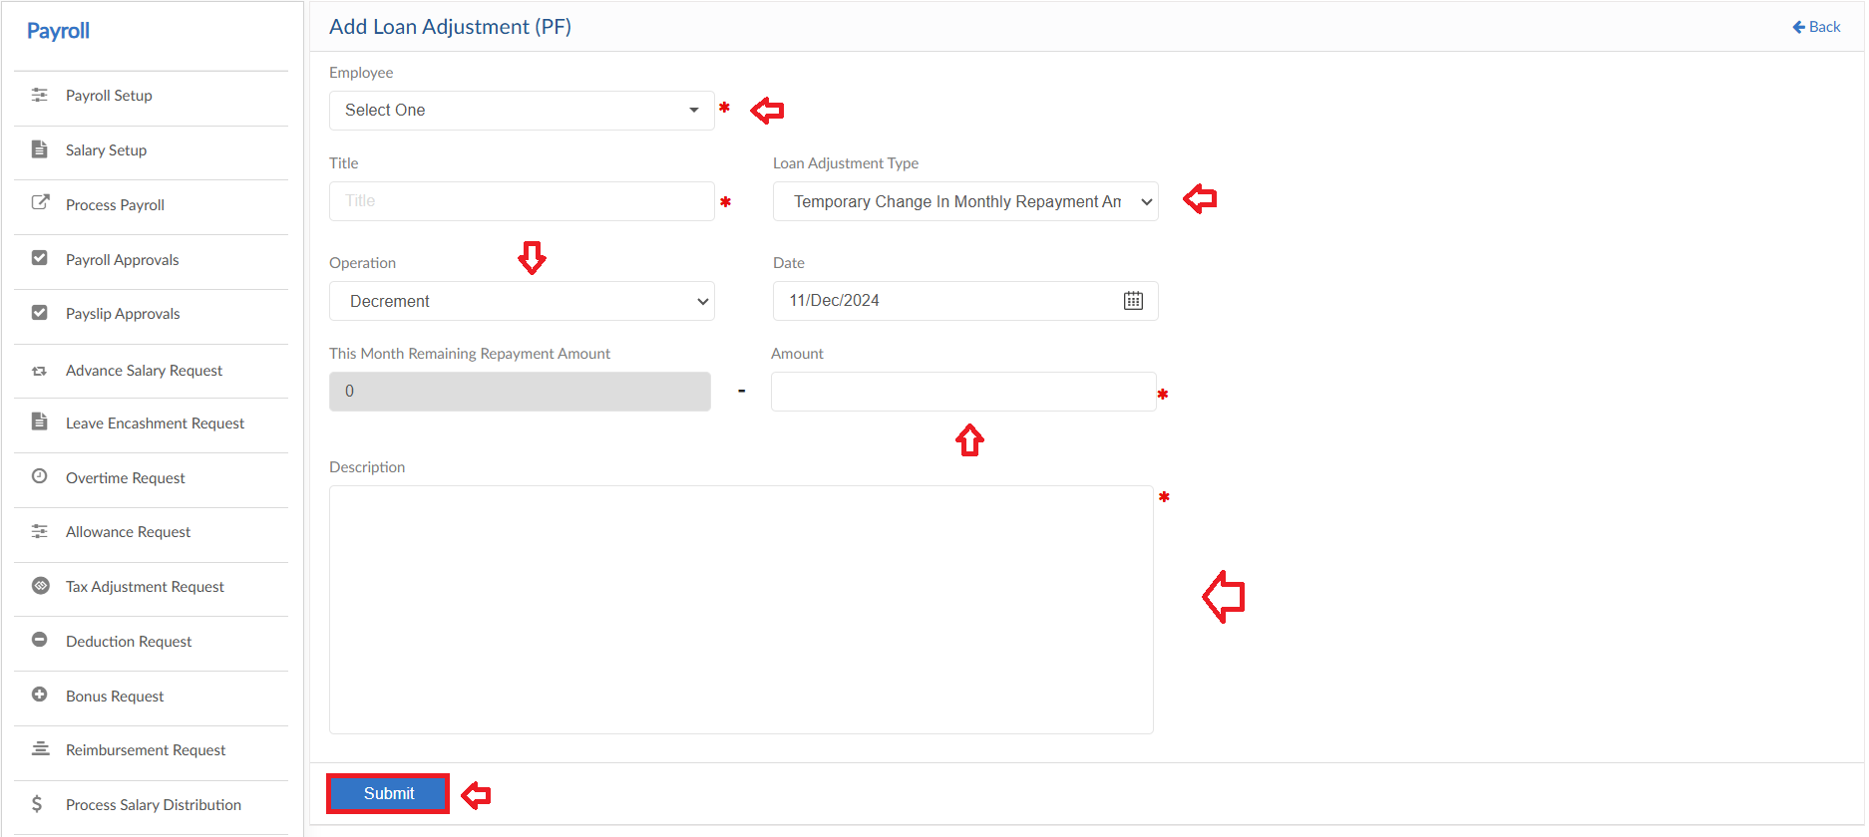

Gratuity Loan Adjustment
- To add Gratuity Loan Adjustment Request, click on Apply for Adjustment (Gratuity) in Loan Adjustment Request form
- Select the employee from dropdown
- Enter Title for request and select Loan Adjustment type
- Select the Operation of Adjustment and date
- System will show the amount on the basis of Adjustment type then enter the amount
- Enter a reason for request
- Then click on submit to raise a requisition
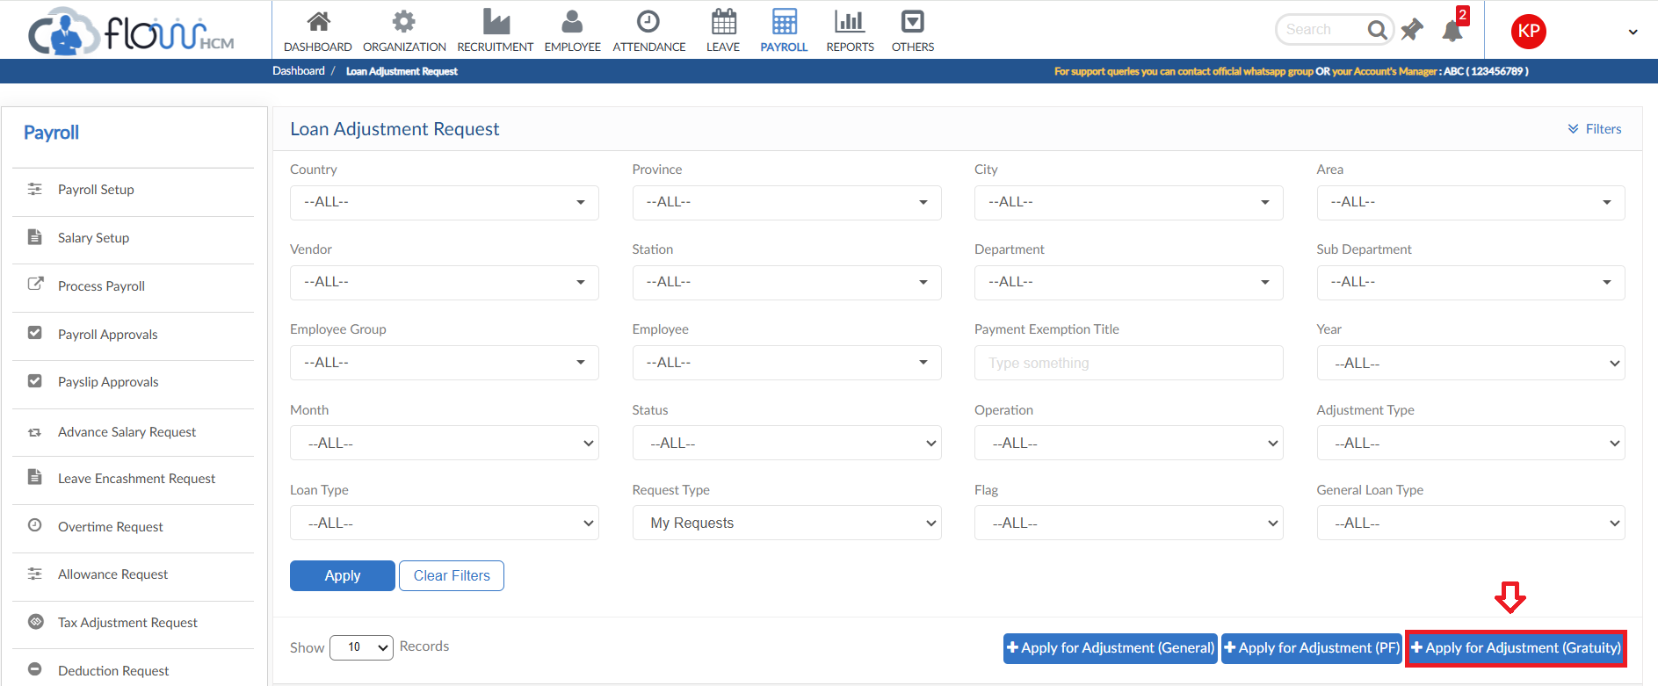
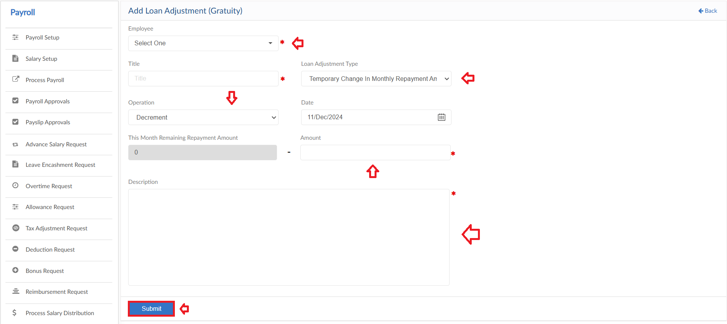

Profit Fund

- To add Profit Fund Request, click on Add Profit Fund in Profit Fund form
- Select the employee from dropdown and enter Title of request
- Enter the required amount
- Define the Year and Month
- Enter a reason for request
- Then click on submit to raise a requisition
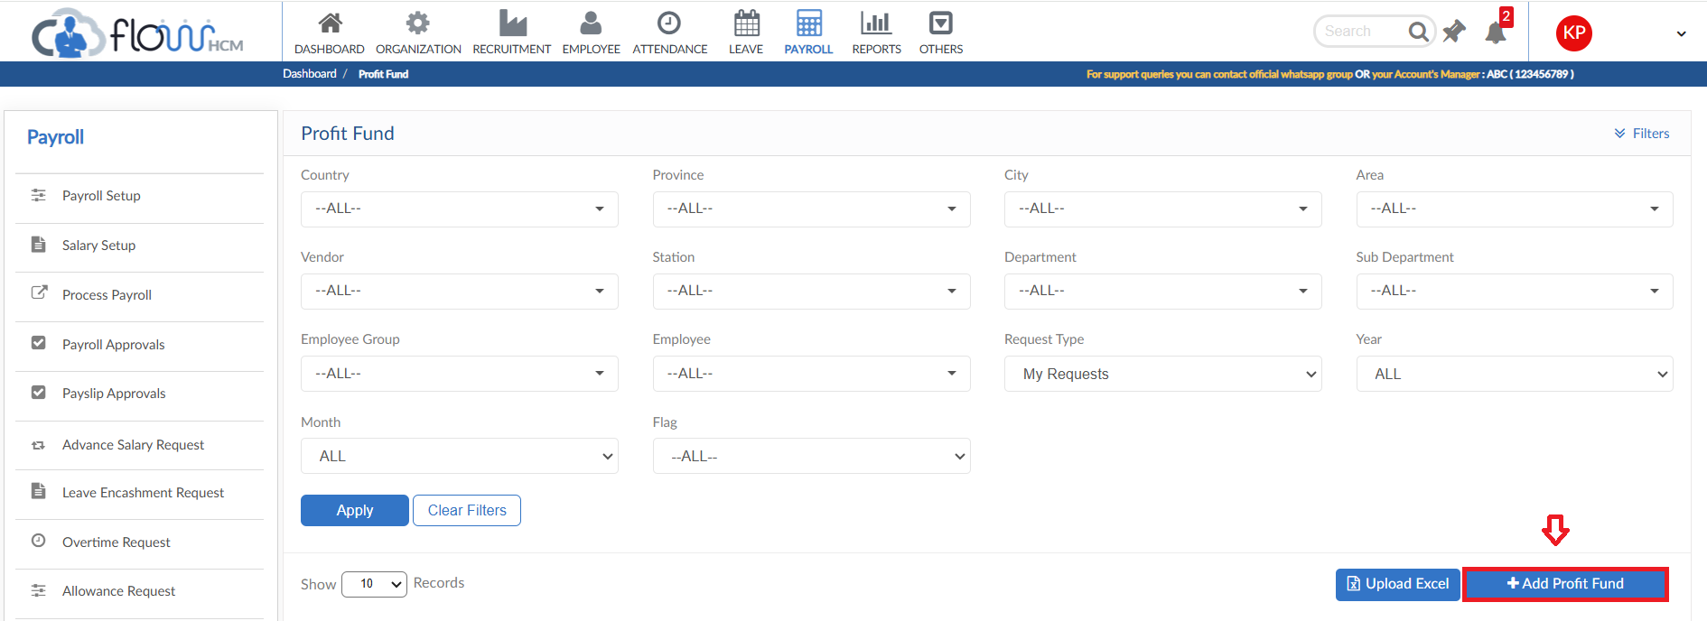
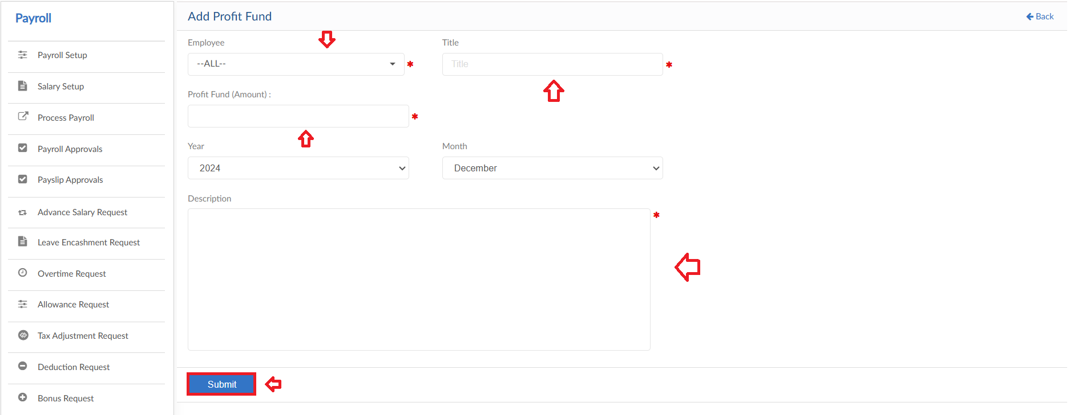

Upload Excel
- If required, upload all Profit Fund requests in one go user can use upload excel
- Click on Upload Excel button, pop up will be visible
- Click on Download Sample Template and enter required data
- Click on choose file and then click on Save button to upload all Profit Fund requests
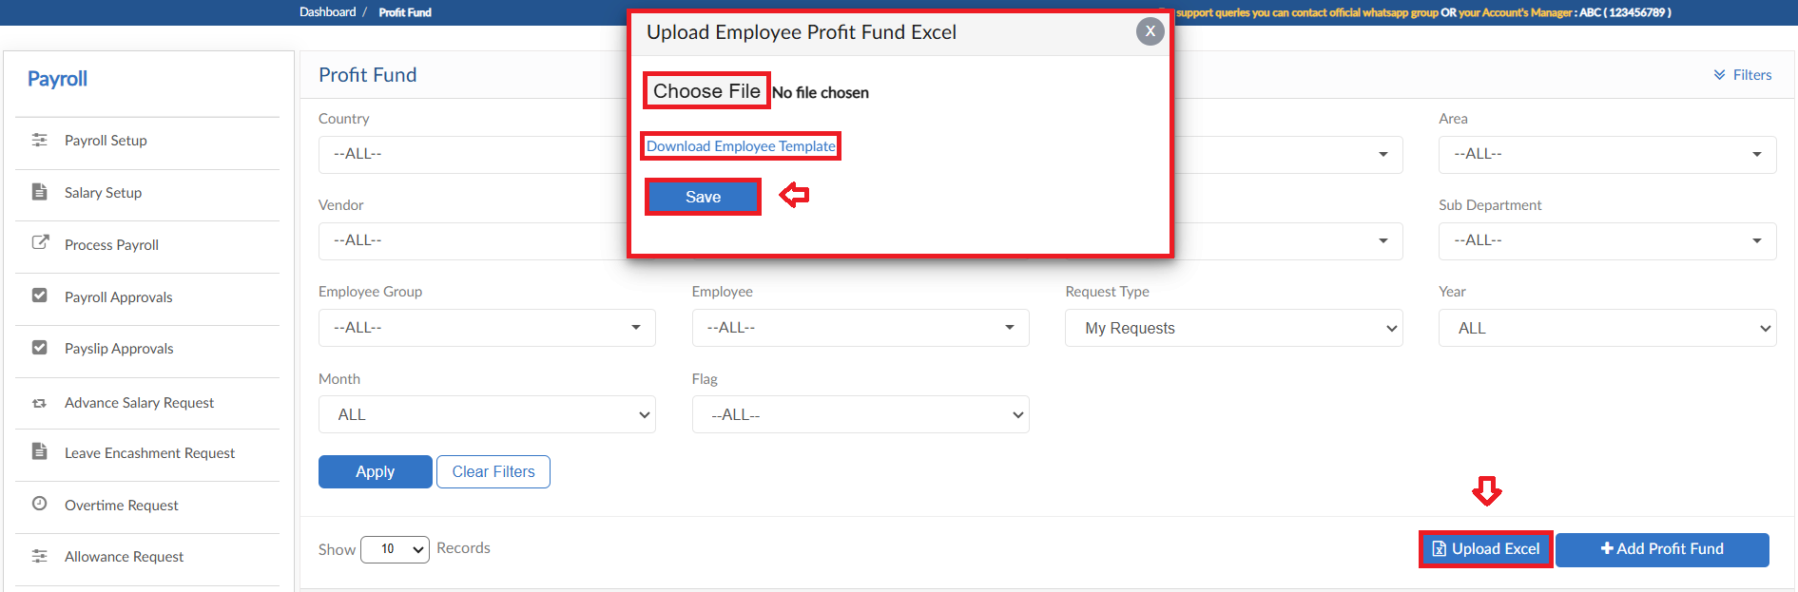

Fund Management
The form consists of multiple buttons/features

Add Provident Fund
- To add Provident Fund Request, click on Add Provident Fund in Fund Management form
- Select the employee and Provident Fund Type from dropdown
- Enter the Employee and Employer share amounts
- Define the criteria for Provident Fund
- Enter a reason for request
- Then click on submit to raise a requisition
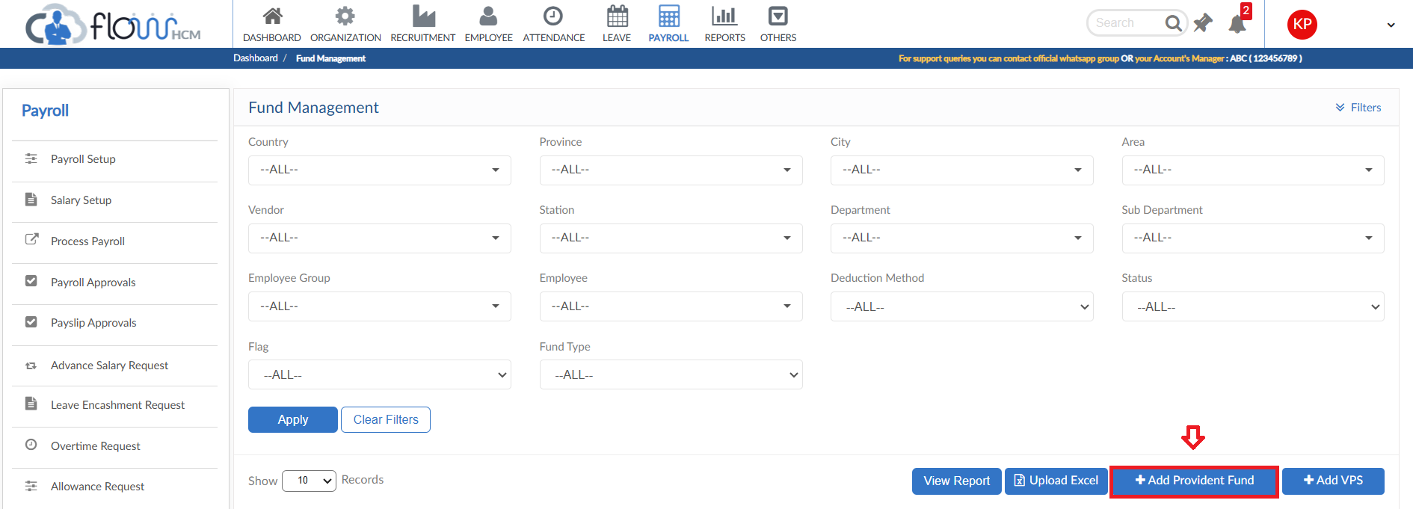
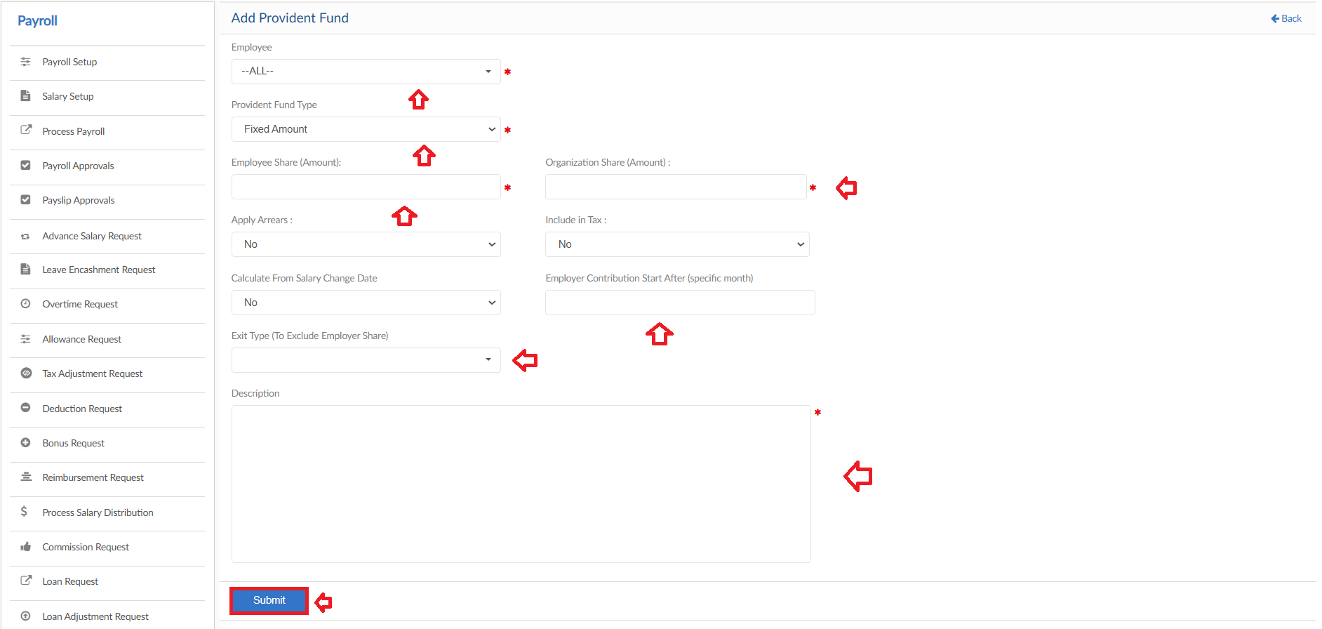

Add VPS
- To add VPS Request, click on Add Provident Fund in Fund Management form
- Select the employee and Deduction Type from dropdown
- Select VPS type from dropdown
- Enter the Employee and Organization share amounts
- Enter a reason for request
- Then click on submit to raise a requisition
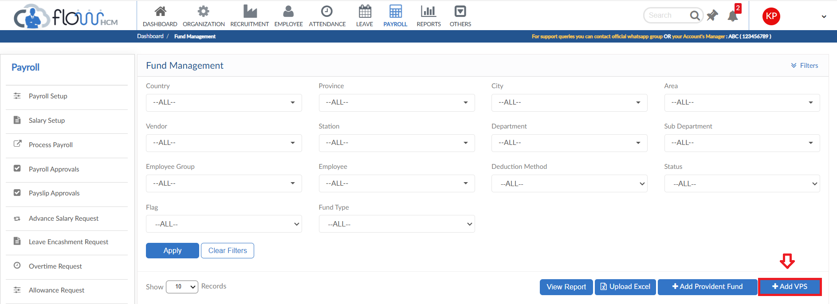
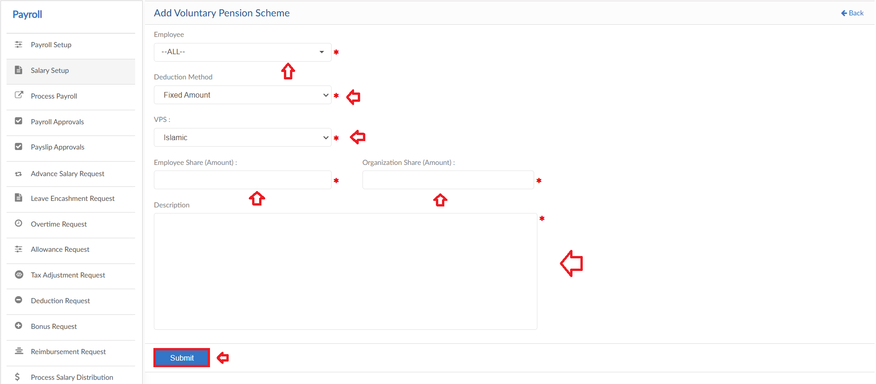

Pending Entries
- The button will show a pop up, list of employees with pending PF contribution according to policy. Select the employees and save to start the contribution
- Auto reminder tile will also show the list in Attendance Dashboard
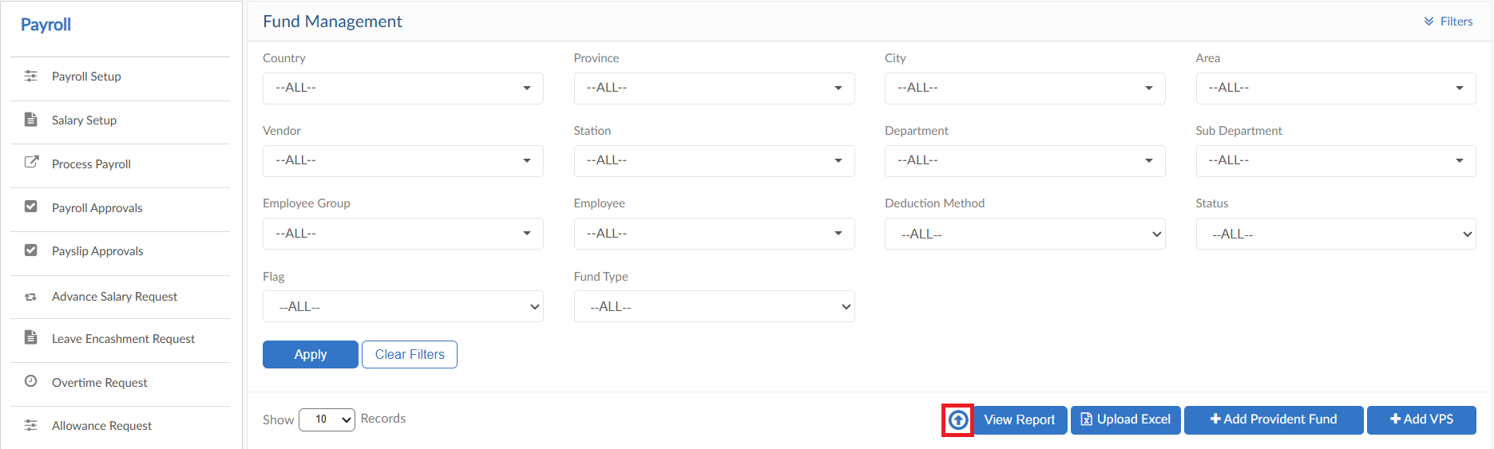
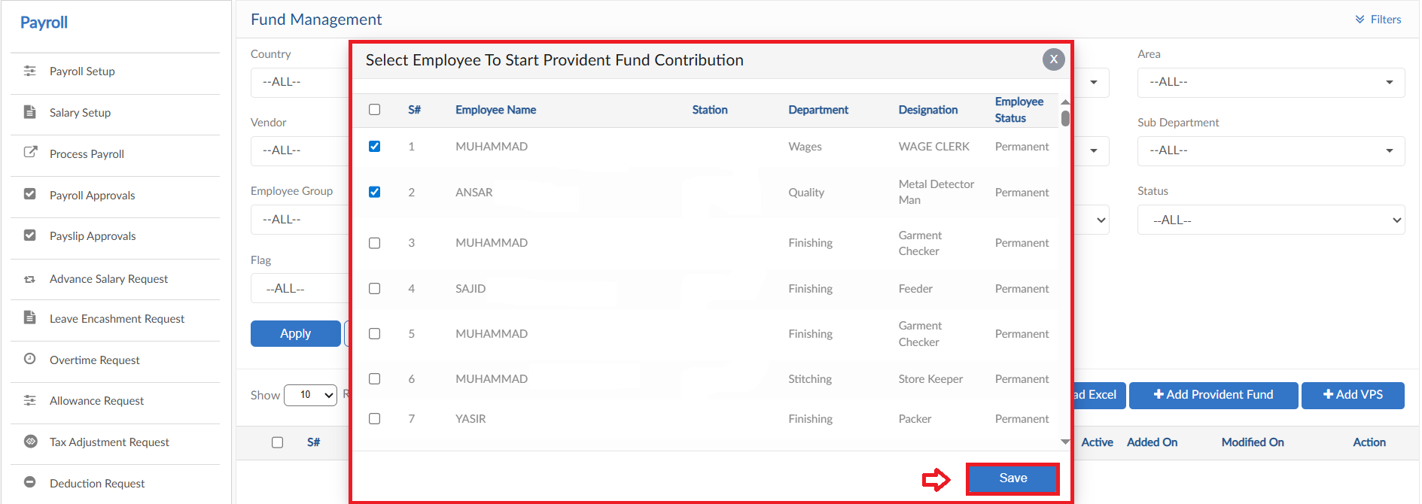
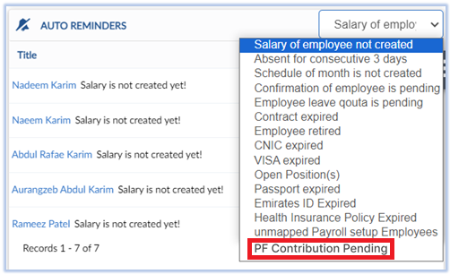

Upload Excel
- If required, upload all Fund requests in one go user can use upload excel
- Click on Upload Excel button, pop up will be visible
- Click on Download Sample Template and enter required data
- Click on choose file and then click on Save button to upload all Fund requests
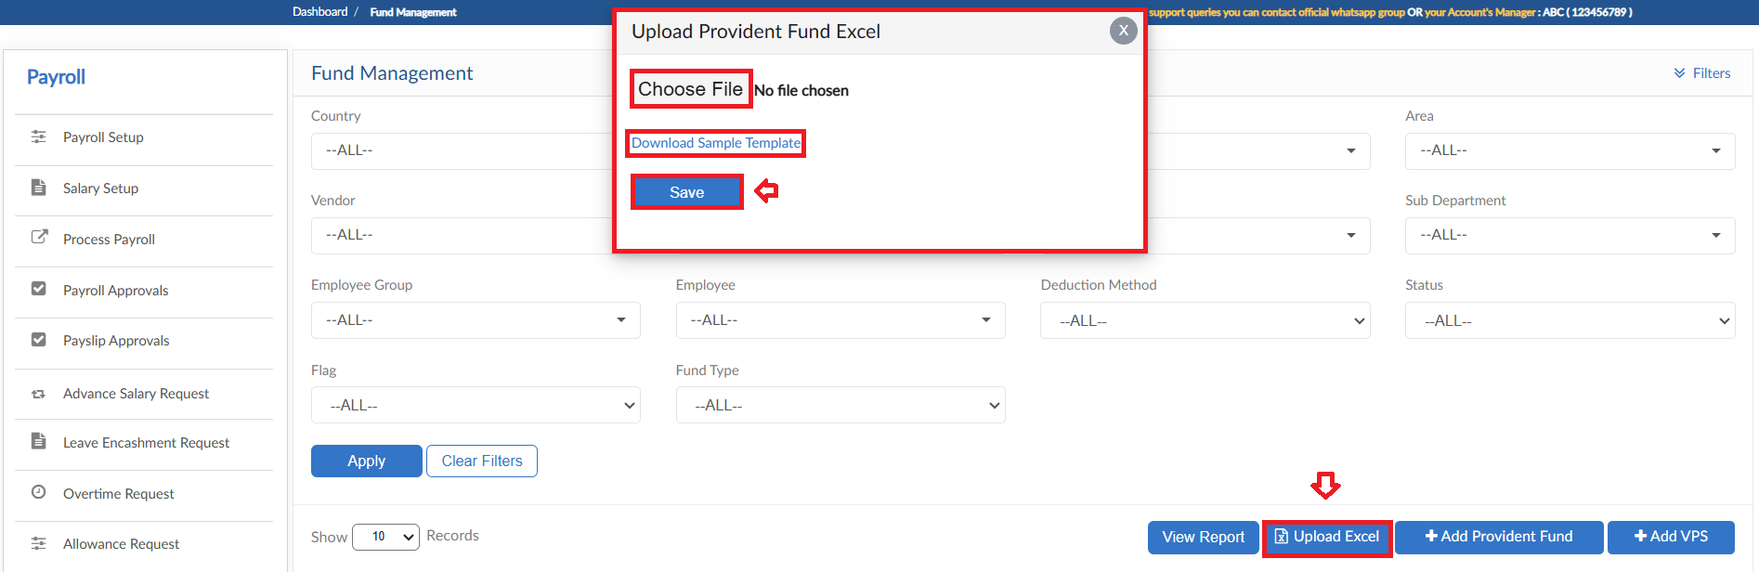

View Report
- To view the data of grid in Fund Management Request form click on view report
- Fund Management Request Report will pop up on screen
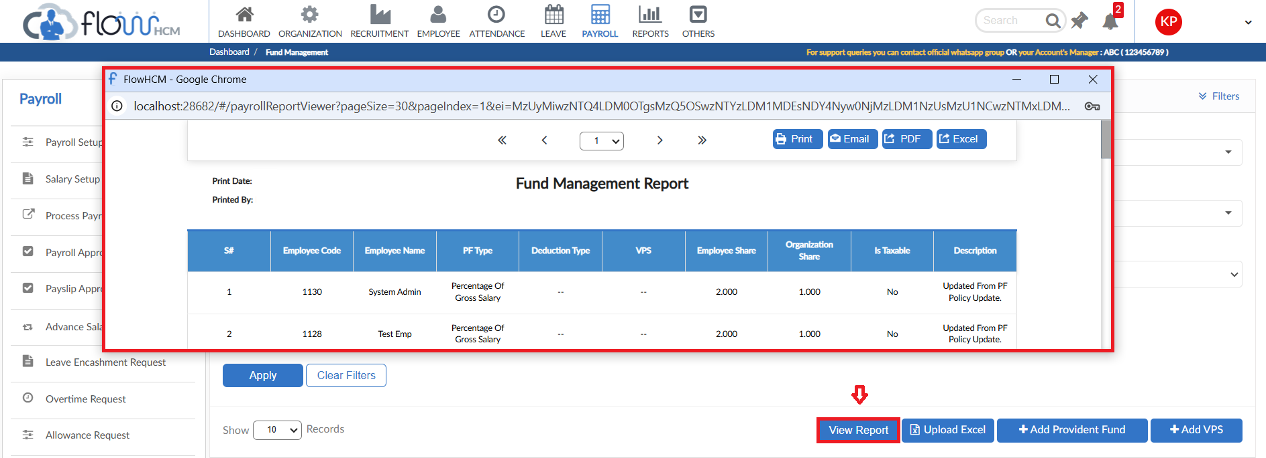

Salary Change Request

- To add Salary Change Request, click on Apply for Salary Change in Salary Change Request form
- Select the employee and enter title for request
- Enter date and select Change Type from dropdown
- Define the amount type and enter Amount
- System will show the impact of Salary Change and history as well
- File attachment feature is also available
- Enter a reason for request
- Then click on submit to raise a requisition
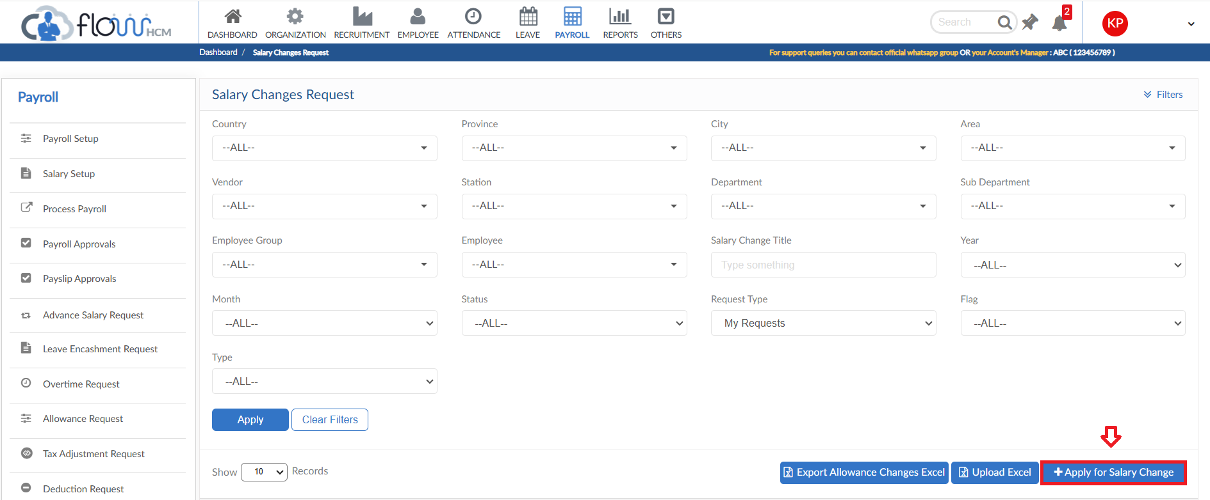
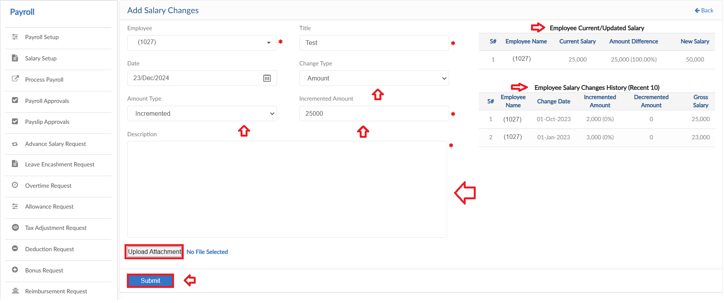

Upload Excel
- If required, upload all salary changes in one go user can use upload excel
- Click on Upload Excel button, pop up will be visible
- Select type (Salary or Allowance changes)
- Then click on Download Sample Template and enter required data
- Click on choose file and then click on Save button to upload all Attendance requests
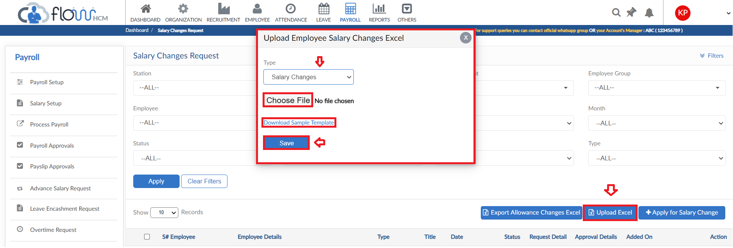

Export Allowance Changes Excel
- To export all Recurring Allowance of employee from system into one file
- Click on Export Allowance Changes Excel button
- All the Recurring Allowances of employees will be exported in Excel file
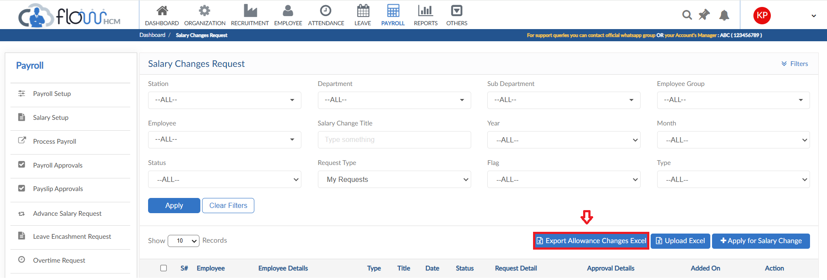

PF Withdrawal Request

- To add PF Withdrawal Request, click on Apply for PF Withdrawal in PF Withdrawal Request form
- Select the employee and enter title for request
- Select date and enter amount to withdraw
- System will show PF Withdrawal History
- Enter a reason for request
- Then click on submit to raise a requisition
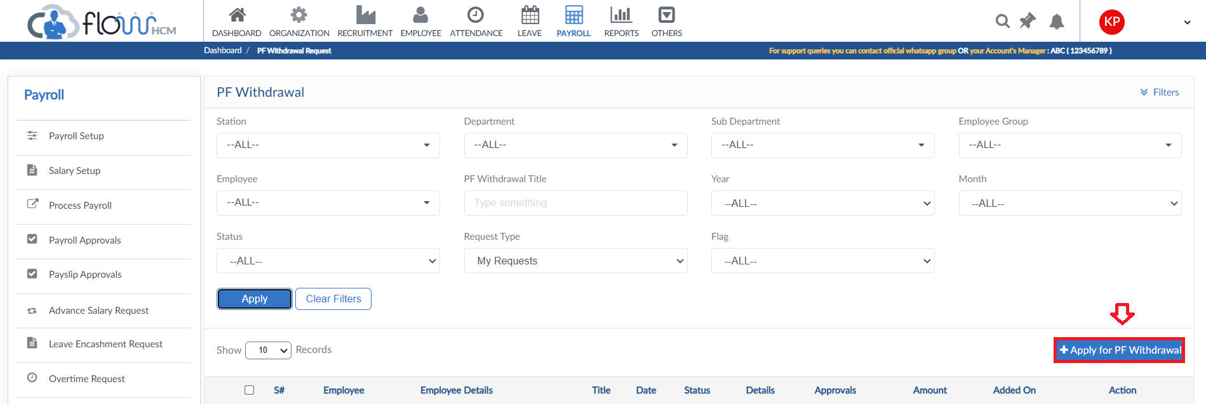
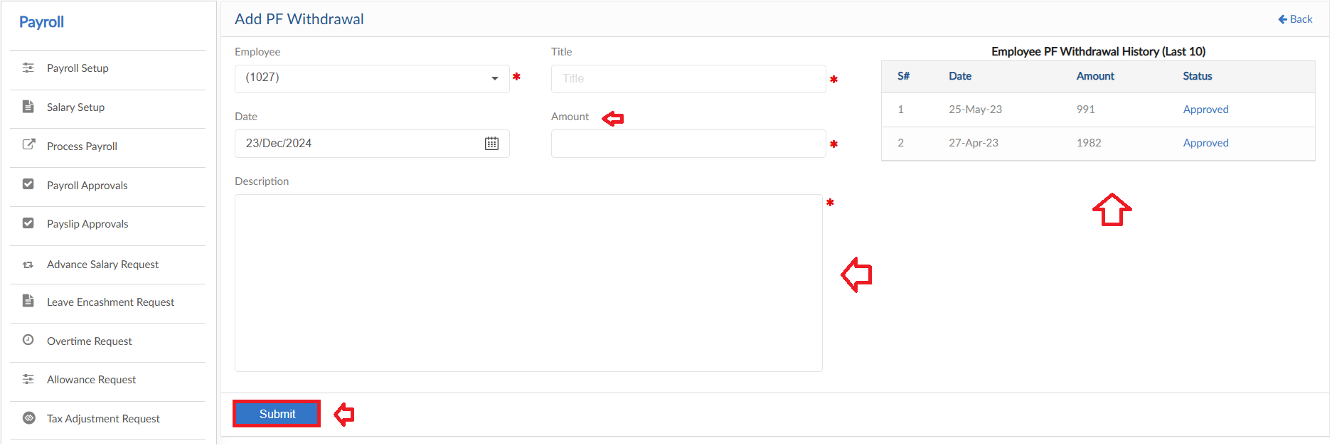

View Report
- To view the data of grid in PF Withdrawal Request form click on view report
- PF Withdrawal Request Report will pop up on screen

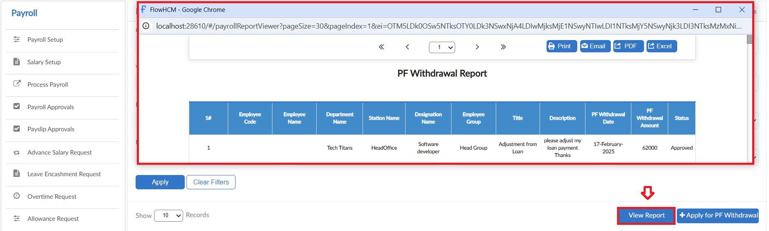

Hold Salary Request

- To add Hold Salary Request, click on Add New Request in Hold Salary Request form
- Select the employee and date for request
- Enter a reason for request
- Then click on submit to raise a requisition
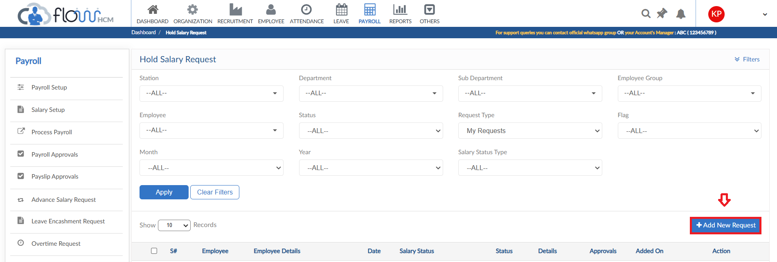
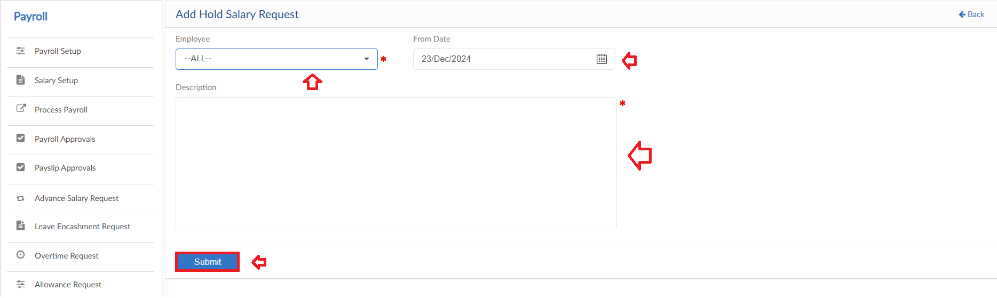

View Report
- To view the data of grid in Hold Salary Request form click on view report
- Hold Salary Request Report will pop up on screen

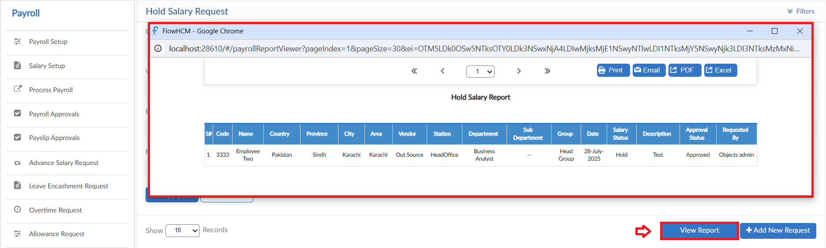

Gratuity Withdrawal

- To add Gratuity Withdrawal Request, click on Apply for Gratuity Withdrawal button in Gratuity Withdrawal form
- Select the employee from dropdown, system will show withdrawal amount according to policy defined in payroll setup
- Enter title and select date
- Enter amount and define reason for request
- A table will show history of employee requests
- Then click on submit to raise a requisition
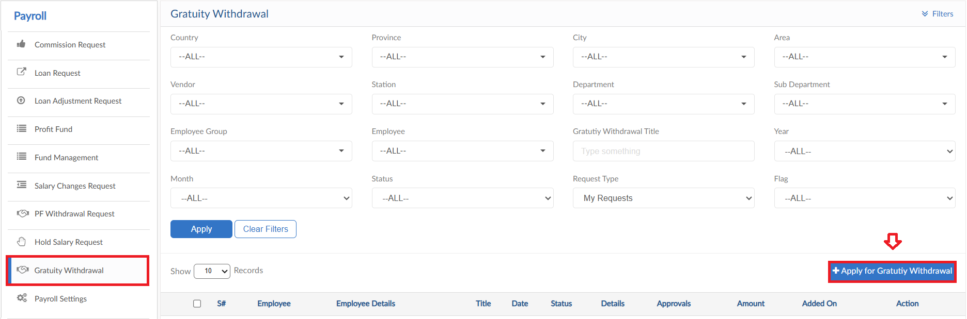
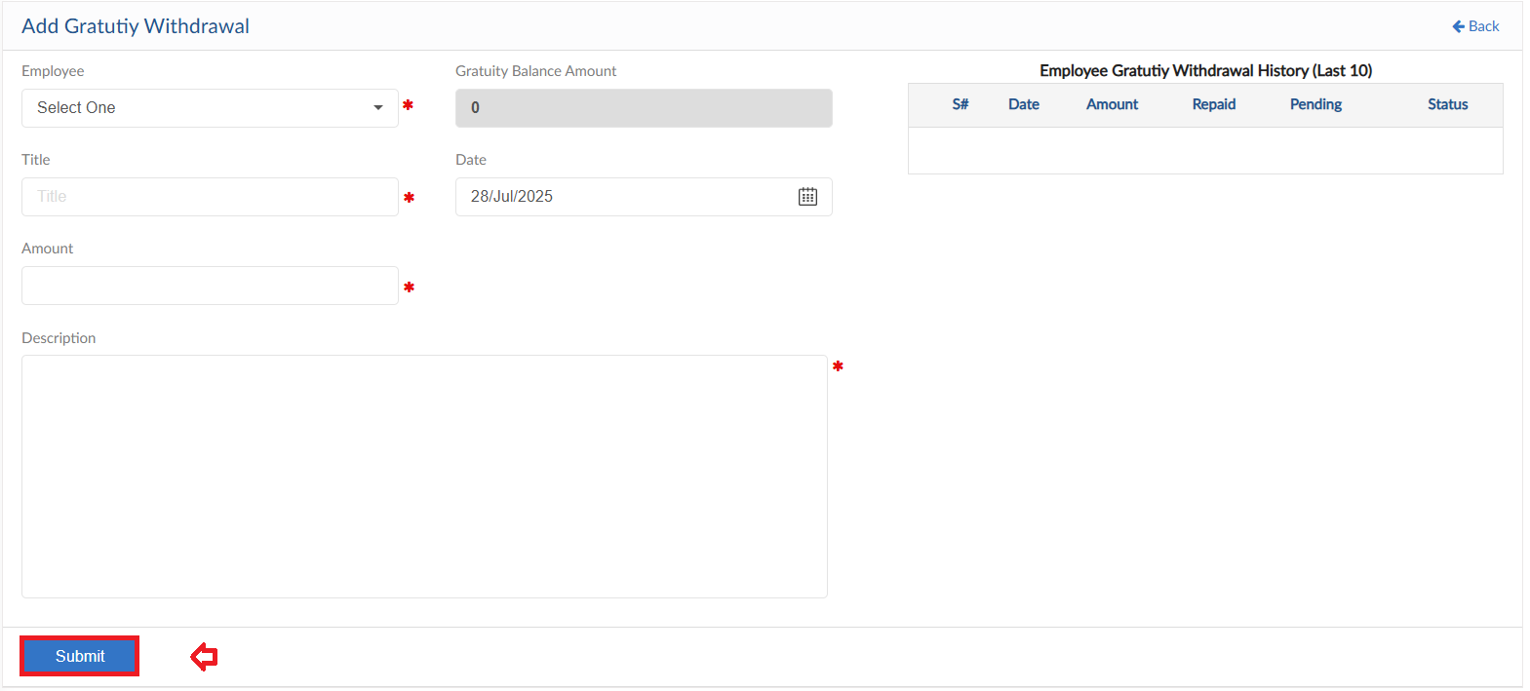

View Report
- To view the data of grid in Gratuity Withdrawal Request form click on view report
- Gratuity Withdrawal Request Report will pop up on screen

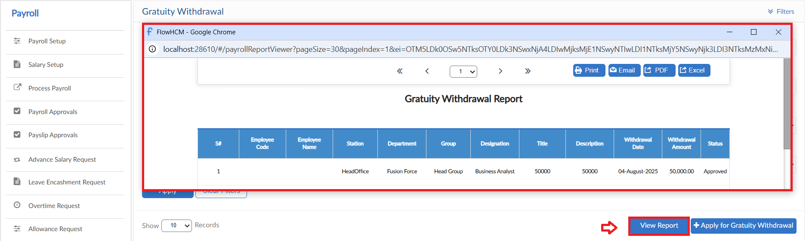

Payroll Settings
- Payroll Setting form consists of multiple setup forms
- Click on Payroll Settings form
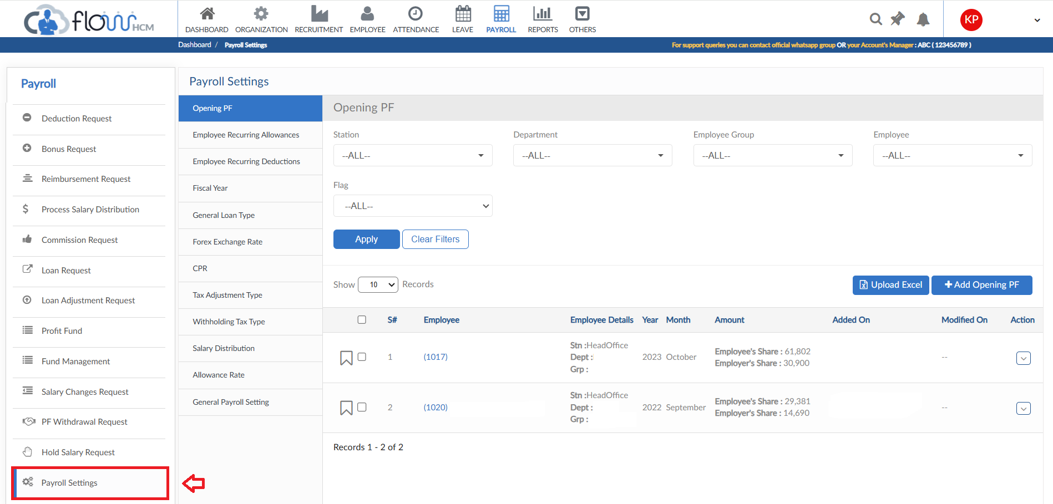

Opening PF
- To add Opening PF, click on Add Opening PF
- A pop up will be visible select the employee from dropdown
- Define Year and Month
- Enter the Employee and Employer share amount
- Click on Save button
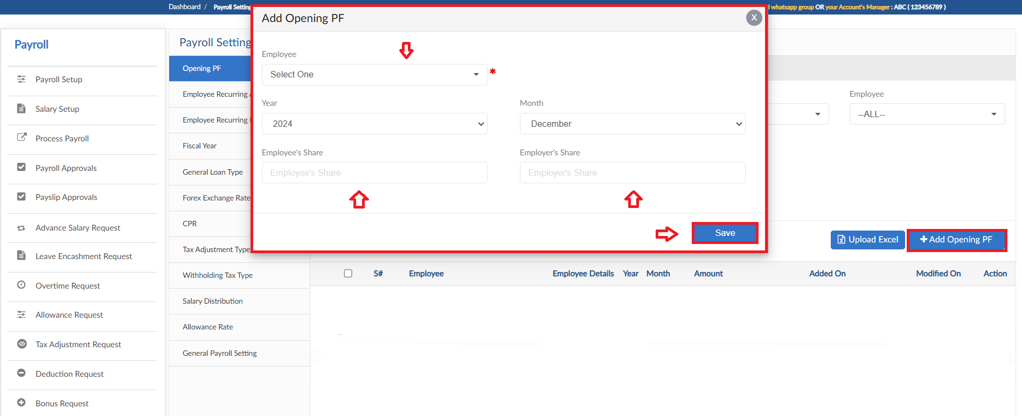

Upload Excel
- If required, upload all Opening PF in one go user can use upload excel
- Click on Upload Excel button, pop up will be visible
- Then click on Download Sample Template and enter required data
- Click on choose file and then click on Save button to upload all Opening PF
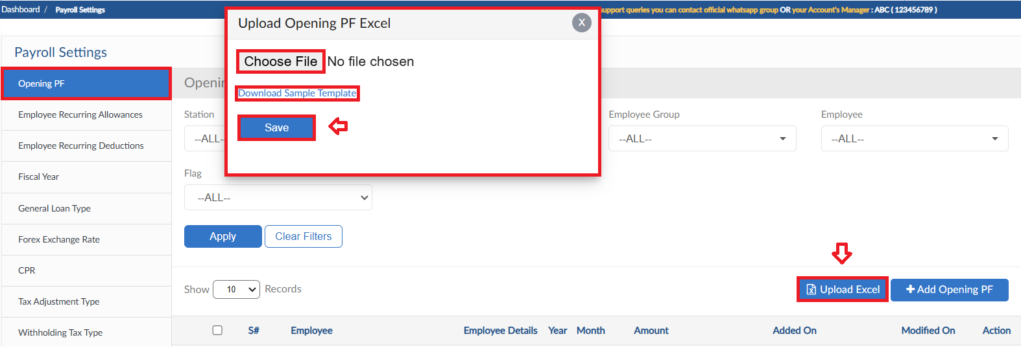

Employee Recurring Allowances
- To add Recurring Allowances, click on Add Recurring Allowances
- A pop up will be visible select the employee from dropdown and enter title
- Select the Allowance Type and enter Amount
- Define the criteria and Taxable settings
- Enter a reason and then click on Save button
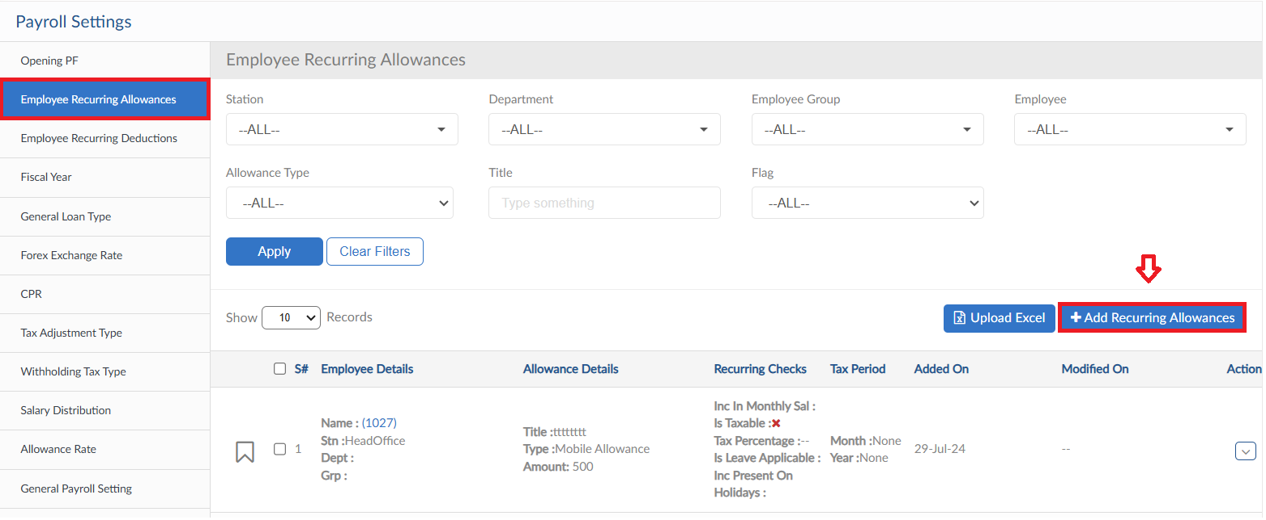
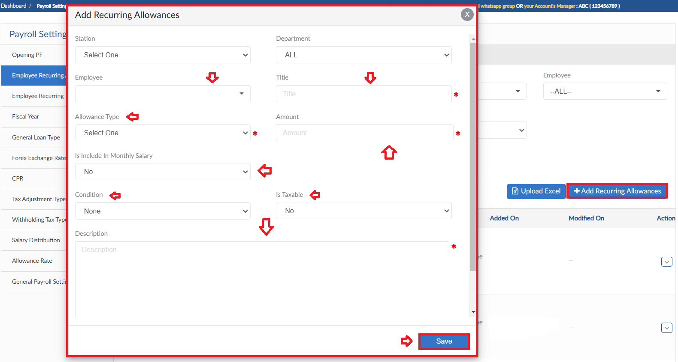

Upload Excel
- If required, upload all Recurring Allowances in one go user can use upload excel
- Click on Upload Excel button, pop up will be visible
- Then click on Download Sample Template and enter required data
- Click on choose file and then click on Save button to upload all Recurring Allowances
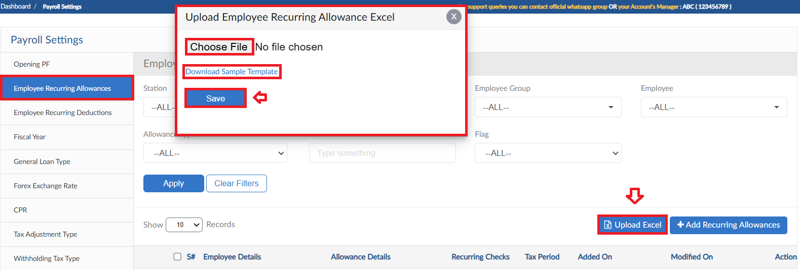

Employee Recurring Deductions
- To add Recurring Deductions, click on Add Reductions Deductions
- A pop up will be visible select the employee from dropdown and enter title
- Select the Allowance Type and enter Amount
- Define the criteria and Taxable settings
- Enter a reason and then click on Save button
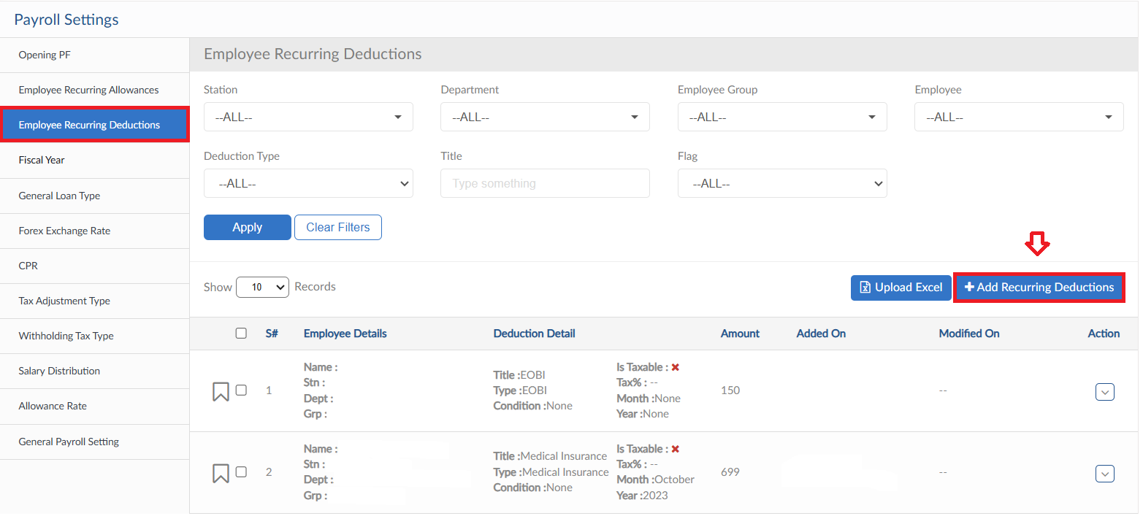
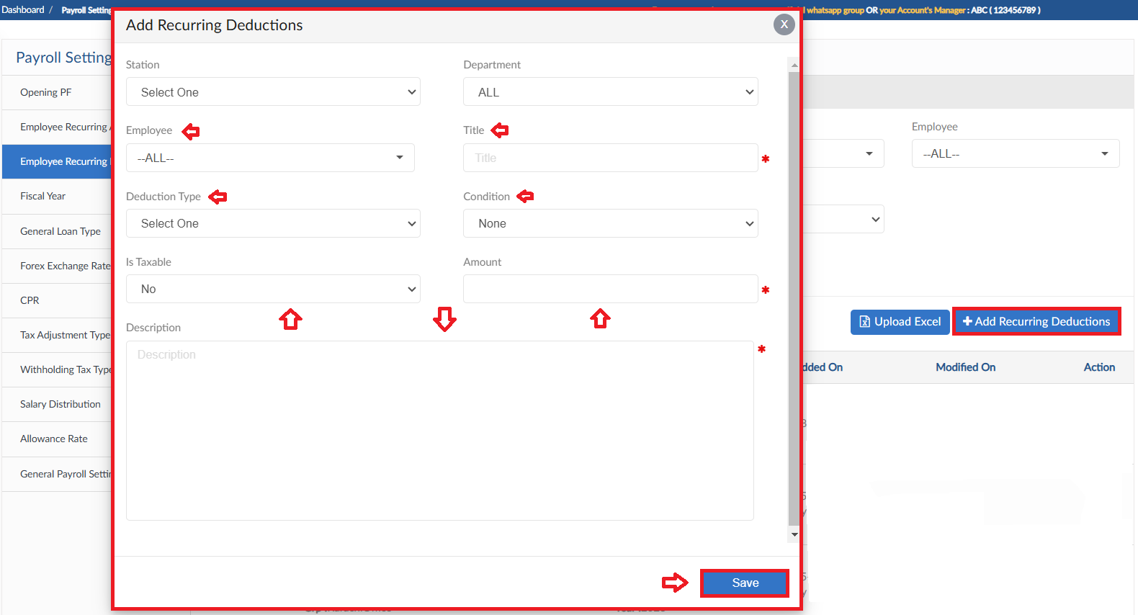

Upload Excel
- If required, upload all Recurring Deductions in one go user can use upload excel
- Click on Upload Excel button, pop up will be visible
- Then click on Download Sample Template and enter required data
- Click on choose file and then click on Save button to upload all Recurring Deductions
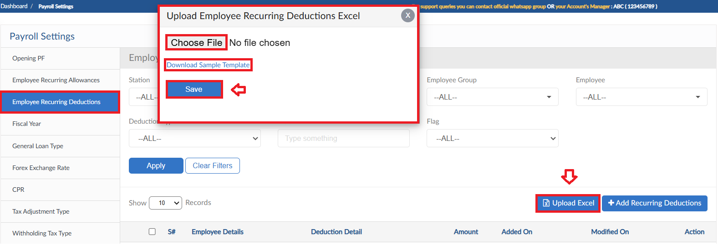

Fiscal Year
- To add a Fiscal Year, click on Add Fiscal Year button
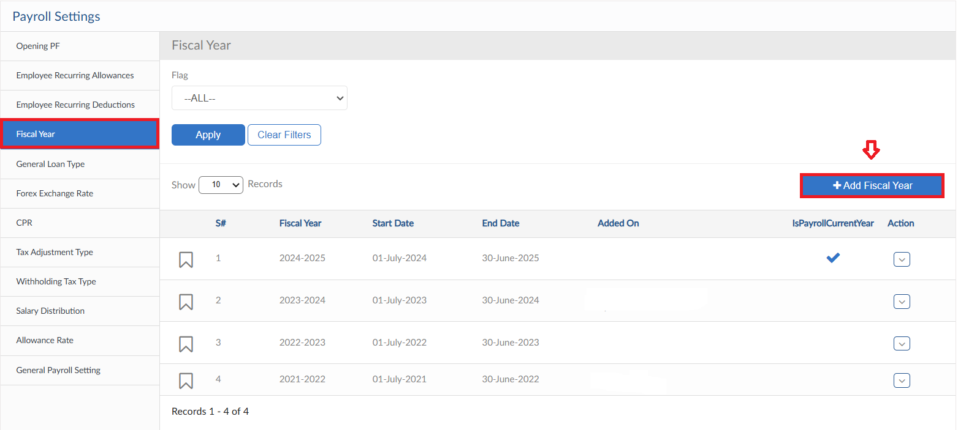
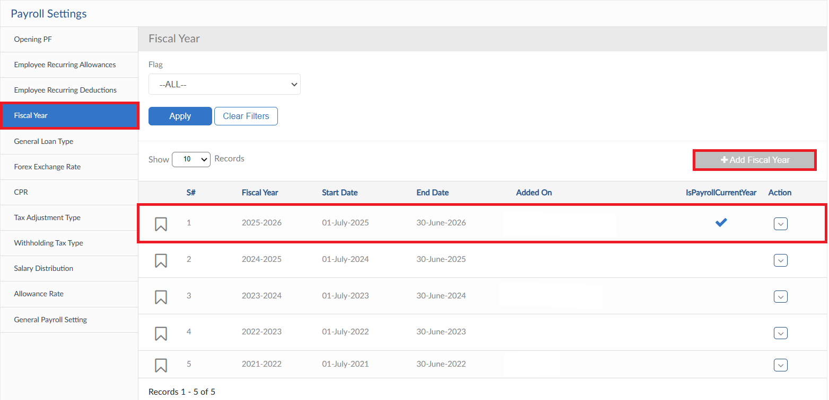

General Loan Type
- To add Loan Type, click on Add Loan Type button
- A pop up will be visible enter Loan Title and select category
- Define the conditions for Loan
- For Loan criteria slabs can be defined, fields are given enter the required data
- After all settings click on save button
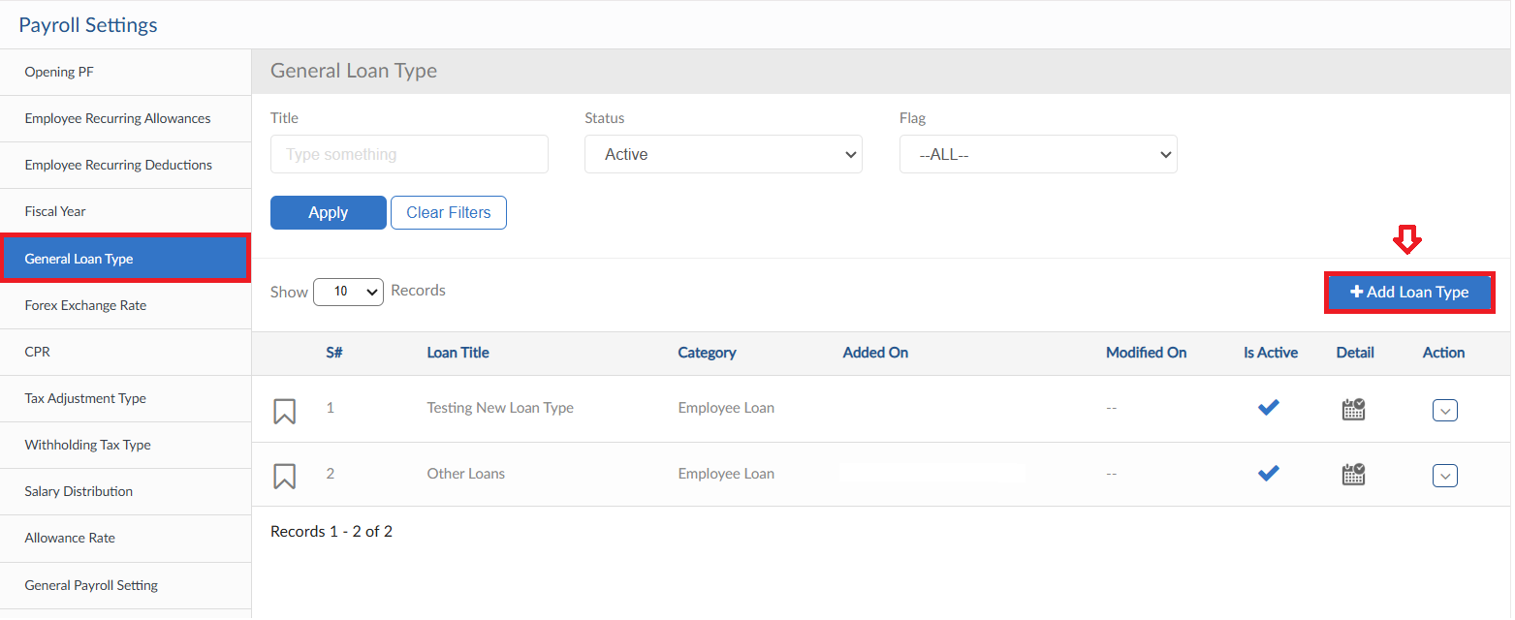
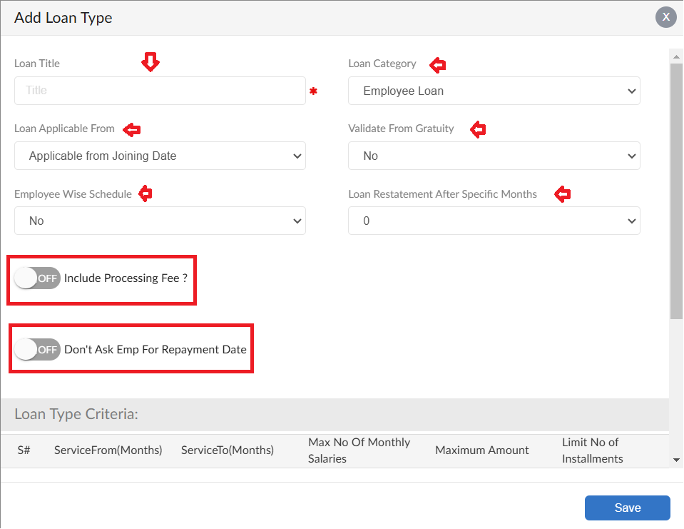
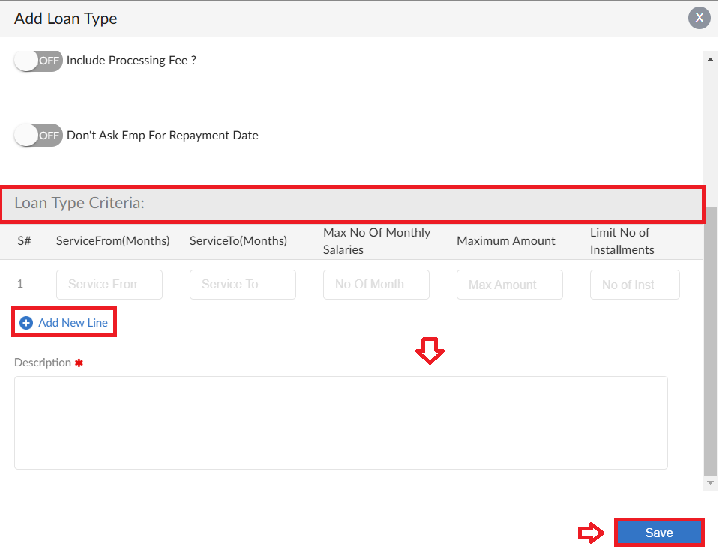

Forex Exchange Rate
- To add Forex exchange rate, click on Add Forex Rate
- A pop up will be visible define Year and Month
- Select Payroll Setup and Schedule from dropdowns
- Select the Forex Currency and enter Forex exchange rate
- Click save button
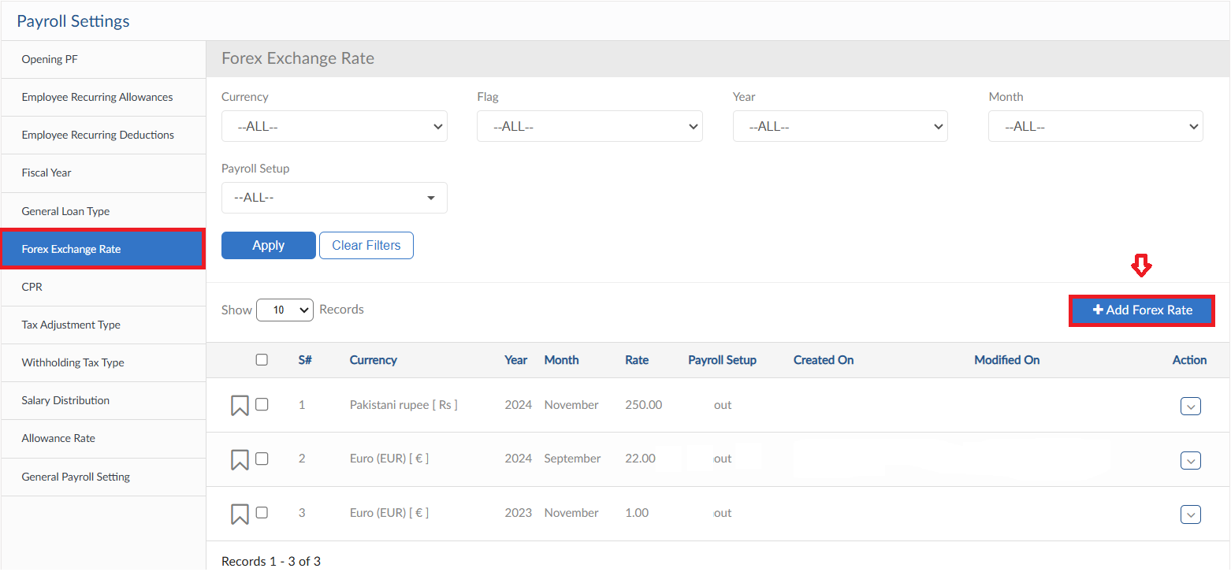
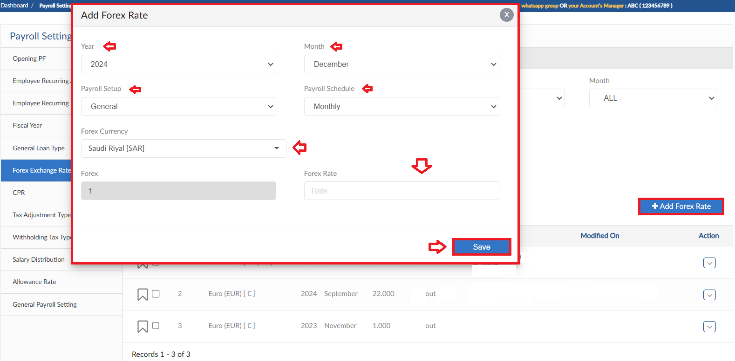

CPR
- To add CPR, click on Add CPR a pop up will be visible
- Select the employee and define Year & Month
- Enter the CPR date and code
- Enter a reason for request and click on save button
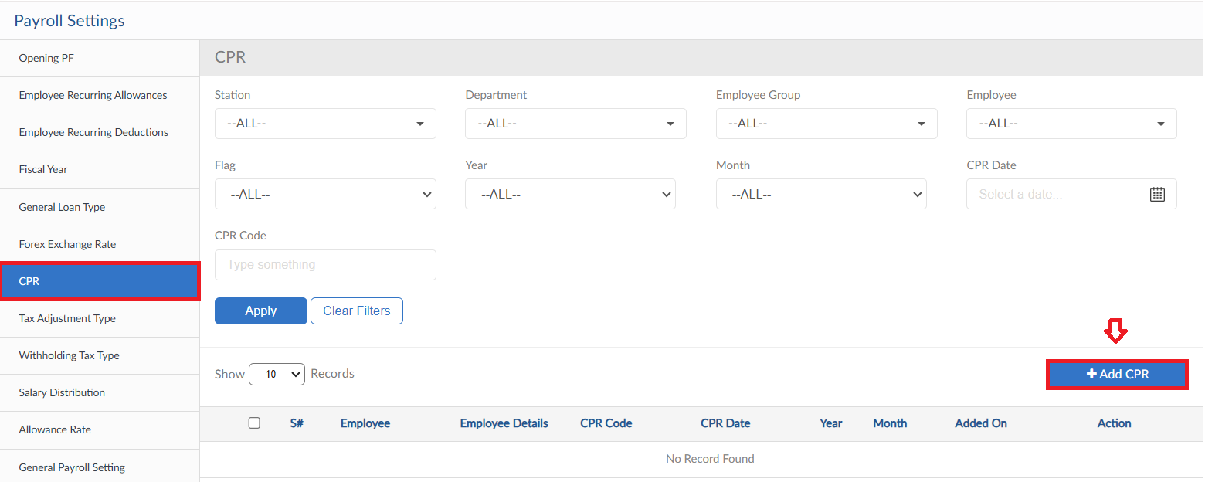
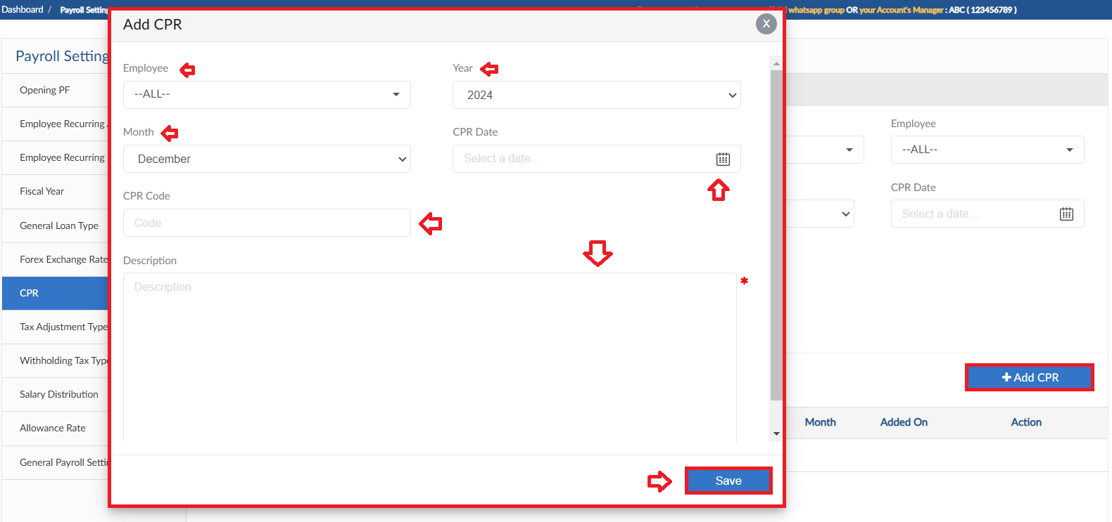

Tax Adjustment Type
- To add Tax Adjustment Type, click on Add Tax Adjustment a pop up will be visible
- Enter Title and select Adjustment Method
- Define the Calculation Criteria then click on save button
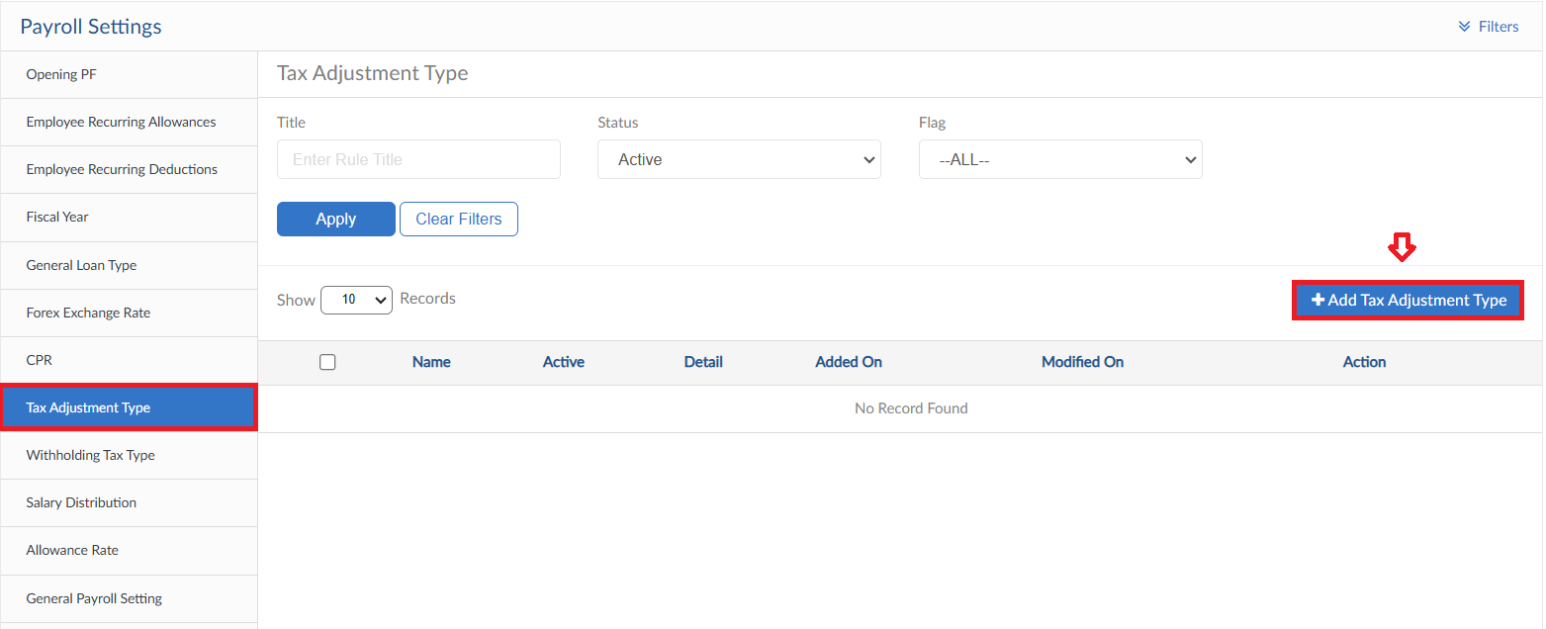
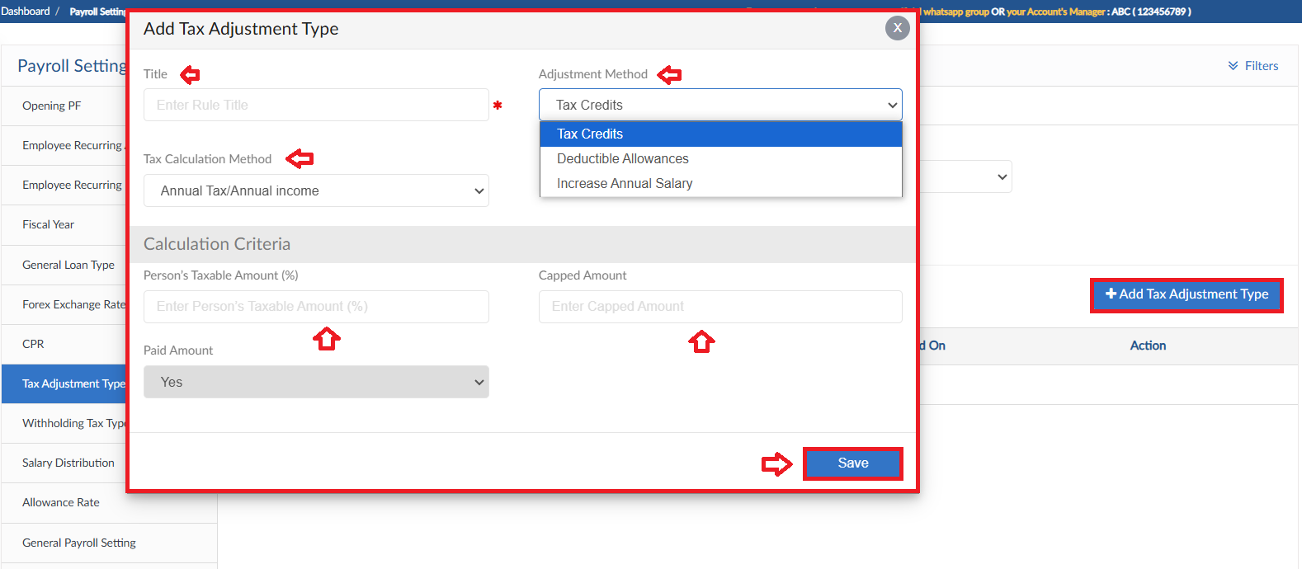

Withholding Tax Type
- To add Withholding Tax Type, click on Add New Type
- A pop up will be visible enter the Name of type
- Click save button
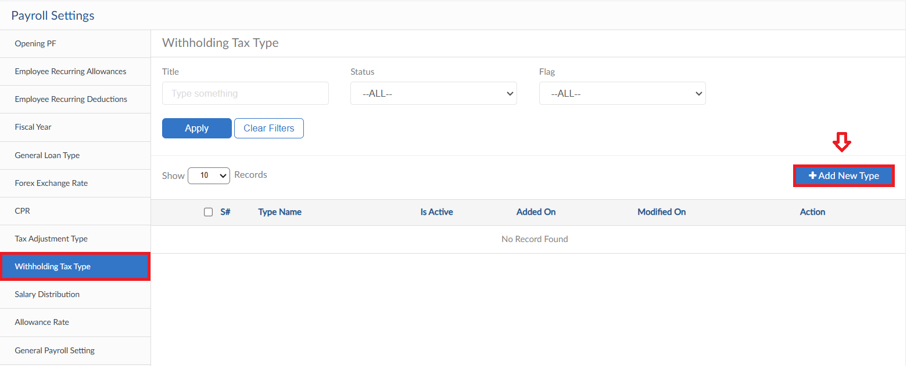
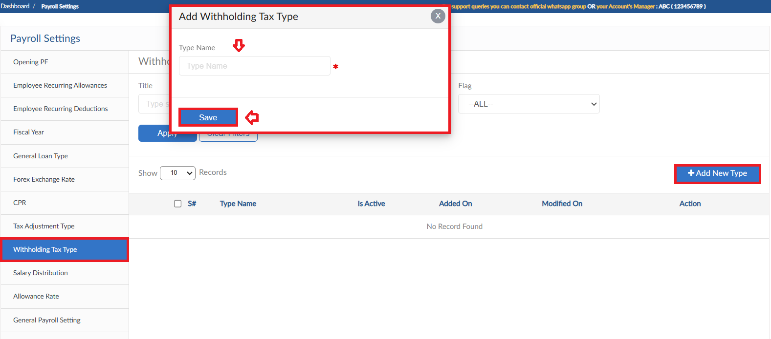

Salary Distribution
- To add Salary Distribution details, click on Add for Salary Distribution
- A pop up will be visible select the employee from dropdown
- Define the criteria by selection the salary Stations and their Percentages
- Click on Submit button
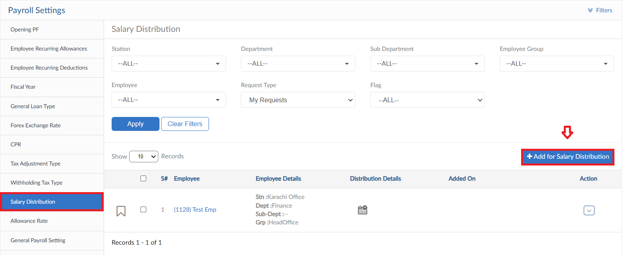
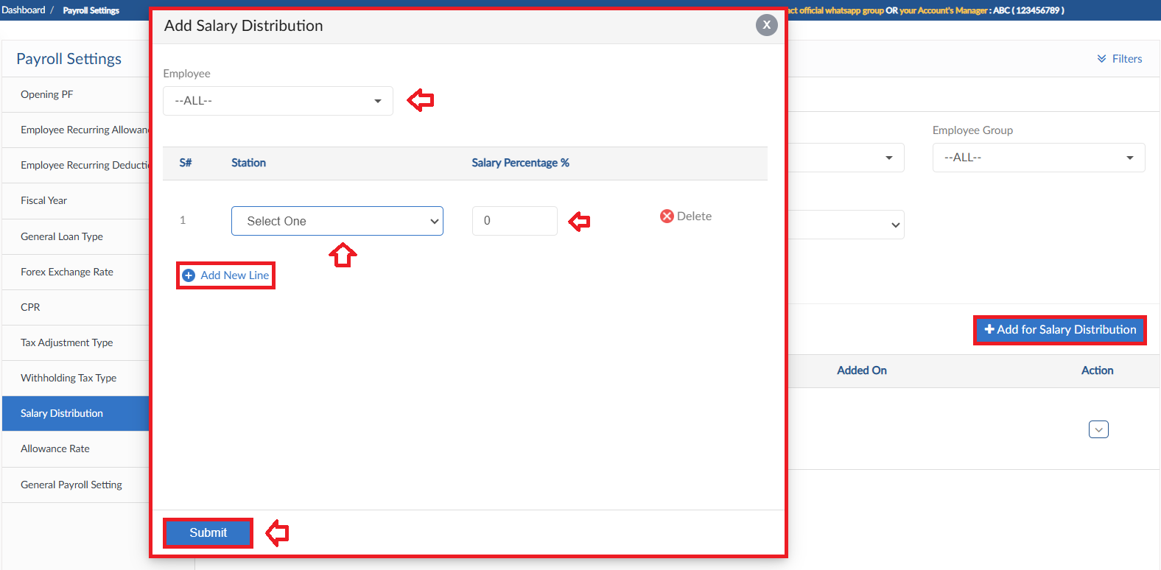

Allowance Rate
- To add Allowance Rate, click on Add Allowance Rate
- A pop will be visible select the Allowance Title from dropdown and enter the rate
- Define Month and Year for Allowance Rate then click Save
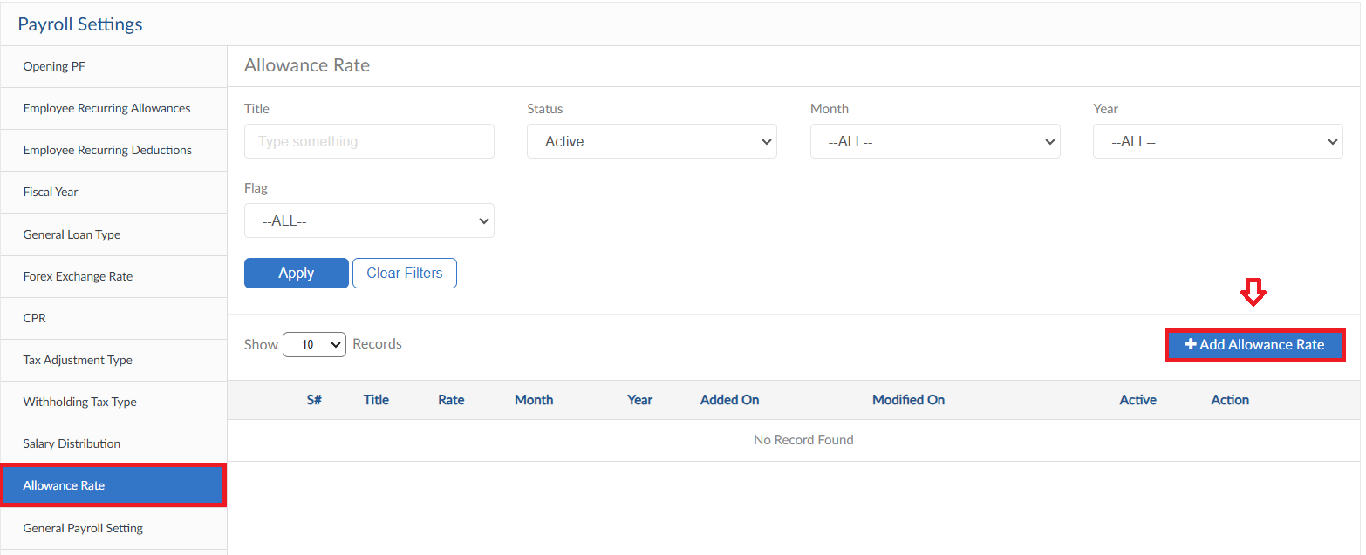
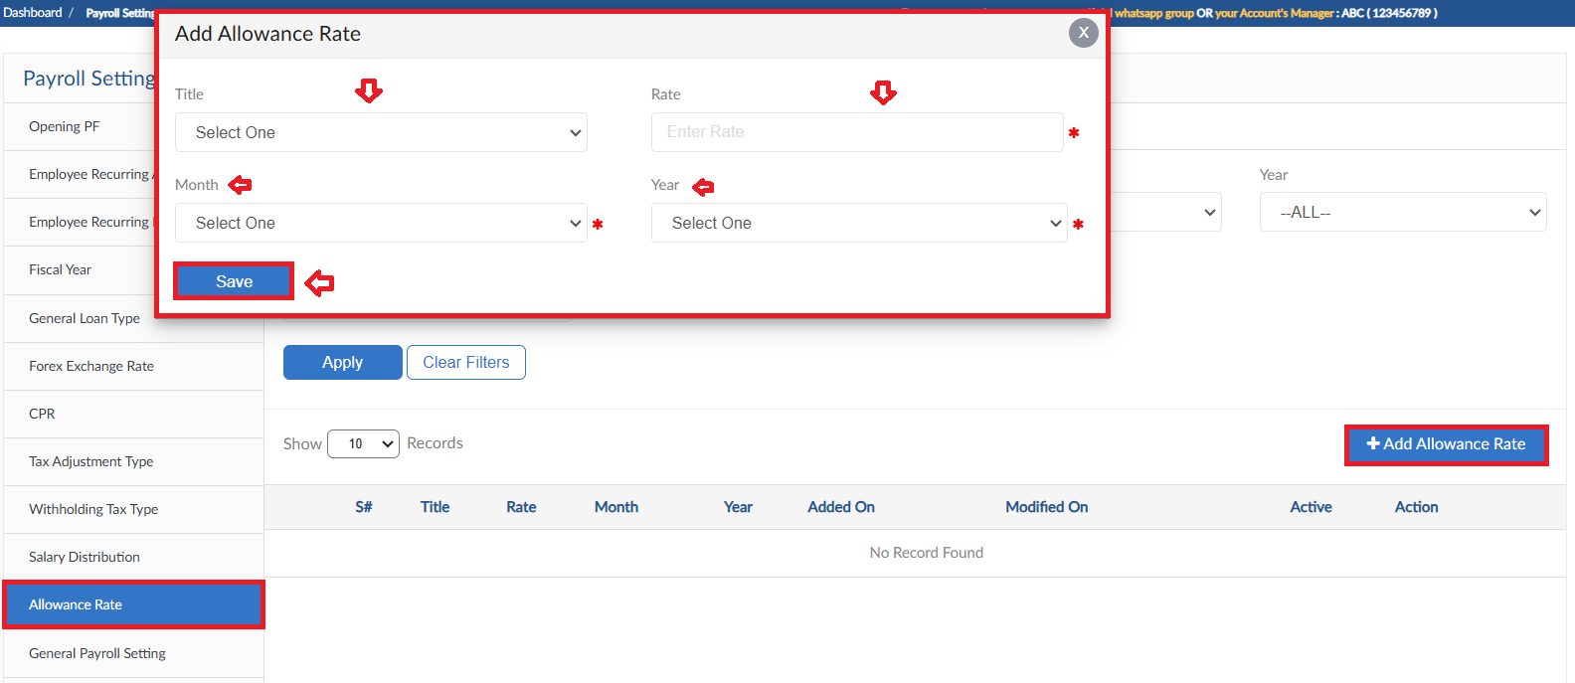

General Payroll Setting
- General payroll Settings form consists of all request approval hierarchy
- For every setting click Save button
